Unit 6 Lesson 11: Graphing from the Factored Form

1 Finding Coordinates (Warm up)

Student Task Statement
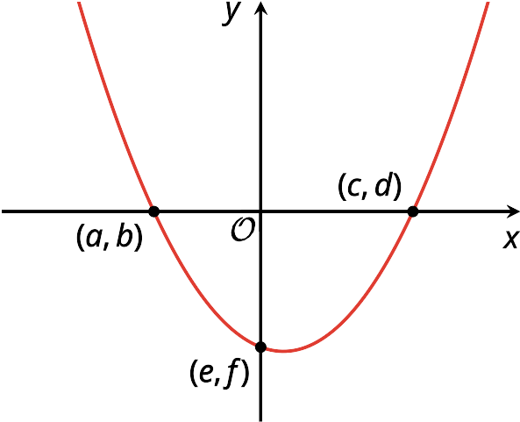
Here is a graph of a function $w$ defined by $w(x)=(x+1.6)(x−2)$. Three points on the graph are labeled.
Find the values of $a,b,c,d,e$, and $f$. Be prepared to explain your reasoning.

2 Comparing Two Graphs

Student Task Statement
Consider two functions defined by $f(x)=x(x+4)$ and $g(x)=x(x−4)$.
- Complete the table of values for each function. Then, determine the $x$-intercepts and vertex of each graph. Be prepared to explain how you know.
- $x$ | - $f(x)$
- -5 | - 5
- -4
- -3
- -2 | - -4
- -1 | - -3
- 0
- 1
- 2
- 3
- 4 | - 32
- 5
- $x$-intercepts:
- Vertex:
- $x$ | - $g(x)$
- -5 | - 45
- -4
- -3
- -2 | - 12
- -1 | - 5
- 0
- 1
- 2
- 3 | - -3
- 4
- 5
- $x$-intercepts:
- Vertex:
- Plot the points from the tables on the same coordinate plane. (Consider using different colors or markings for each set of points so you can tell them apart.)
- Then, make a couple of observations about how the two graphs compare.
- 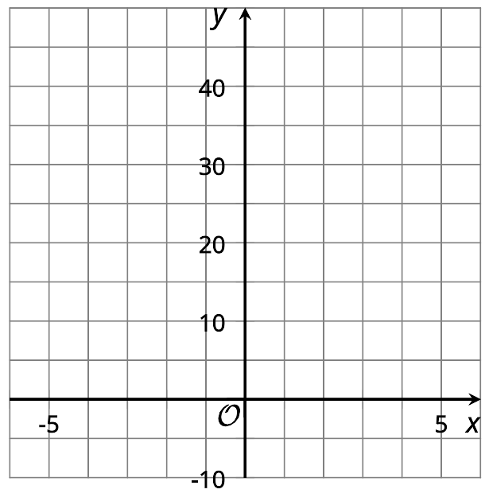
- ​​​​​​

3 What Do We Need to Sketch a Graph?

Student Task Statement
- The functions $f$, $g$, and $h$ are given. Predict the $x$-intercepts and the $x$-coordinate of the vertex of each function.
- equation | - $x$-intercepts | - $x$-coordinate of the vertex
- $f(x)=(x+3)(x−5)$
- $g(x)=2x(x−3)$
- $h(x)=(x+4)(4−x)$
- Use graphing technology to graph the functions $f$, $g$, and $h$. Use the graphs to check your predictions.
- Without using technology, sketch a graph that represents the equation $y=(x−7)(x+11)$ and that shows the $x$-intercepts and the vertex. Think about how to find the $y$-coordinate of the vertex. Be prepared to explain your reasoning.
- 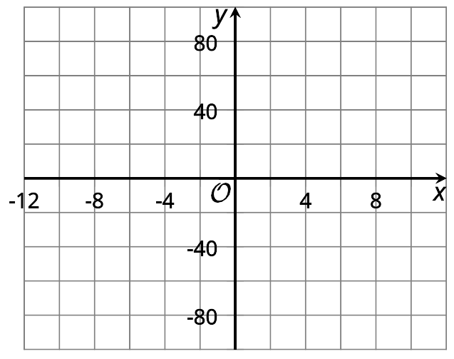
© CC BY 2019 by Illustrative Mathematics

