Unit 7 Lesson 5: Attributes of Other Quadrilaterals

WU Number Talk: Divide by 7 (Warm up)

Student Task Statement
Find the value of each expression mentally.
- $70÷7$
- $77÷7$
- $63÷7$
- $56÷7$

1 All the Ways

Student Task Statement
Select all the ways you could describe each shape. Be prepared to explain your reasoning.
1
- triangle
- quadrilateral
- square
- rhombus
- rectangle
2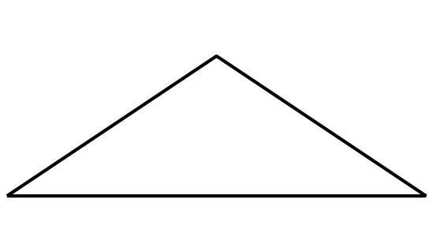
- triangle
- quadrilateral
- hexagon
- rhombus
- rectangle
- square
3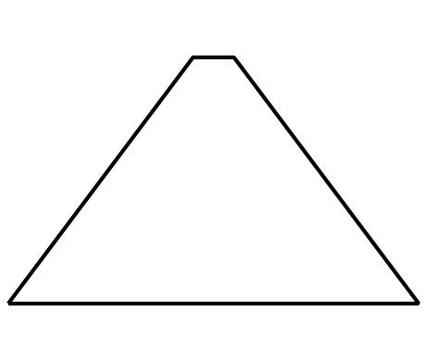
- triangle
- quadrilateral
- pentagon
- rhombus
- rectangle
- square
4
- triangle
- quadrilateral
- hexagon
- rhombus
- rectangle
- square
5
- hexagon
- quadrilateral
- triangle
- square
- rectangle
- rhombus
6
- hexagon
- quadrilateral
- triangle
- rhombus
- rectangle
- square

2 Draw One That’s Not . . .

Student Task Statement
- Draw a quadrilateral that isn’t a square.
- Draw a quadrilateral that isn’t a rhombus.
- Draw a quadrilateral that isn’t a rectangle.
- Draw as many quadrilaterals as you can that aren’t rhombuses, rectangles, or squares.
© CC BY 2021 Illustrative Mathematics®

