Unit 6 Lesson 15: Ways to Solve Problems and Show Solutions

WU Number Talk: Divide by 8 (Warm up)

Student Task Statement
Find the value of each expression mentally.
- $80÷8$
- $72÷8$
- $96÷8$
- $96÷4$

1 A Day at the Fair

Student Task Statement
You spent a day at the fair. Solve four problems about your day and create a poster to show your reasoning and solutions.
- You arrived at the fair!
- Entry to the fair is $9 a person. You went there with 6 other people. How much did it cost your group to enter the fair?
- How did you start your day? (Choose one.)
- 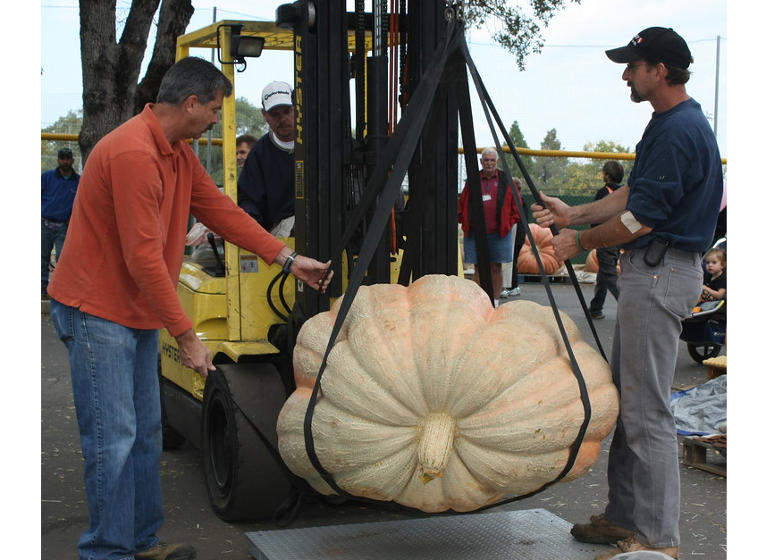
- You arrived at the giant pumpkin weigh-off at 11:12 a.m. and left at 12:25 p.m. How long were you there?
- You spent 48 minutes at the carnival and left at 12:10 p.m. What time did you get to the carnival?
- What was next? (Choose one.)
- 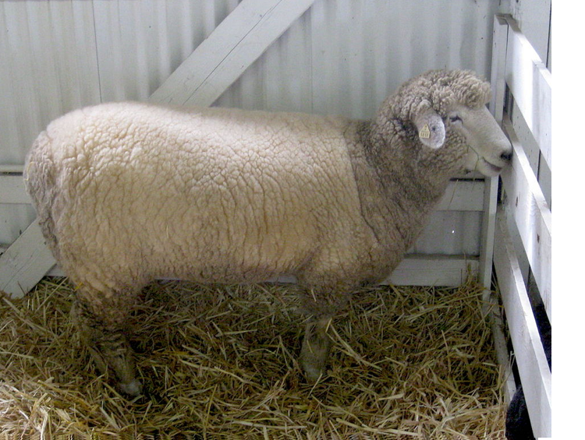
- You visited a barn with 7 sheep. The sheep drink 91 liters of water a day, each sheep drinking about the same amount. How much does each sheep drink a day?
- You visited a life-size sculpture of a cow made of butter. The butter cow weighs 273 kilograms, which is 277 kilograms less than the actual cow. How much does the actual cow weigh?
- 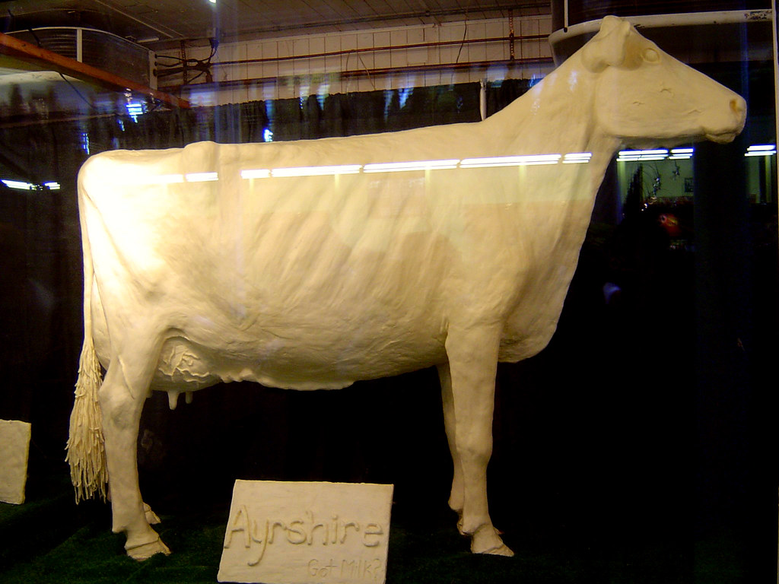
- Before you went home . . .
- You stopped for some grilled corn on the cob. On the grill, there were 54 ears of corn arranged in 9 equal rows. How many ears of corn were in each row?

2 A Day at the Fair Gallery Walk

Student Task Statement
As you visit the posters with your partner:
- Look for a problem that was solved using a strategy that is different from yours. What made it different? Describe the strategy.
- Look for ways that your classmates made their thinking and the math work clear to you. Describe at least three things they did or showed on the posters.
© CC BY 2021 Illustrative Mathematics®

