Lesson 2: Interpret Representations of Multiplicative Comparison
- Let’s make sense of representations of problems with “times as many.”

Warm-up: How Many Do You See: Times as Many
How many do you see? How do you see them?

2.1: Represent “Times as Many”
- Jada has 4 times as many cubes as Kiran. Draw a diagram to represent the situation.
- Diego has 5 times as many cubes as Kiran. Draw a diagram to represent the situation.
- Lin has 6 times as many cubes as Kiran. How many cubes does Lin have? Explain or show your reasoning.

2.2: Diagrams to Solve Multiplicative Comparison Problems
Here are four sets of descriptions, diagrams, and equations that compare pairs of quantities.
Match each description to a diagram and an equation that represent the same situation. Be prepared to explain your reasoning.
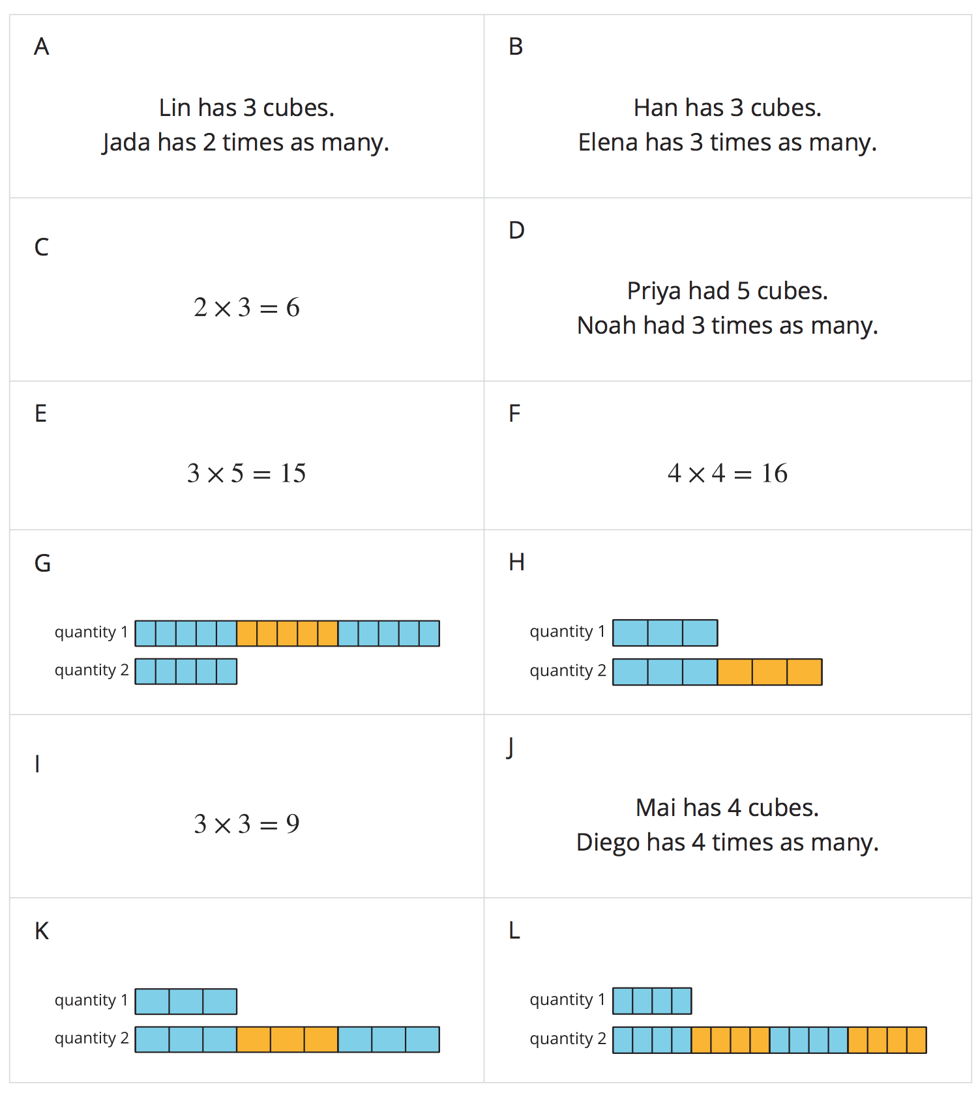
Record your matches here:
Set 1: _____, _____, _____
Set 2: _____, _____, _____
Set 3: _____, _____, _____
Set 4: _____, _____, _____
© CC BY 2021 Illustrative Mathematics®

