Unit 3 Lesson 19: Real and Non-Real Solutions

1 Notice and Wonder: Where Is It 0? (Warm up)

Student Task Statement
What do you notice? What do you wonder?
$f(x)=2x^{2}+4x$
$f(x)=0$ when $x=0,\text{-}2$.
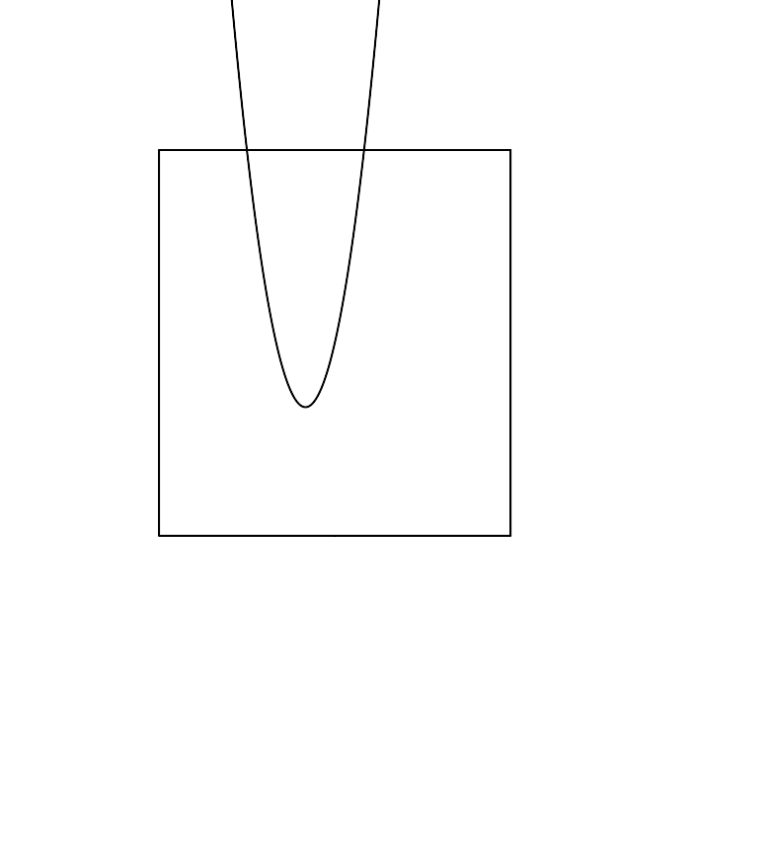
$g(x)=2x^{2}+4x+2$
$g(x)=0$ when $x=\text{-}1$.
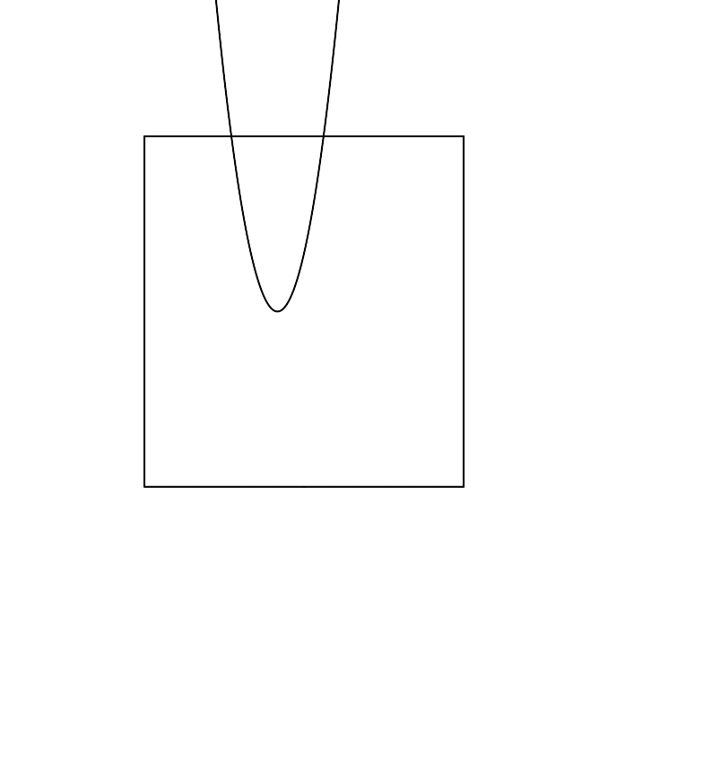
$h(x)=2x^{2}+4x+4$
$h(x)=0$ when $x=\text{-}1+i,\text{-}1−i$.

2 Real or Not? (Optional)

Student Task Statement
Here are some equations:
Equation | Prediction
$x^{2}−6x+5=0$
$x^{2}−6x+13=0$
$\text{-}x^{2}+6x−9=0$
$\text{-}x^{2}−9=0$
- Which equations will have real solutions, and which ones will not? Write your prediction in the table.
Pause here for discussion.
- What advice would you give to someone who is trying to figure out whether a quadratic equation has real solutions?

3 Make Your Own (Optional)

Student Task Statement
- Create three different quadratic equations. At least one should have solutions with an imaginary part, and at least one should have solutions with only real parts.
- Solve your equations. Write down your equations and their solutions in the table.
- Equation | - Solutions
© CC BY 2019 by Illustrative Mathematics®

