Unit 7 Lesson 5: Negative Exponents with Powers of 10

1 Number Talk: What's That Exponent? (Warm up)

Student Task Statement
Solve each equation mentally.
$\frac{100}{1}={10}^{x}$
$\frac{100}{x}={10}^{1}$
$\frac{x}{100}={10}^{0}$
$\frac{100}{1,​000}={10}^{x}$

2 Negative Exponent Table

Student Task Statement
Complete the table to explore what negative exponents mean.
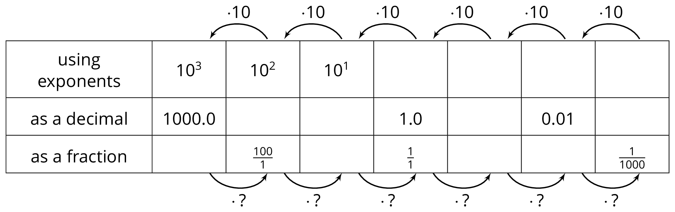
- As you move toward the left, each number is being multiplied by 10. What is the multiplier as you move right?
- How does a multiplier of 10 affect the placement of the decimal in the product? How does the other multiplier affect the placement of the decimal in the product?
- Use the patterns you found in the table to write ${10}^{\text{-}7}$ as a fraction.
- Use the patterns you found in the table to write ${10}^{\text{-}5}$ as a decimal.
- Write $\frac{1}{100,000,000}$ using a single exponent.
- Use the patterns in the table to write ${10}^{\text{-}n}$ as a fraction.

3 Follow the Exponent Rules

Student Task Statement
  - Match each exponential expression with an equivalent multiplication expression:
  - ${\left({10}^{2}\right)}^{3}$
  - ${\left({10}^{2}\right)}^{\text{-}3}$
  - ${\left({10}^{\text{-}2}\right)}^{3}$
  - ${\left({10}^{\text{-}2}\right)}^{\text{-}3}$
  - $\frac{1}{(10⋅10)}⋅\frac{1}{(10⋅10)}⋅\frac{1}{(10⋅10)}$
  - $\left(\frac{1}{10}⋅\frac{1}{10}\right)\left(\frac{1}{10}⋅\frac{1}{10}\right)\left(\frac{1}{10}⋅\frac{1}{10}\right)$
  - $\frac{1}{\frac{1}{10}⋅\frac{1}{10}}⋅\frac{1}{\frac{1}{10}⋅\frac{1}{10}}⋅\frac{1}{\frac{1}{10}⋅\frac{1}{10}}$
  - $(10⋅10)(10⋅10)(10⋅10)$
  - Write $({10}^{2})^{\text{-}3}$ as a power of 10 with a single exponent. Be prepared to explain your reasoning.
  - Match each exponential expression with an equivalent multiplication expression:
  - $\frac{{10}^{2}}{{10}^{5}}$
  - $\frac{{10}^{2}}{{10}^{\text{-}5}}$
  - $\frac{{10}^{\text{-}2}}{{10}^{5}}$
  - $\frac{{10}^{\text{-}2}}{{10}^{\text{-}5}}$
  - $\frac{\frac{1}{10}⋅\frac{1}{10}}{\frac{1}{10}⋅\frac{1}{10}⋅\frac{1}{10}⋅\frac{1}{10}⋅\frac{1}{10}}$
  - $\frac{10⋅10}{10⋅10⋅10⋅10⋅10}$
  - $\frac{\frac{1}{10}⋅\frac{1}{10}}{10⋅10⋅10⋅10⋅10}$
  - $\frac{10⋅10}{\frac{1}{10}⋅\frac{1}{10}⋅\frac{1}{10}⋅\frac{1}{10}⋅\frac{1}{10}}$
  - Write $\frac{{10}^{\text{-}2}}{{10}^{\text{-}5}}$ as a power of 10 with a single exponent. Be prepared to explain your reasoning.
  - Match each exponential expression with an equivalent multiplication expression:
  - ${10}^{4}⋅{10}^{3}$
  - ${10}^{4}⋅{10}^{\text{-}3}$
  - ${10}^{\text{-}4}⋅{10}^{3}$
  - ${10}^{\text{-}4}⋅{10}^{\text{-}3}$
  - $(10⋅10⋅10⋅10)⋅(\frac{1}{10}⋅\frac{1}{10}⋅\frac{1}{10})$
  - $\left(\frac{1}{10}⋅\frac{1}{10}⋅\frac{1}{10}⋅\frac{1}{10}\right)⋅\left(\frac{1}{10}⋅\frac{1}{10}⋅\frac{1}{10}\right)$
  - $\left(\frac{1}{10}⋅\frac{1}{10}⋅\frac{1}{10}⋅\frac{1}{10}\right)⋅\left(10⋅10⋅10\right)$
  - $(10⋅10⋅10⋅10)⋅(10⋅10⋅10)$
  - Write ${10}^{\text{-}4}⋅{10}^{3}$ as a power of 10 with a single exponent. Be prepared to explain your reasoning.
© CC BY Open Up Resources. Adaptations CC BY IM.

