Lesson 8 Practice Problems
- Different stores across the country sell a book for different prices. The table shows the price of the book in dollars and the number of books sold at that price.
- price in dollars | - number sold
- 11.25 | - 53
- 10.50 | - 60
- 12.10 | - 30
- 8.45 | - 81
- 9.25 | - 70
- 9.75 | - 80
- 7.25 | - 120
- 12 | - 37
- 9.99 | - 130
- 7.99 | - 100
- 8.75 | - 90
  - Draw a scatter plot of this data. Label the axes.
  - Are there any outliers? Explain your reasoning.
  - If there is a relationship between the variables, explain what it is.
  - Remove any outliers, and draw a line that you think is a good fit for the data.
- Here is a scatter plot:
- 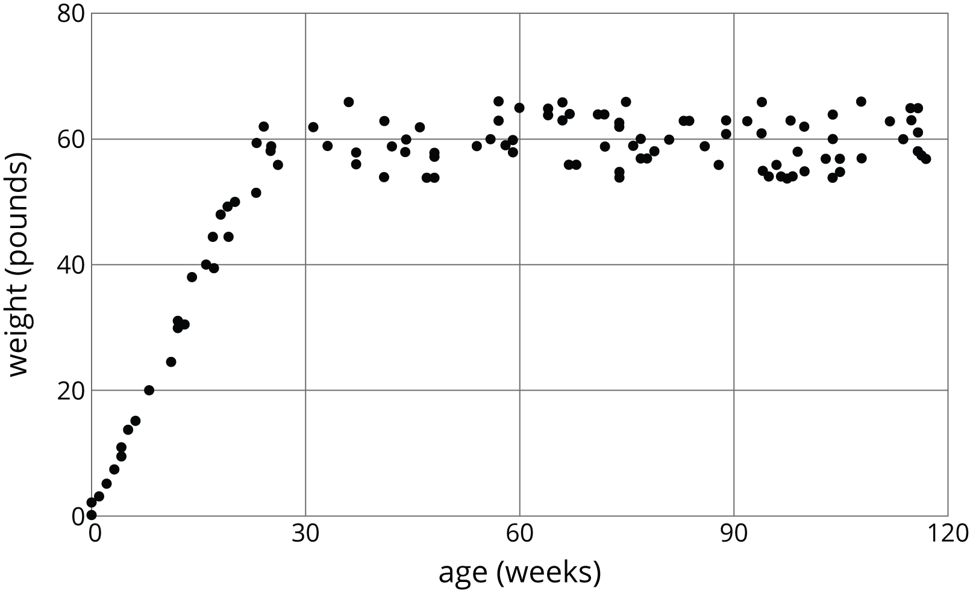
- Select all the following that describe the association in the scatter plot:
  - Linear association
  - Non-linear association
  - Positive association
  - Negative association
  - No association
- (From Unit 6, Lesson 7.)
- Using the data in the scatter plot, what can you tell about the slope of a good model?
- 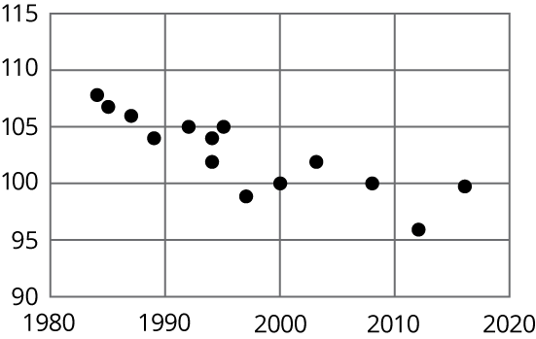
  - The slope is positive.
  - The slope is zero.
  - The slope is negative.
  - There is no association.
- (From Unit 6, Lesson 6.)
© CC BY Open Up Resources. Adaptations CC BY IM.

