Lesson 2: Representaciones de grupos iguales de fracciones

Standards Alignments
Addressing | 4.NF.B.4, 4.NF.B.4.a, 4.NF.B.4.c
Building Towards | 4.NBT.B.5, 4.NF.B.4.a

Teacher-facing Learning Goals
- Interpret diagrams and expressions that represent multiplication of a whole number and a unit fraction.
- Use diagrams and expressions to represent and find the product of a whole number and a unit fraction.

Student-facing Learning Goals
- Examinemos diagramas y expresiones que puedan ayudarnos a multiplicar un número entero por una fracción.

Lesson Purpose
The purpose of this lesson is for students to interpret and generate diagrams and expressions that represent multiplication of a whole number and a unit fraction in order to find the value of the product.
In this lesson, students interpret and relate multiplication expressions and diagrams that represent products of whole numbers and fractions. After matching expressions and diagrams in a card-sort activity, they practice using diagrams and expressions to find the result of multiplying a whole number and a fraction. They draw a diagram given a multiplication expression, or write an expression given a diagram (MP2).

Access for:

Students with Disabilities
- Engagement (Activity 1)

English Learners
- MLR8 (Activity 1)

Instructional Routines
Card Sort (Activity 1), Number Talk (Warm-up)

Materials to Copy
- Expressions and Diagrams (groups of 2): Activity 1

Lesson Timeline
Warm-up | 10 min
Activity 1 | 25 min
Activity 2 | 10 min
Lesson Synthesis | 10 min
Cool-down | 5 min

Teacher Reflection Question
Revisit class norms and routines. Are all students contributing to the conversation? Do some students’ ideas seem to hold more value in the dynamics of the group? Are there any adjustments you might make so that all students do math tomorrow?

Cool-down
(to be completed at the end of the lesson) 5min
Grupos iguales de fracciones

Standards Alignments
Addressing | 4.NF.B.4

Student-facing Task Statement
Escribe una expresión de multiplicación que represente las partes sombreadas del diagrama. Luego, encuentra el valor de la expresión. Explica o muestra tu razonamiento.
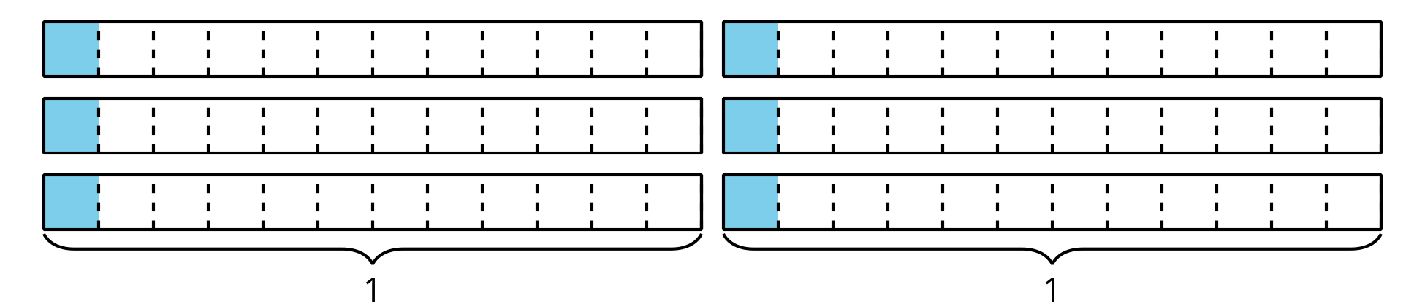

Student Responses
$6×\frac{1}{12}$. Its value is $\frac{6}{12}$. Sample response:
- There are 6 equal groups of $\frac{1}{12}$.
- I counted by $\frac{1}{12}$ six times.
- If all the shaded parts are moved to a single rectangle that represents 1 whole, they would take up 6 parts, which represent $\frac{6}{12}$.

