Unit 1 Lesson 2: Corresponding Parts and Scale Factors

1 Number Talk: Multiplying by a Unit Fraction (Warm up)

Student Task Statement
Find each product mentally.
$\frac{1}{4}⋅32$
$\left(7.2\right)⋅\frac{1}{9}$
$\frac{1}{4}⋅\left(5.6\right)$

2 Corresponding Parts

Student Task Statement
Here is a figure and two copies, each with some points labeled.
- Complete this table to show corresponding parts in the three figures.
- original | - copy 1 | - copy 2
- point $P$
- segment $LM$
 | - segment $EF$
 |  | - point $W$
- angle $KLM$
 |  | - angle $XYZ$
- Is either copy a scaled copy of the original figure? Explain your reasoning.
- Use tracing paper to compare angle $KLM$ with its corresponding angles in Copy 1 and Copy 2. What do you notice?
- Use tracing paper to compare angle $NOP$ with its corresponding angles in Copy 1 and Copy 2. What do you notice?

3 Scaled Triangles

Student Task Statement
Here is Triangle O, followed by a number of other triangles.
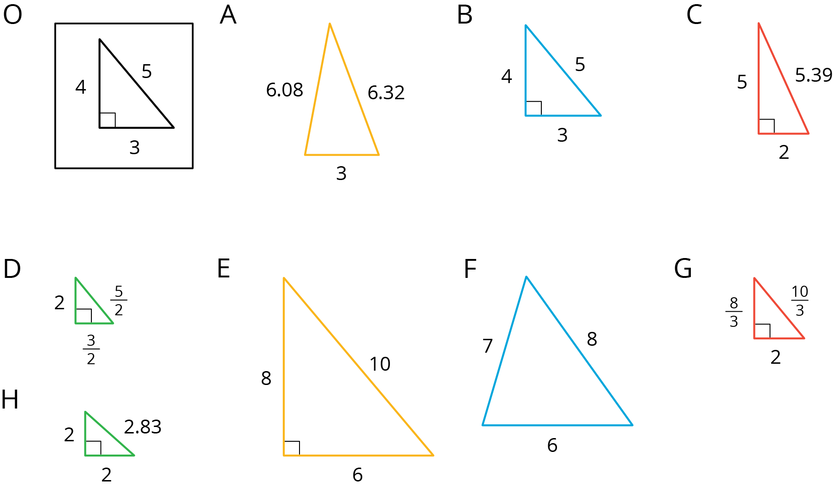
Your teacher will assign you two of the triangles to look at.
- For each of your assigned triangles, is it a scaled copy of Triangle O? Be prepared to explain your reasoning.
- As a group, identify all the scaled copies of Triangle O in the collection. Discuss your thinking. If you disagree, work to reach an agreement.
- List all the triangles that are scaled copies in the table. Record the side lengths that correspond to the side lengths of Triangle O listed in each column.
- Triangle O | - 3 | - 4 | - 5
- Explain or show how each copy has been scaled from the original (Triangle O).

Activity Synthesis
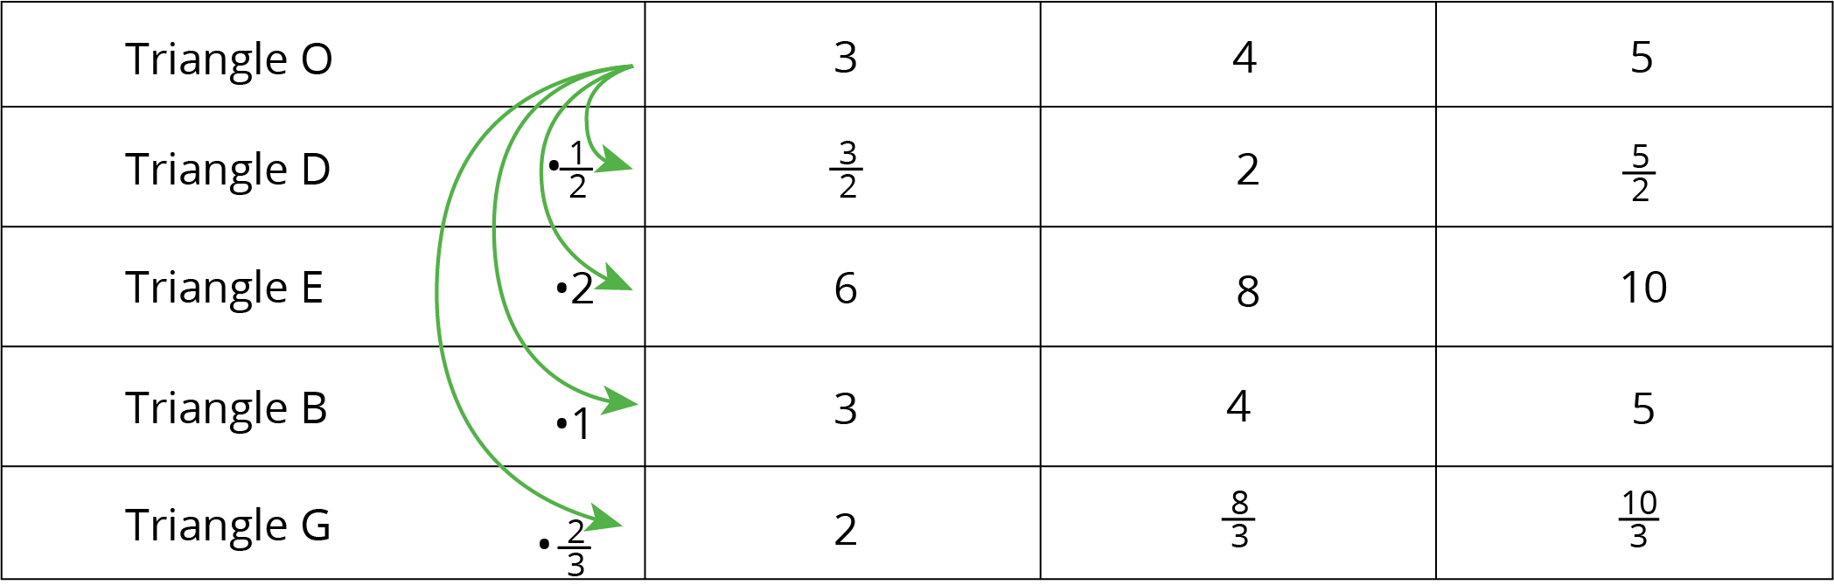

Images for Activity Synthesis
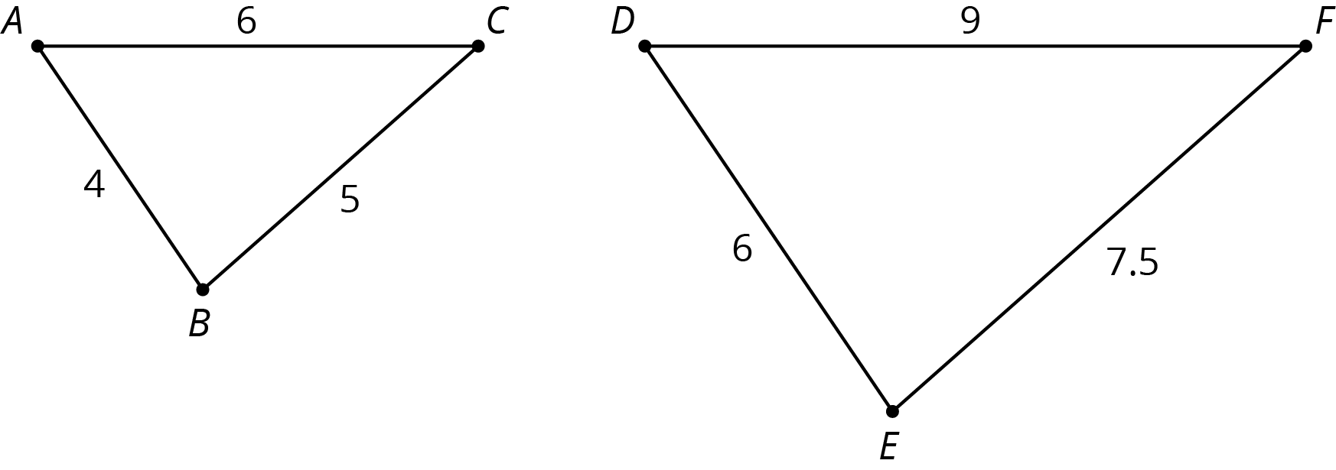
© CC BY Open Up Resources. Adaptations CC BY IM.

