Lesson 7: Adding and Subtracting to Solve Problems
Let’s apply what we know about signed numbers to different situations.

7.1: Positive or Negative?
Without computing:
- Is the solution to $\text{-}2.7+x=\text{-}3.5$ positive or negative?
- Select all the expressions that are solutions to $\text{-}2.7+x=\text{-}3.5$.
  - $\text{-}3.5+2.7$
  - $3.5−2.7$
  - $\text{-}3.5−\left(\text{-}2.7\right)$
  - $\text{-}3.5−2.7$

7.2: Phone Inventory
A store tracks the number of cell phones it has in stock and how many phones it sells.
The table shows the inventory for one phone model at the beginning of each day last week. The inventory changes when they sell phones or get shipments of phones into the store.
 | inventory | change
Monday | 18 | -2
Tuesday | 16 | -5
Wednesday | 11 | -7
Thursday | 4 | -6
Friday | -2 | 20
- What do you think it means when the change is positive? Negative?
- What do you think it means when the inventory is positive? Negative?
- Based on the information in the table, what do you think the inventory will be at on Saturday morning? Explain your reasoning.
- What is the difference between the greatest inventory and the least inventory?

7.3: Solar Power
Han's family got a solar panel. Each month they get a credit to their account for the electricity that is generated by the solar panel. The credit they receive varies based on how sunny it is.
Current charges: $83.56
Solar Credit: -$6.75
Amount due: $76.81
Here is their electricity bill from January.
In January they used $83.56 worth of electricity and generated $6.75 worth of electricity.
- In July they were traveling away from home and only used $19.24 worth of electricity. Their solar panel generated $22.75 worth of electricity. What was their amount due in July?
- The table shows the value of the electricity they used and the value of the electricity they generated each week for a month. What amount is due for this month?
 | - used ($) | - generated ($)
- week 1 | - 13.45 | - -6.33
- week 2 | - 21.78 | - -8.94
- week 3 | - 18.12 | - -7.70
- week 4 | - 24.05 | - -5.36

- What is the difference between the value of the electricity generated in week 1 and week 2? Between week 2 and week 3?

Are you ready for more?
While most rooms in any building are all at the same level of air pressure, hospitals make use of "positive pressure rooms" and "negative pressure rooms." What do you think it means to have negative pressure in this setting? What could be some uses of these rooms?

7.4: Differences and Distances
Plot these points on the coordinate grid: $A=\left(5,4\right),B=\left(5,\text{-}2\right),C=\left(\text{-}3,\text{-}2\right),D=\left(\text{-}3,4\right)$
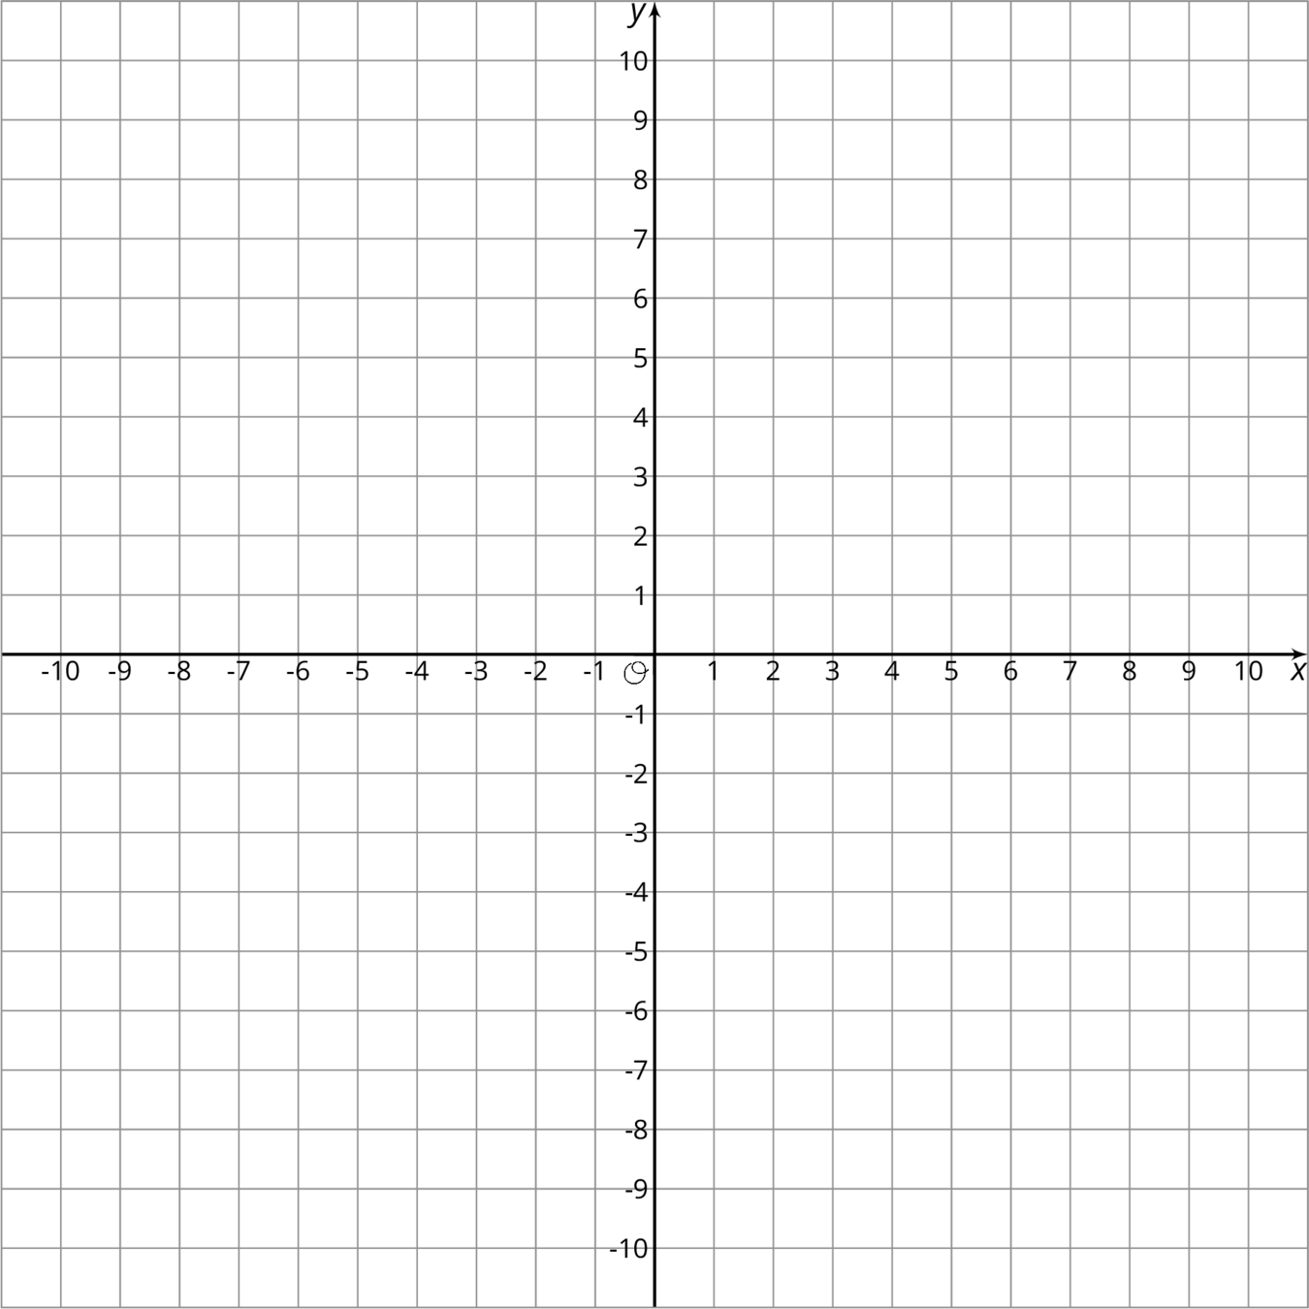
- What shape is made if you connect the dots in order?
- What are the side lengths of figure $ABCD$?
- What is the difference between the $x$-coordinates of $B$ and $C$?
- What is the difference between the $x$-coordinates of $C$ and $B$?
- How do the differences of the coordinates relate to the distances between the points?

Lesson 7 Summary
Sometimes we use positive and negative numbers to represent quantities in context. Here are some contexts we have studied that can be represented with positive and negative numbers:
- temperature
- elevation
- inventory
- an account balance
- electricity flowing in and flowing out
In these situations, using positive and negative numbers, and operations on positive and negative numbers, helps us understand and analyze them. To solve problems in these situations, we just have to understand what it means when the quantity is positive, when it is negative, and what it means to add and subtract them.
When two points in the coordinate plane lie on a horizontal line, you can find the distance between them by subtracting their $x$-coordinates.
When two points in the coordinate plane lie on a vertical line, you can find the distance between them by subtracting their $y$-coordinates.
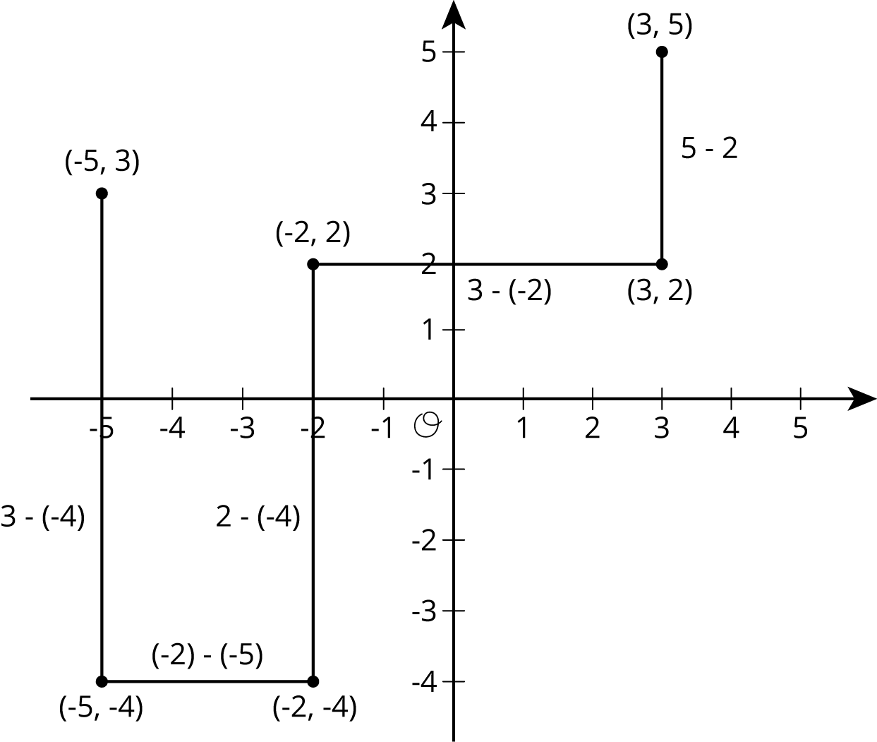
Remember: the distance between two numbers is independent of the order, but the difference depends on the order.
© CC BY Open Up Resources. Adaptations CC BY IM.

