Unit 5 Lesson 14: Estimating Areas

1 Mental Calculations (Warm up)

Student Task Statement
Find a strategy to make each calculation mentally:
$599+87$
$254−88$
$99⋅75$

2 House Floorplan

Student Task Statement
Here is a floor plan of a house. Approximate lengths of the walls are given. What is the approximate area of the home, including the balcony? Explain or show your reasoning.
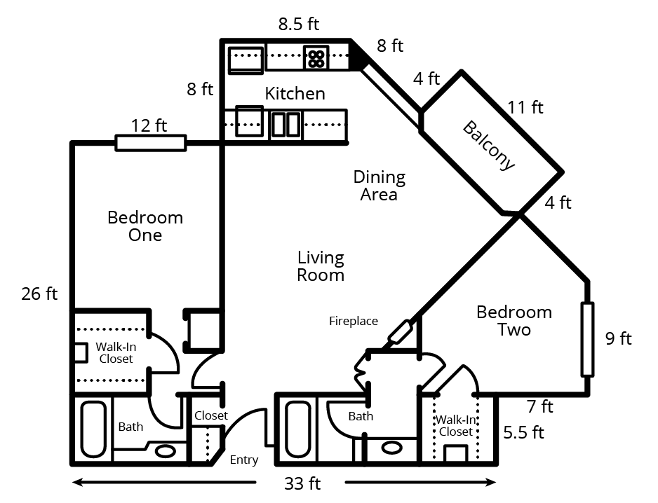

3 Area of Nevada

Images for Launch
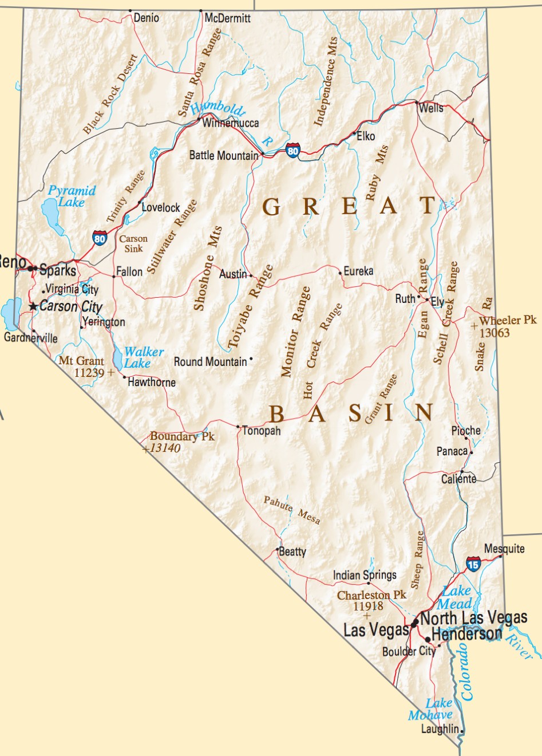
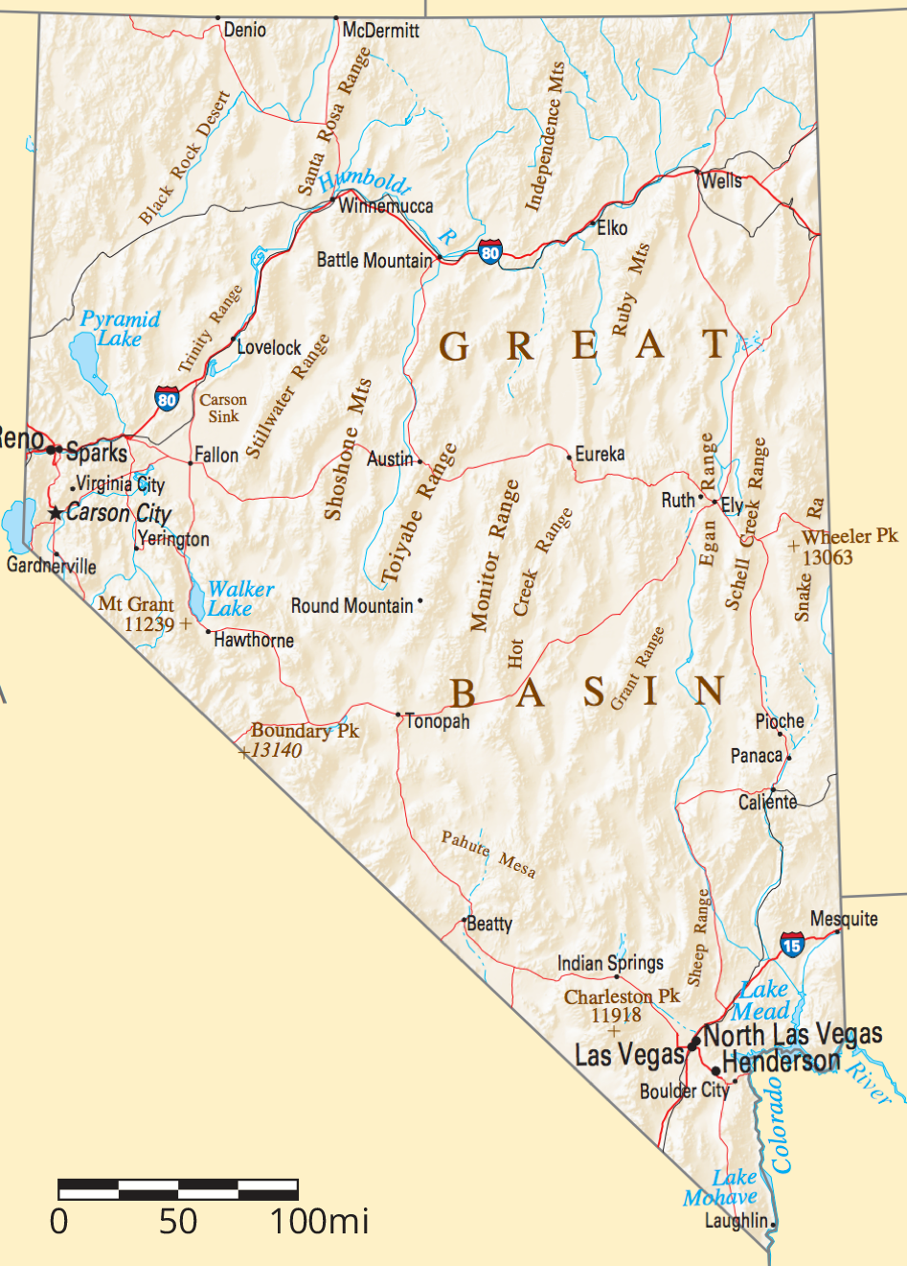

Student Task Statement
Estimate the area of Nevada in square miles. Explain or show your reasoning.
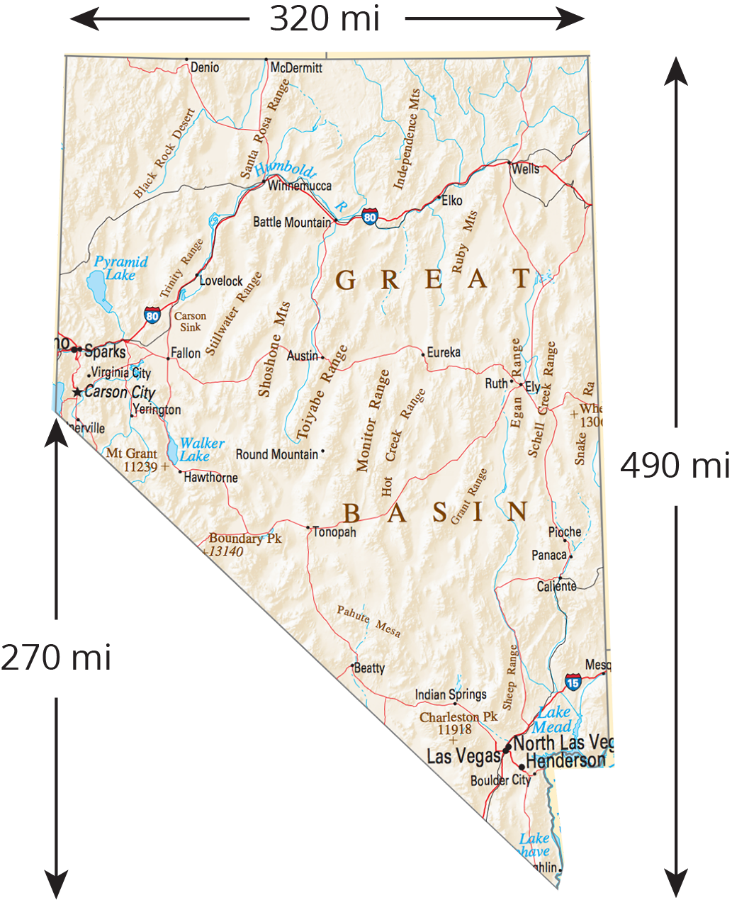

© CC BY Open Up Resources. Adaptations CC BY IM.

