## Lesson 10: Find More or Fewer

* Let’s compare groups of images using the words “more,” “fewer,” or “the same number.”

### 10.1: Circle More, Circle Fewer



* 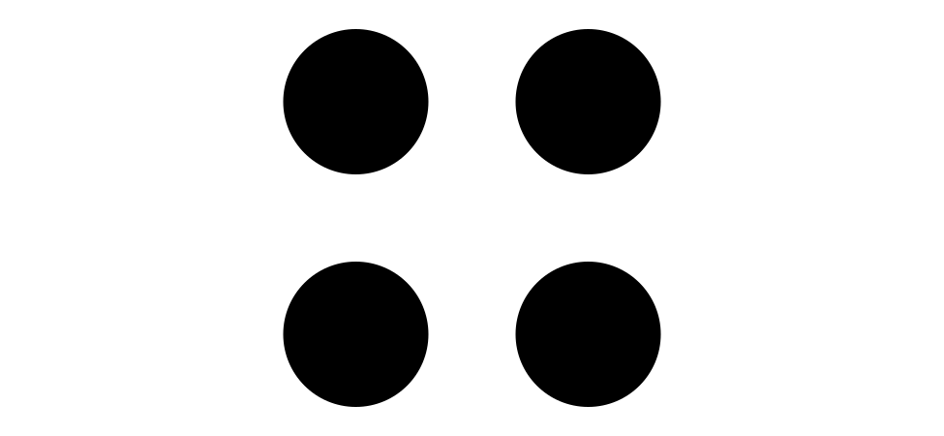
* 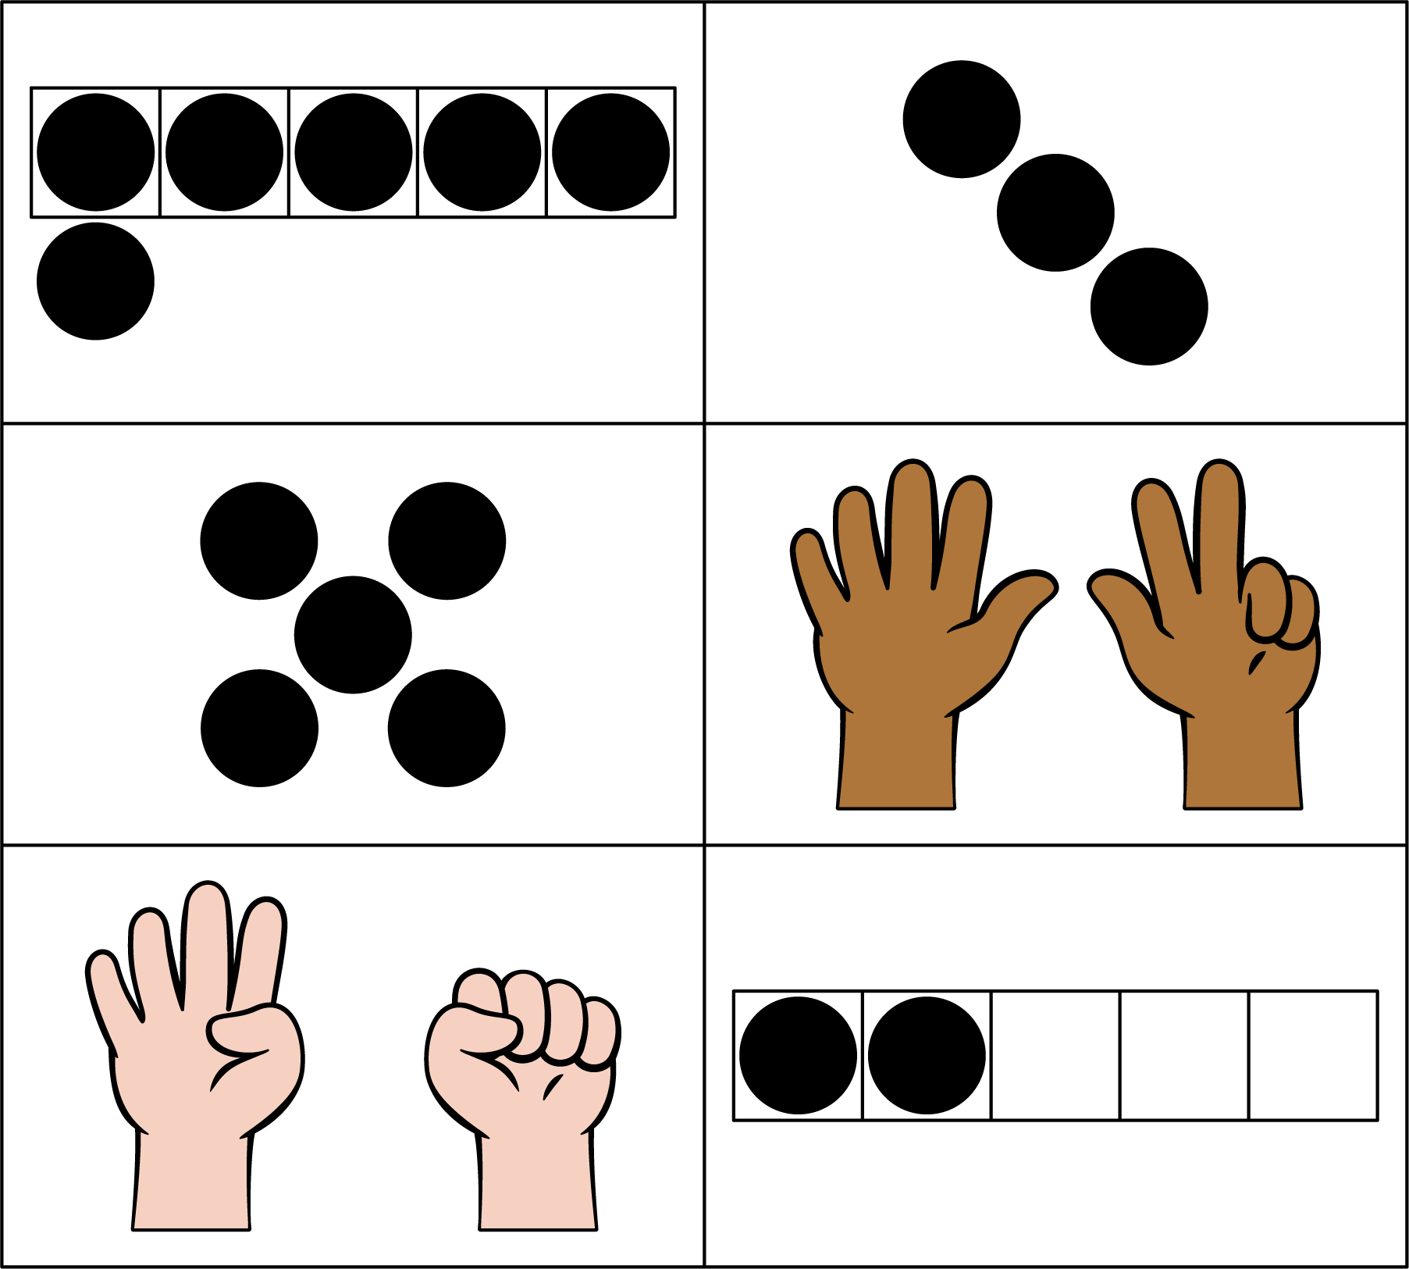



* 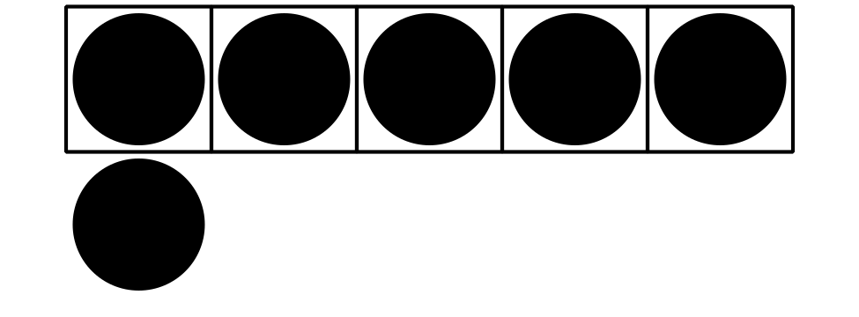
* 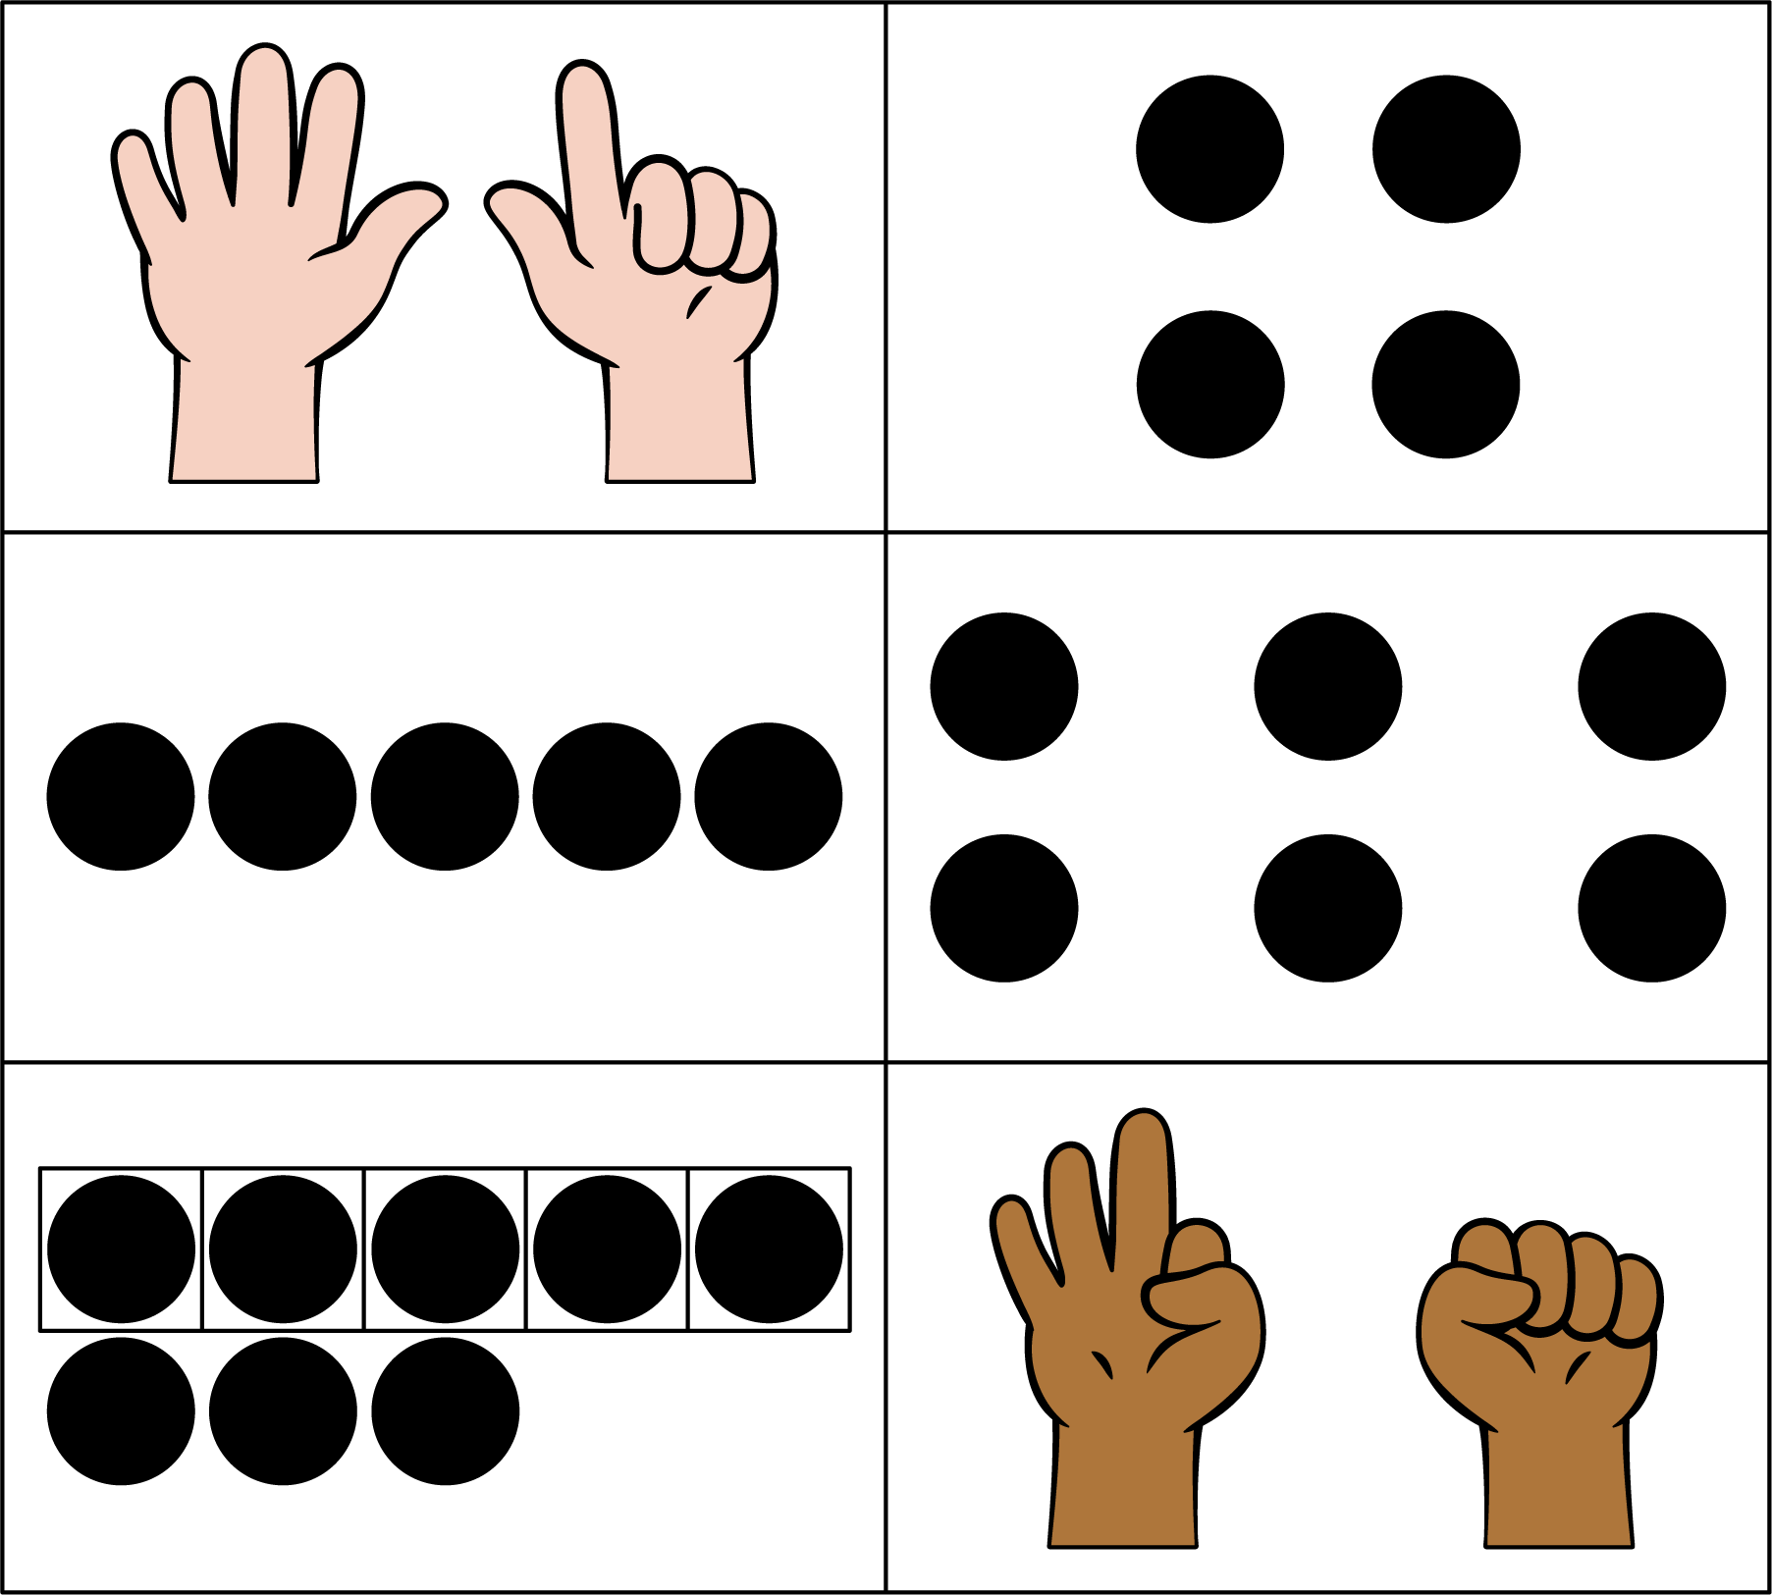

### 10.2: Introduce Less, Same, More, Images

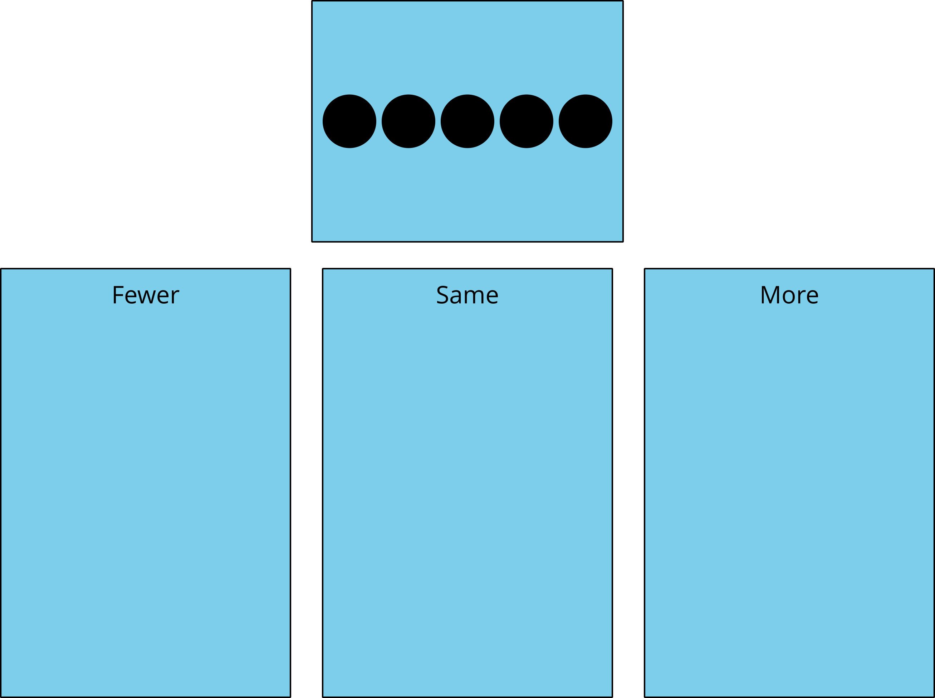

### 10.3: Centers: Choice Time

Choose a center.

Less, Same, More

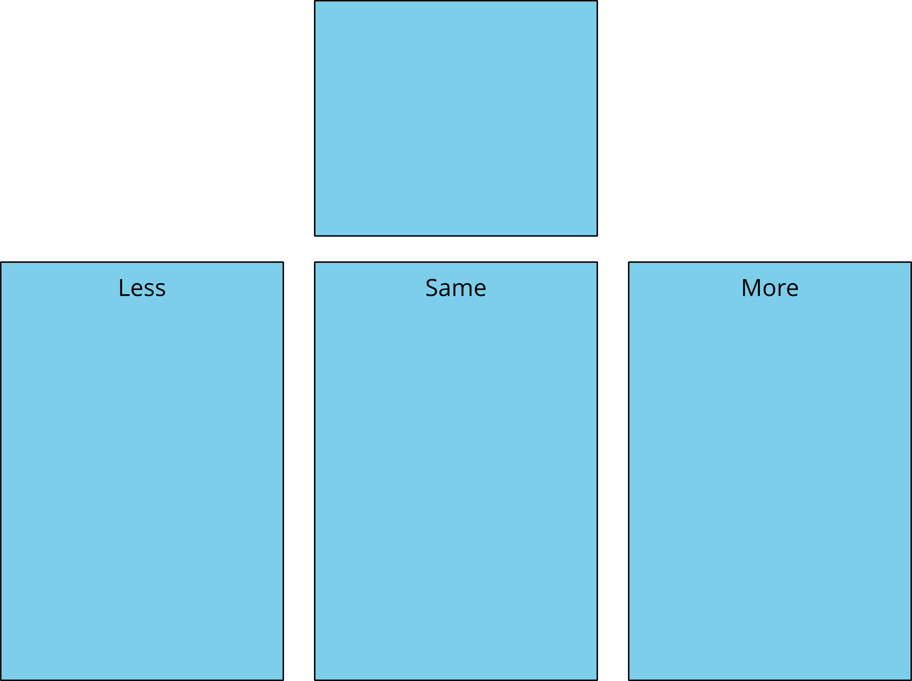

Bingo

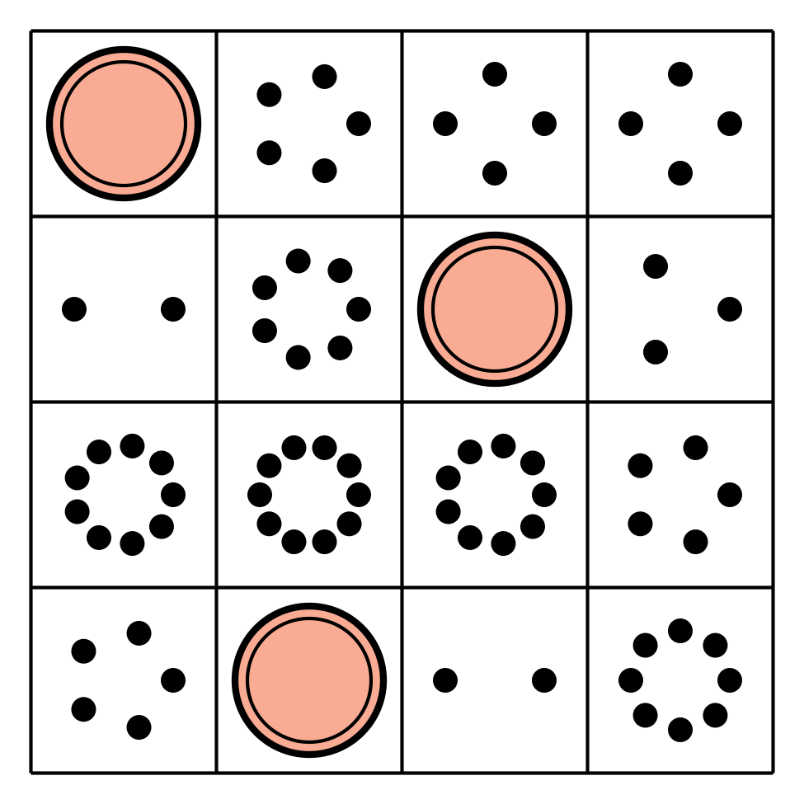

Math Stories

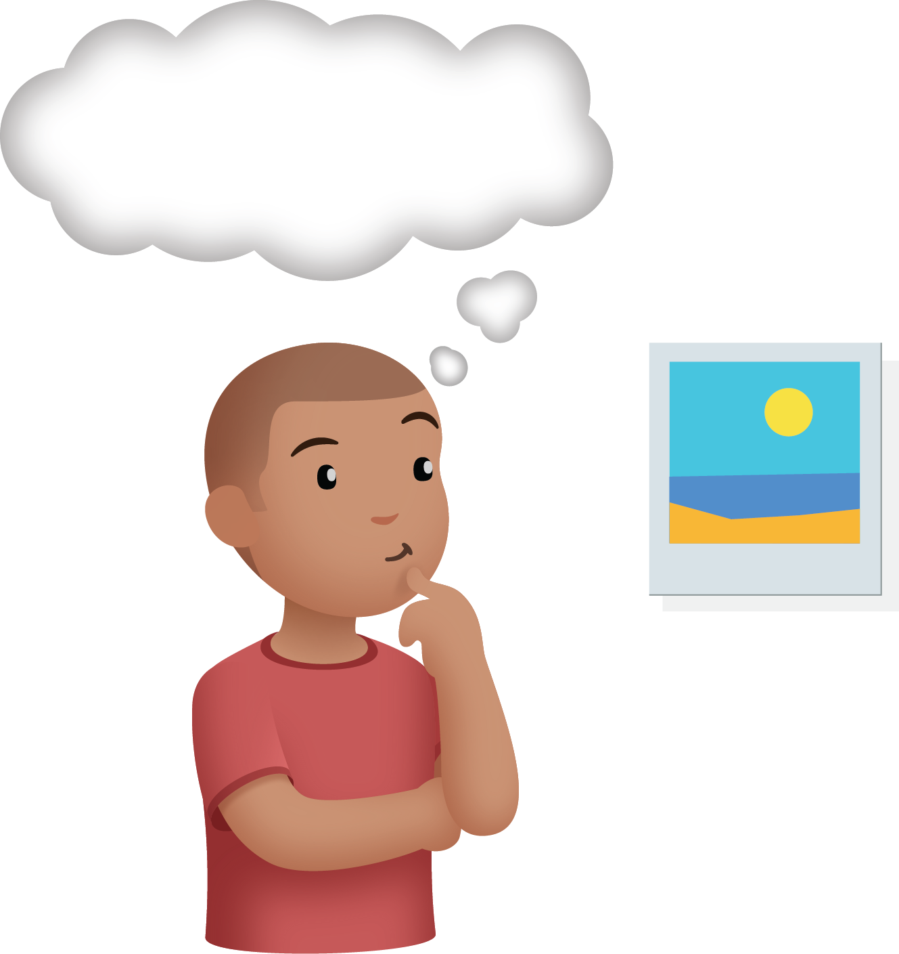

Connecting Cubes

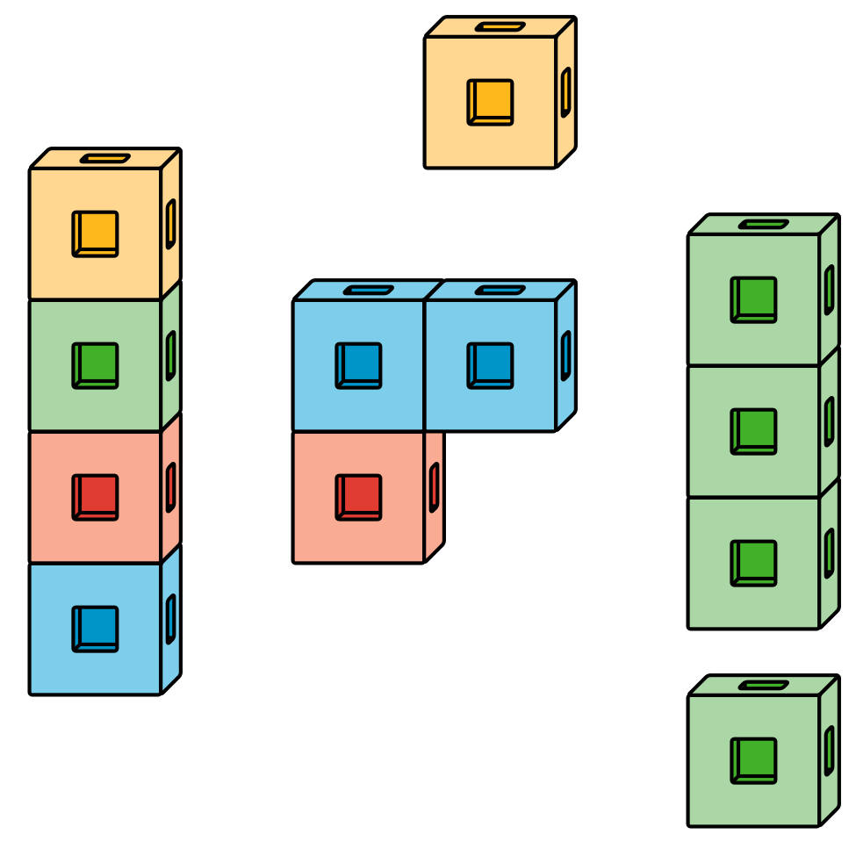

Number Race

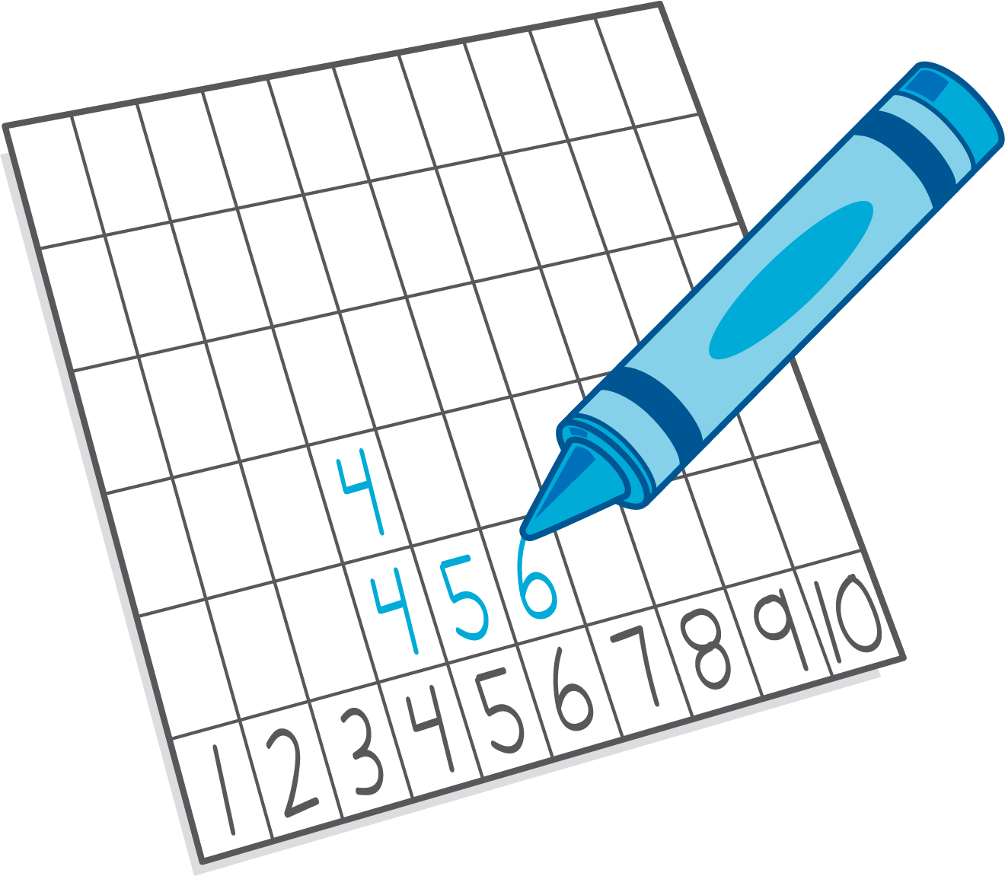



© CC BY 2021 Illustrative Mathematics®