Unit 6 Lesson 4: Does the Number Change?

WU Notice and Wonder: Lots of Dots (Warm up)

Student Task Statement
What do you notice?
What do you wonder?
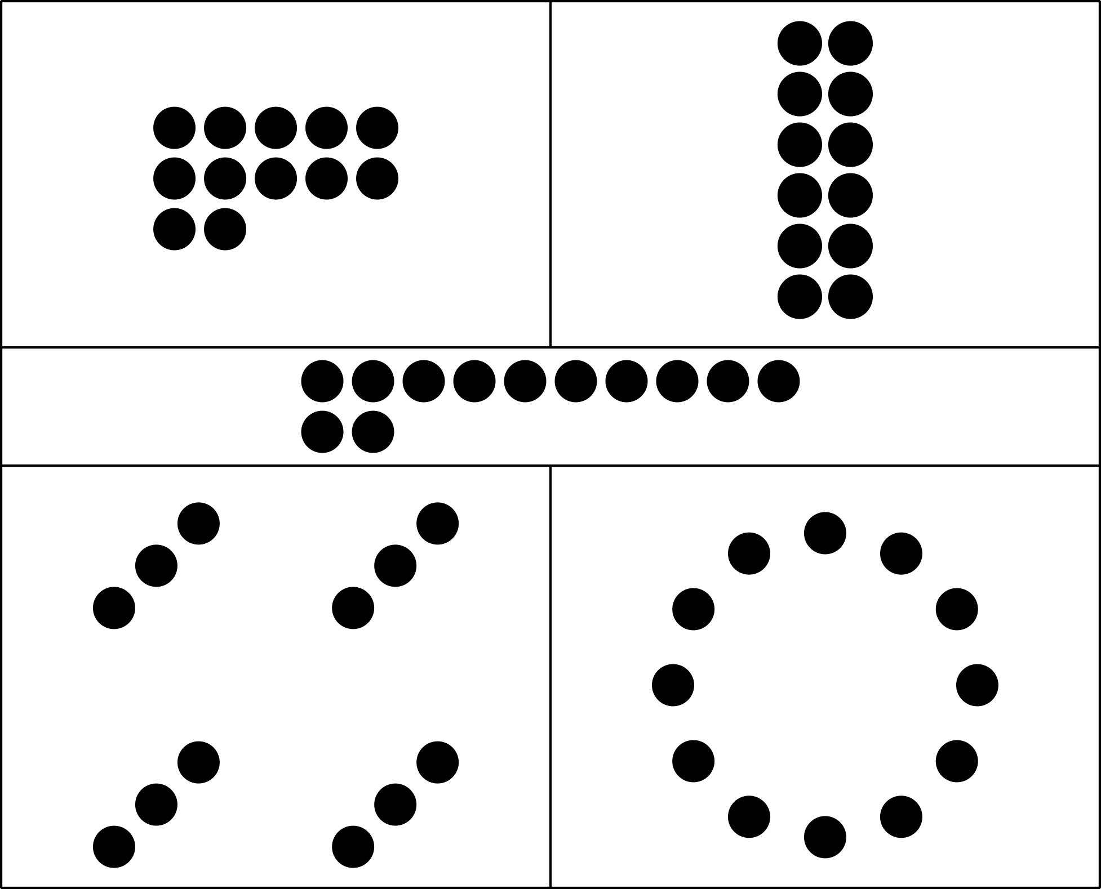

1 Counting Collections

Student Task Statement

2 Count, Rearrange, Recount

Student Task Statement

3 Introduce Tower Build, Count and Build to 20

Student Task Statement
Choose a center.
Tower Build
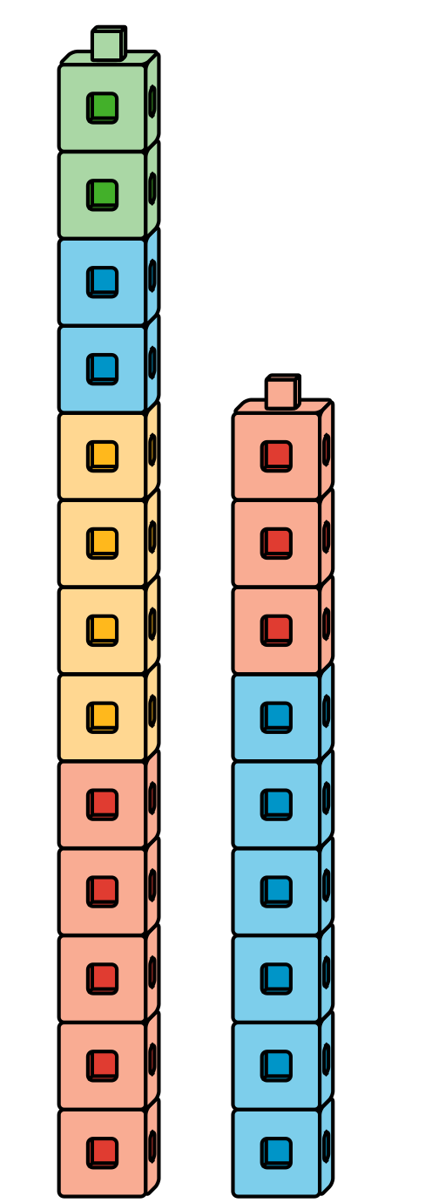
Find the Pair
Number Race
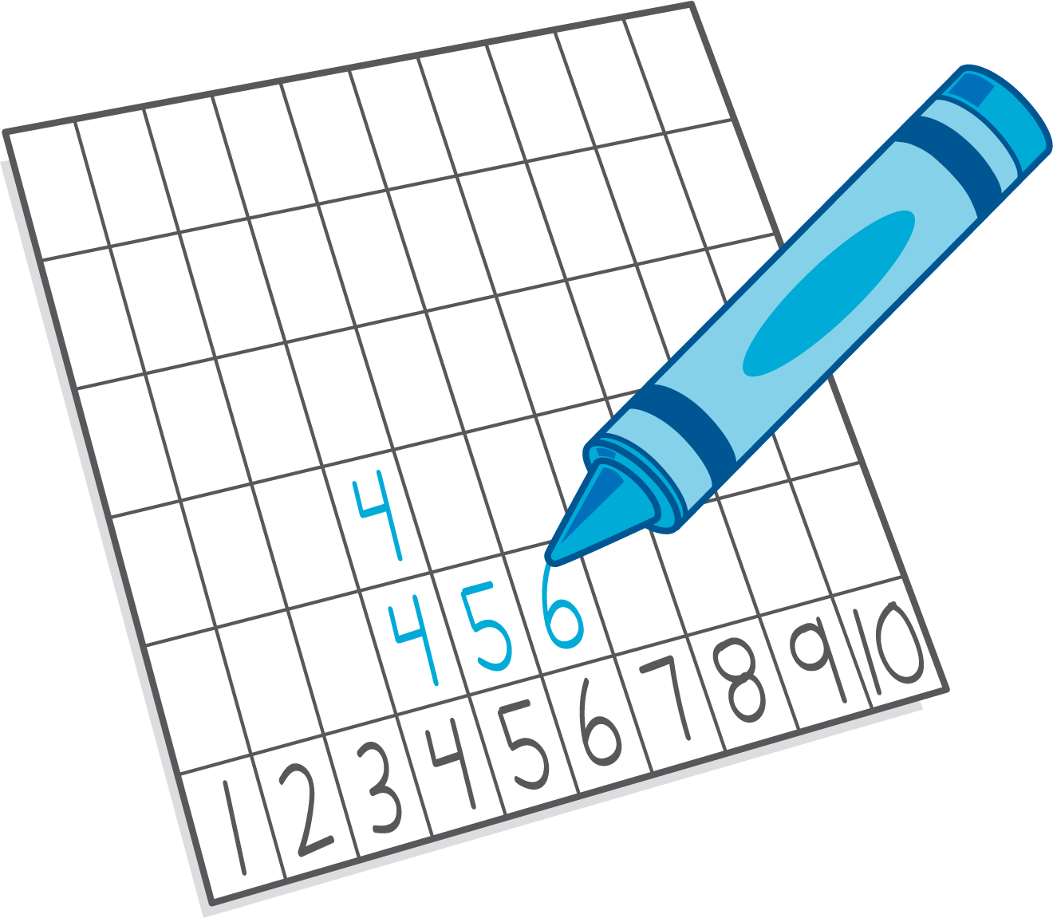
Subtraction Towers
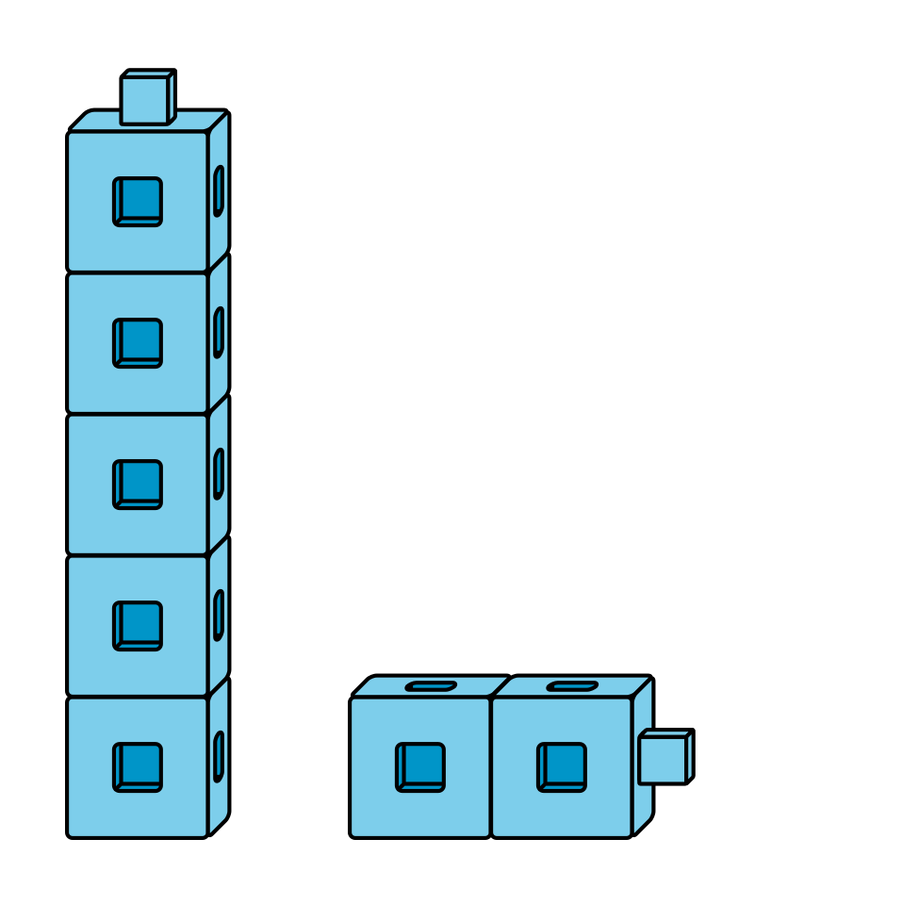
5-frames
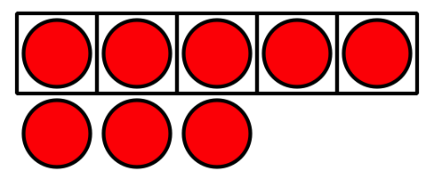
© CC BY 2021 Illustrative Mathematics®

