Lesson 19 Practice Problems
- The water level $f$, in feet, at a certain beach is modeled by the function $f\left(t\right)=2sin\left(\frac{2πt}{24}\right)$, where $t$ is the number of hours since the level was measured.
  - What is the amplitude of the function? What does it mean in this context?
  - What is the period of the function? What does it mean in this context?
  - Sketch a graph of the function over 72 hours.
- 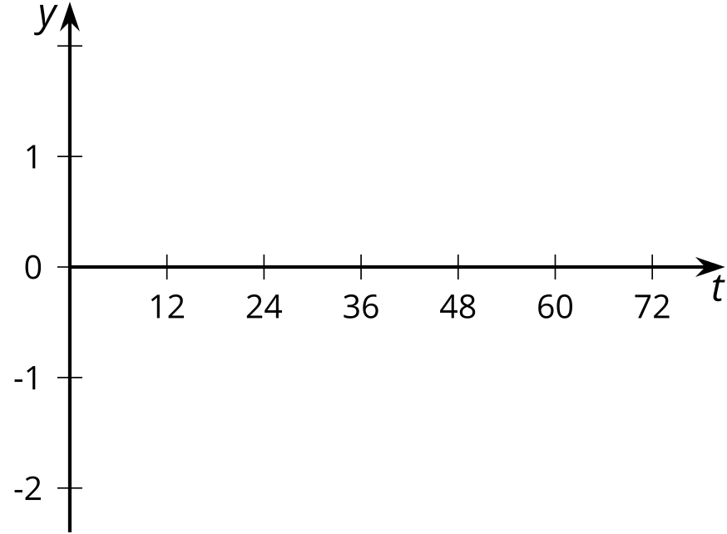
- The amount of the Moon visible $d$ days after November 30 is modeled by the equation $f\left(d\right)=0.5cos\left(\frac{2π⋅\left(d−6\right)}{30}\right)+0.5$. Select all the statements that are true for this model.
  - The model predicts a full moon on December 6.
  - The model predicts that there will be two full moons in December.
  - The model predicts that none of the Moon will be visible on December 21.
  - The model predicts that more than half of the Moon will be visible on December 13.
  - The model predicts that there is a full moon every 30 days.
- One month, the amount of the Moon visible $d$ days after the beginning of the month is modeled by the equation $y=0.5cos\left(\frac{2πd}{30}−\frac{π}{4}\right)+0.5$.
  - Explain why the Moon will be full when $\frac{2πd}{30}=\frac{π}{4}$. Which day of the month is this?
  - Explain why none of the Moon will be visible when $\frac{2πd}{30}=\frac{5π}{4}$. Which day of the month is this?
  - Sketch a graph of the equation.
  - 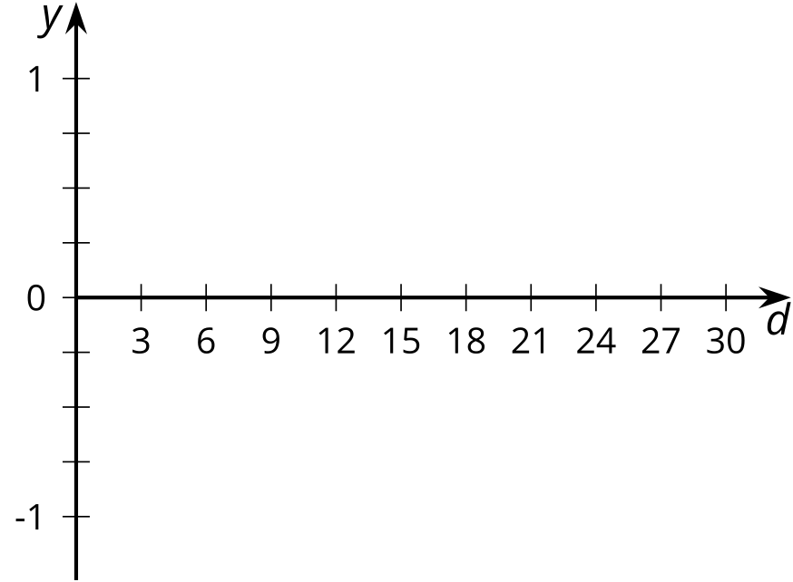
- The center of a clock is $\left(0,0\right)$ in a coordinate system, and the hour hand is 8 inches long. It is 10:30 p.m. Which of the following are true of the end of the hour hand? Select all that apply.
  - its coordinates are about $\left(\text{-}5.7,5.7\right)$
  - its coordinates are about $\left(5.7,\text{-}5.7\right)$
  - its coordinates are about $\left(\text{-}5.7,\text{-}5.7\right)$
  - its coordinates are $\left(8cos\left(\frac{3π}{4}\right),8sin\left(\frac{3π}{4}\right)\right)$
  - its coordinates are $\left(8sin\left(\frac{3π}{4}\right),8cos\left(\frac{3π}{4}\right)\right)$
- (From Unit 6, Lesson 7.)
- Label these points on the unit circle.
- 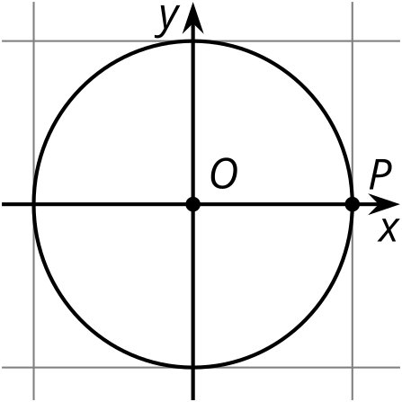
  - $Q$ is the image of $P$ after a $\text{-}\frac{π}{6}$ radian rotation with center $O$.
  - $R$ is the image of $P$ after a $\text{-}\frac{π}{2}$ radian rotation with center $O$.
  - $S$ is the image of $P$ after a $\text{-}\frac{4π}{3}$ radian rotation with center $O$.
  - $T$ is the image of $P$ after a $\text{-}\frac{5π}{3}$ radian rotation with center $O$.
- (From Unit 6, Lesson 11.)
- The function $h$ given by $h\left(θ\right)=15+4sin\left(θ\right)$ models the height, in feet, at the tip of a windmill blade that has rotated through an angle $θ$.
  - What is the height of the windmill? Explain how you know.
  - What is the length of the windmill blade? Explain how you know.
- (From Unit 6, Lesson 13.)
- The vertical position of a seat on a Ferris wheel is described by the function $f\left(t\right)=80sin\left(\frac{2πt}{30}\right)+95$. Time $t$ is measured in seconds and the output of $f$ is measured in feet.
  - Write an equation describing the vertical position on a Ferris wheel that is the same size as the Ferris wheel described by $f$ but spins twice as quickly.
  - Write an equation describing the vertical position on a Ferris wheel that spins the same speed as the Ferris wheel described by $f$ but whose radius is twice as large.
- (From Unit 6, Lesson 16.)
- Here is the initial position of a bike wheel before it starts to move.
- The vertical position, in inches, of $P$ is given by $y=10⋅sin\left(\frac{π}{2}+6πs\right)+10$, where $s$ is the number of seconds since the wheel began to move. Select all the true statements.
- 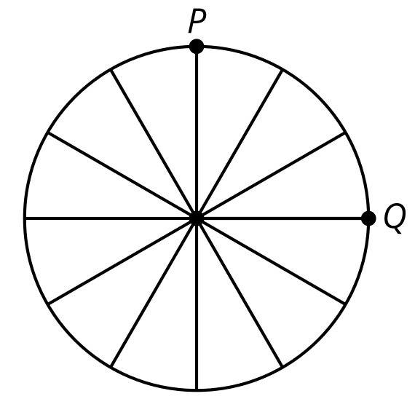
  - The wheel makes 3 revolutions per second.
  - The wheel makes one revolution every 3 seconds.
  - After $\frac{1}{4}$ of a second, the point $P$ will be in the position marked $Q$.
  - After $\frac{3}{4}$ of a second, the point $P$ will be in the position marked $Q$.
  - The radius of the wheel is 10 inches.
- (From Unit 6, Lesson 18.)
© CC BY 2019 by Illustrative Mathematics®

