Unit 3 Lesson 4: Positive Rational Exponents

1 Math Talk: Regrouping Fractions (Warm up)

Student Task Statement
Find the value of each expression mentally.
$\frac{1}{2}⋅5⋅4$
$\frac{5}{2}⋅4$
$\frac{2}{3}⋅7⋅\frac{3}{2}$
$7⋅\frac{5}{3}⋅\frac{3}{7}$

2 You Can Use Any Fraction As an Exponent

Student Task Statement
- Use exponent rules to explain why these expressions are equal to each other:
- ${\left(5^{\frac{1}{3}}\right)}^{2}$ | - ${\left(5^{2}\right)}^{\frac{1}{3}}$

- Write $5^{\frac{2}{3}}$ using radicals.
- Write $5^{\frac{4}{3}}$ using radicals. Show your reasoning using exponent rules.

3 Fractional Powers Are Just Numbers

Student Task Statement
- Complete the table as much as you can without using a calculator. (You should be able to fill in three spaces.)
- $x$ | - 0 | - $\frac{1}{3}$ | - $\frac{2}{3}$ | - 1 | - $\frac{4}{3}$ | - $\frac{5}{3}$ | - 2
- $2^{x}$ (using exponents) | - $2^{0}$ | - $2^{\frac{1}{3}}$ | - $2^{\frac{2}{3}}$ | - $2^{1}$ | - $2^{\frac{4}{3}}$ | - $2^{\frac{5}{3}}$ | - $2^{2}$
- $2^{x}$ (decimal approximation)
  - Plot the points that you filled in.
  - 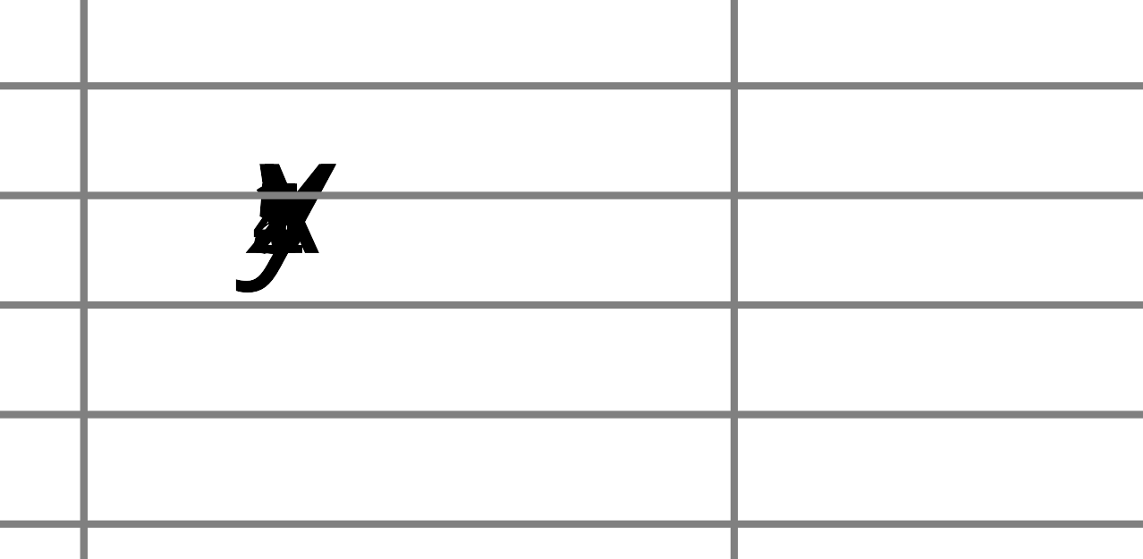
  - Connect the points as smoothly as you can.
  - Use this graph of $y=2^{x}$ to estimate the value of the other powers in the table, and write your estimates in the table.
- Let’s investigate $2^{\frac{1}{3}}$:
  - Write $2^{\frac{1}{3}}$ using radical notation.
  - What is ${\left(2^{\frac{1}{3}}\right)}^{3}$?
  - Raise your estimate from the table of $2^{\frac{1}{3}}$ to the third power. What should it be? How close did you get?
- Let’s investigate $2^{\frac{2}{3}}$:
  - Write $2^{\frac{2}{3}}$ using radical notation.
  - What is the value of ${\left(2^{\frac{2}{3}}\right)}^{3}$?
  - Raise your estimate from the table of $2^{\frac{2}{3}}$ to the third power. What should it be? How close did you get?
© CC BY 2019 by Illustrative Mathematics®

