Unit 8 Lesson 16: Box Plots

1 Notice and Wonder: Puppy Weights (Warm up)

Student Task Statement
Here are the birth weights, in ounces, of all the puppies born at a kennel in the past month.
13 | 14 | 15 | 15 | 16 | 16 | 16 | 16
17 | 17 | 17 | 17 | 17 | 17 | 17 | 18
18 | 18 | 18 | 18 | 18 | 18 | 18 | 19
20

What do you notice and wonder about the distribution of the puppy weights?

Activity Synthesis
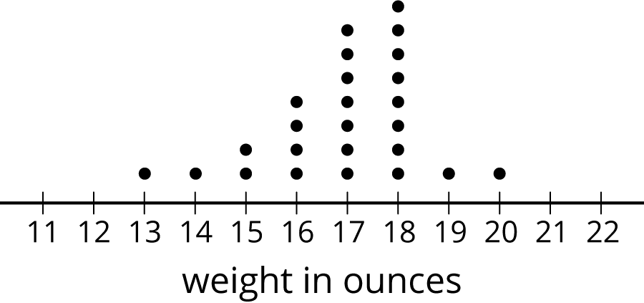

2 Human Box Plot

Images for Launch
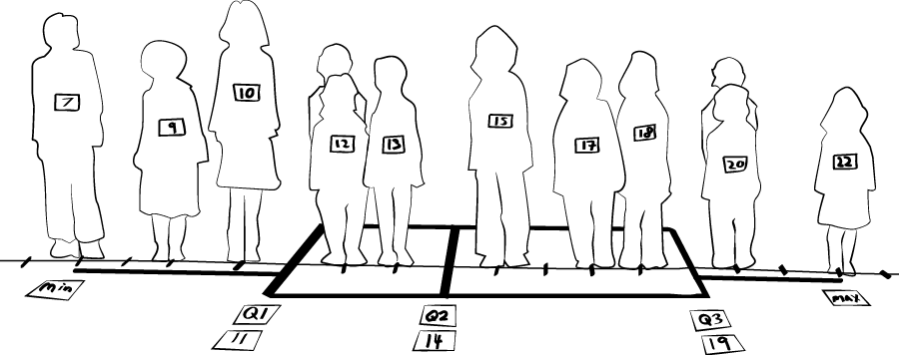

Student Task Statement
Your teacher will give you the data on the lengths of names of students in your class. Write the five-number summary by finding the data set's minimum, Q1, Q2, Q3, and the maximum.
Pause for additional instructions from your teacher.

3 Studying Blinks

Images for Launch
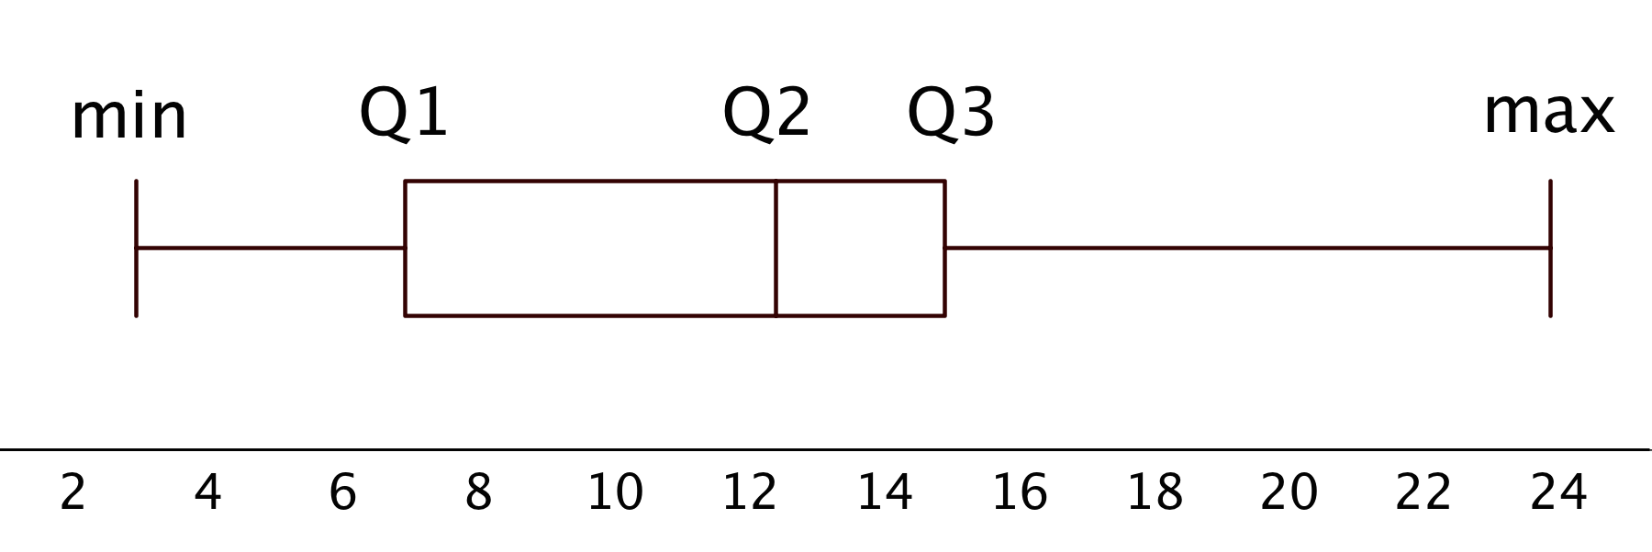

Student Task Statement
Twenty people participated in a study about blinking. The number of times each person blinked while watching a video for one minute was recorded. The data values are shown here, in order from smallest to largest.
3 | 6 | 8 | 11 | 11 | 13 | 14 | 14
14 | 14 | 16 | 18 | 20 | 20 | 20 | 22
24 | 32 | 36 | 51

  - Use the grid and axis to make a dot plot of this data set.
  - 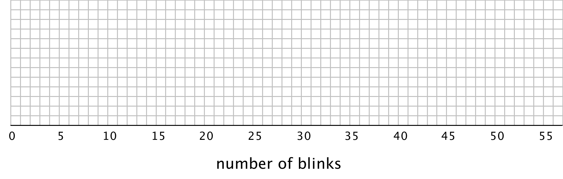
  - Find the median (Q2) and mark its location on the dot plot.
  - Find the first quartile (Q1) and the third quartile (Q3). Mark their locations on the dot plot.
  - What are the minimum and maximum values?
- A box plot can be used to represent the five-number summary graphically. Let’s draw a box plot for the number-of-blinks data. On the grid, above the dot plot:
  - Draw a box that extends from the first quartile (Q1) to the third quartile (Q3). Label the quartiles.
  - At the median (Q2), draw a vertical line from the top of the box to the bottom of the box. Label the median.
  - From the left side of the box (Q1), draw a horizontal line (a whisker) that extends to the minimum of the data set. On the right side of the box (Q3), draw a similar line that extends to the maximum of the data set.
- You have now created a box plot to represent the number of blinks data. What fraction of the data values are represented by each of these elements of the box plot?
  - The left whisker
  - The box
  - The right whisker

Activity Synthesis
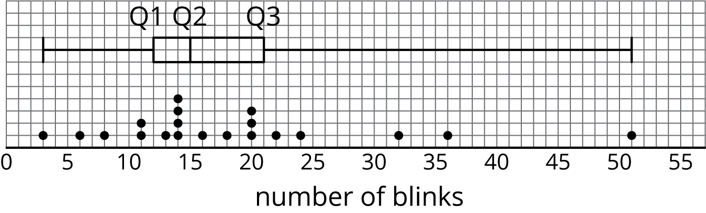
© CC BY Open Up Resources. Adaptations CC BY IM.

