Unit 5 Lesson 11: Exploring Circles

1 How Do You Figure? (Warm up)

Student Task Statement
Here are two figures.
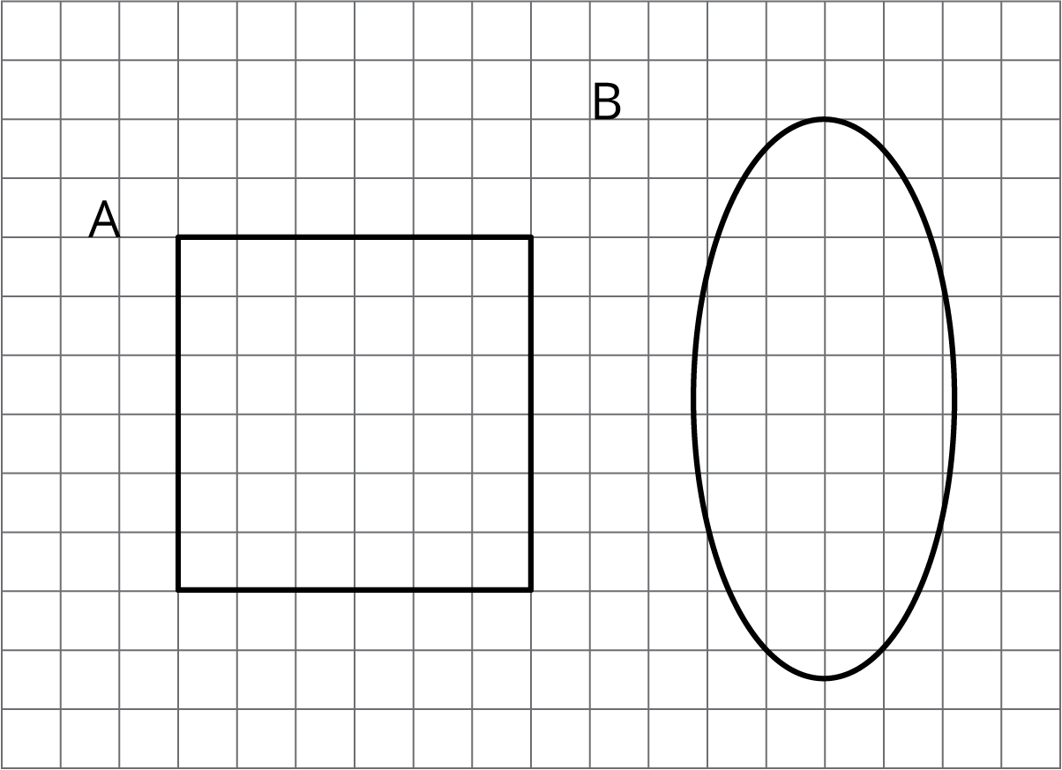
Figure C looks more like Figure A than like Figure B. Sketch what Figure C might look like. Explain your reasoning.

2 Sorting Round Objects

Student Task Statement
Your teacher will give you some pictures of different objects.
- How could you sort these pictures into two groups? Be prepared to share your reasoning.
- Work with your partner to sort the pictures into the categories that your class has agreed on. Pause here so your teacher can review your work.
- What are some characteristics that all circles have in common?
- Put the circular objects in order from smallest to largest.
- Select one of the pictures of a circular object. What are some ways you could measure the actual size of your circle?

3 Measuring Circles

Student Task Statement
Priya, Han, and Mai each measured one of the circular objects from earlier.
- Priya says that the bike wheel is 24 inches.
- Han says that the yo-yo trick is 24 inches.
- Mai says that the glow necklace is 24 inches.
- Do you think that all these circles are the same size?
- What part of the circle did each person measure? Explain your reasoning.

Activity Synthesis
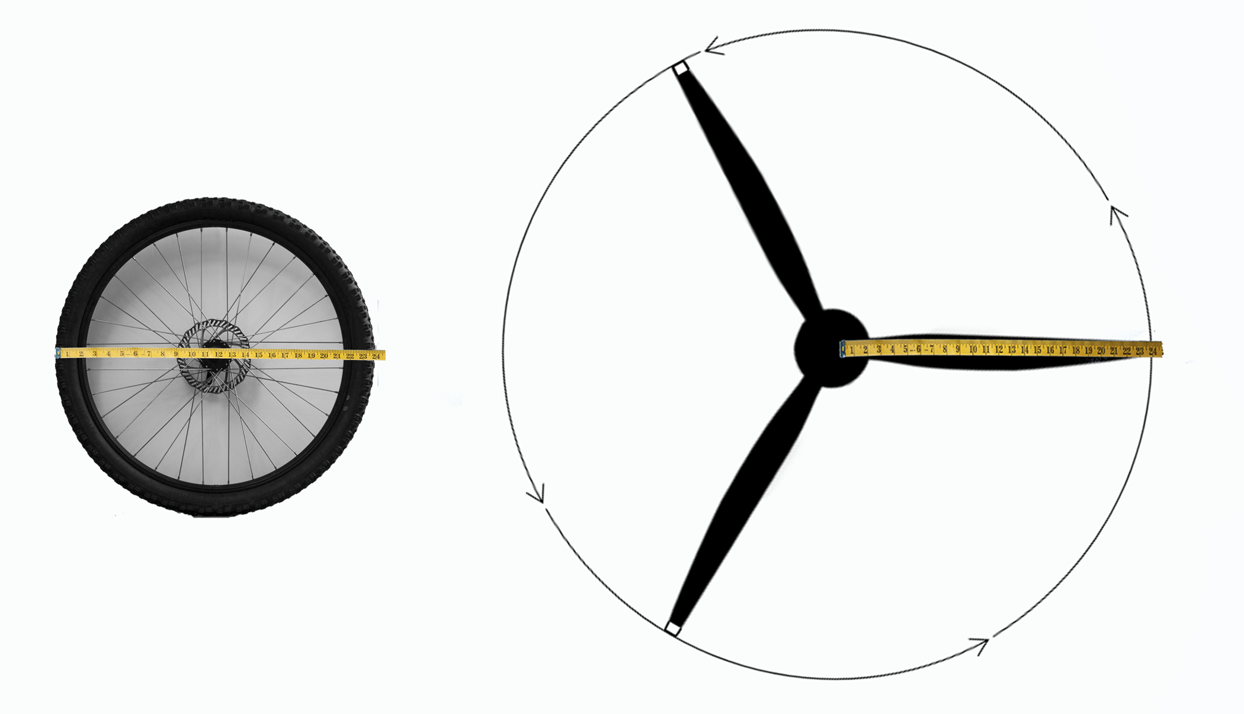

4 Drawing Circles (Optional)

Student Task Statement
Draw and label each circle.
- Circle A, with a diameter of 6 cm.
- Circle B, with a radius of 5 cm. Pause here so your teacher can review your work.
- Circle C, with a radius that is equal to Circle A’s diameter.
- Circle D, with a diameter that is equal to Circle B’s radius.
- Use a compass to recreate one of these designs.
- 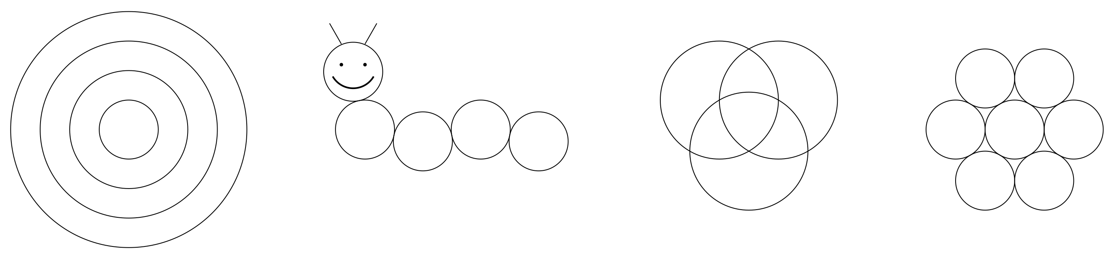
© CC BY Open Up Resources. Adaptations CC BY IM.

