Lesson 7: Count Images in Different Arrangements
- Let’s figure out how many images there are.

7.2: Count Images

7.3: Introduce Math Stories, How Many?
Choose a center.
Math Stories
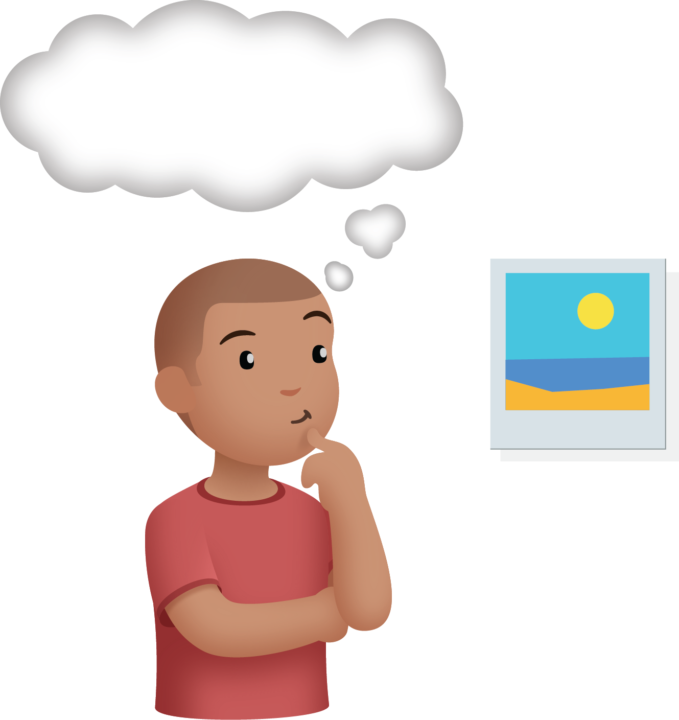
Connecting Cubes
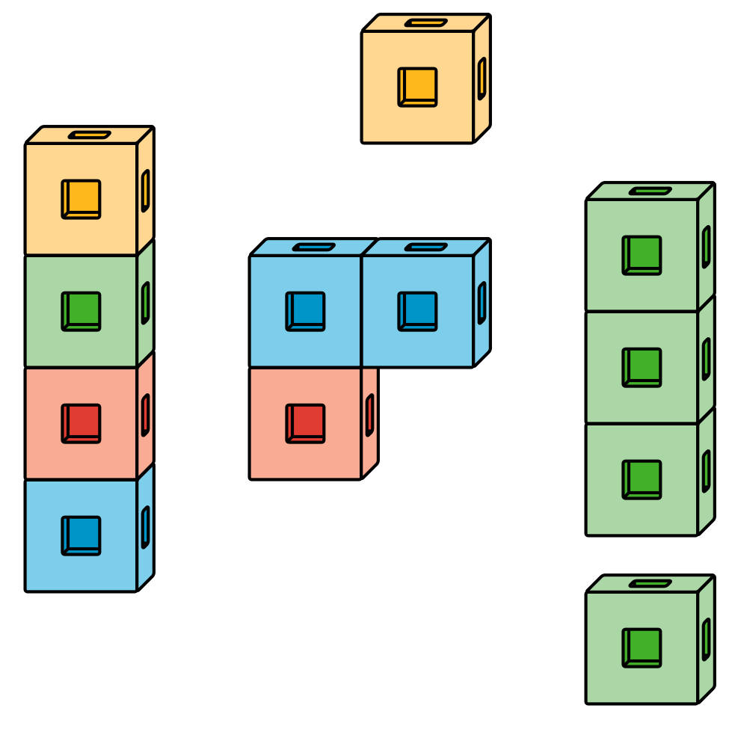
Number Race
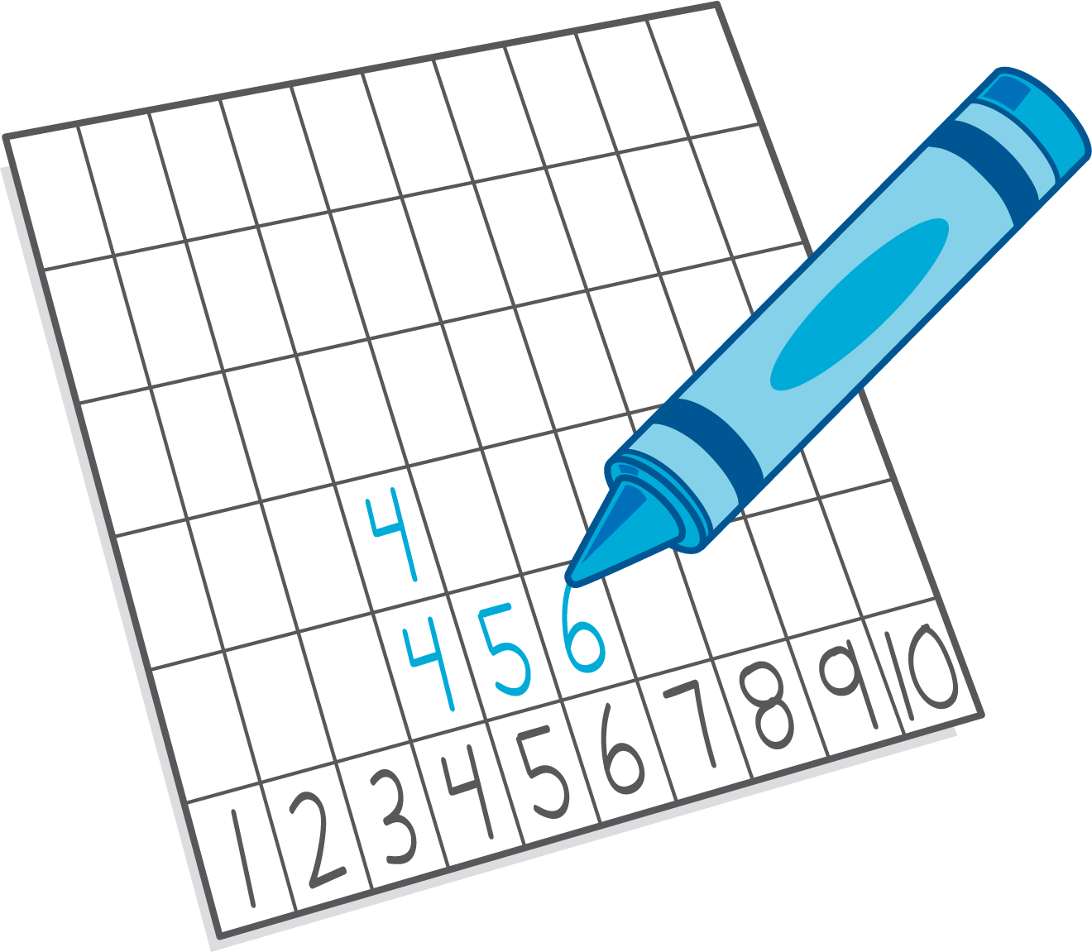
© CC BY 2021 Illustrative Mathematics®

