Unit 3 Lesson 15: Animal Shape Stamp Art

WU Notice and Wonder: Animals at the Watering Hole (Warm up)

Student Task Statement
What do you notice?
What do you wonder?
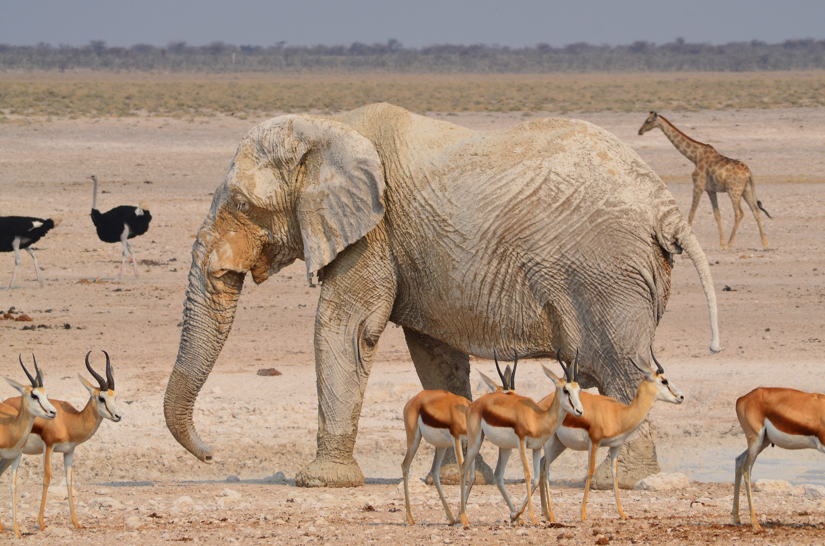

1 Animal Print Making

Student Task Statement
Use the shape stamps to create an animal.

2 Mathematical Questions About Our Animals

Student Task Statement

Images for Activity Synthesis
© CC BY 2021 Illustrative Mathematics®

