Unit 6 Lesson 1: Count Larger Collections of Objects

WU Choral Count: Count to 80 and Count On (Warm up)

Student Task Statement

1 Counting Collections

Student Task Statement

2 How We Count

Student Task Statement

3 Introduce Number Race, 11–20

Student Task Statement
Choose a center.
Number Race
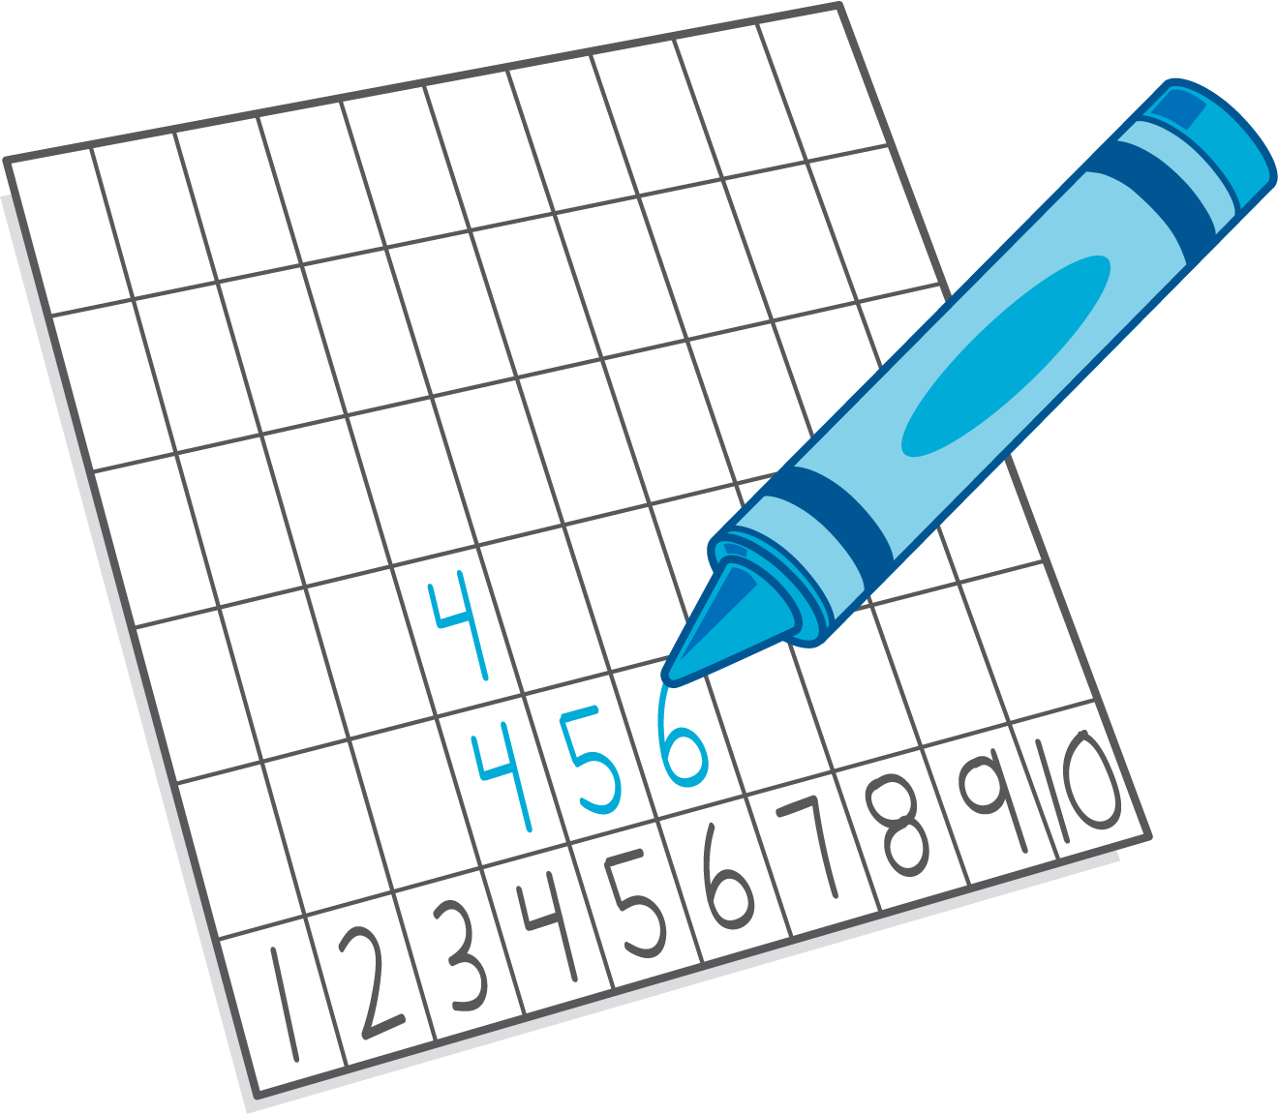
Subtraction Towers
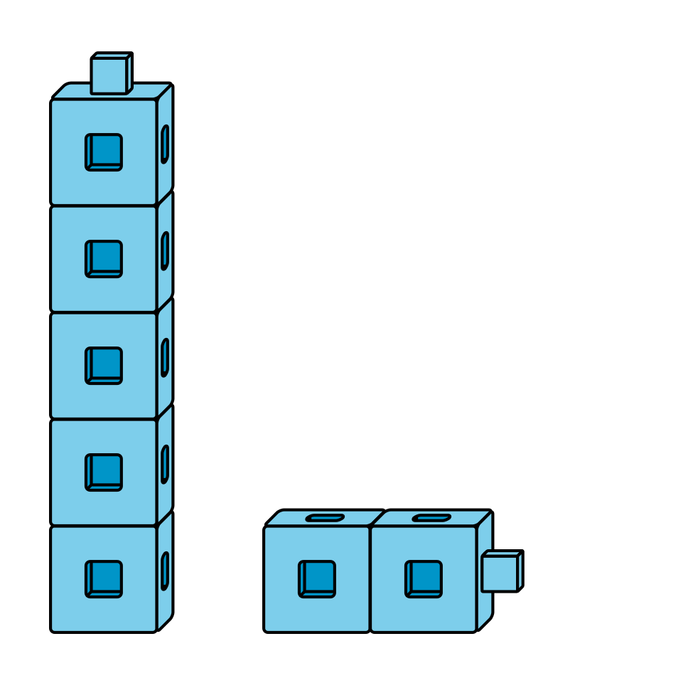
5-frames
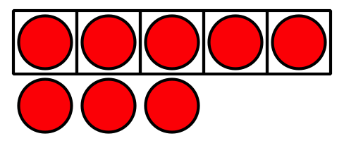
© CC BY 2021 Illustrative Mathematics®

