Lesson 16 Practice Problems
- A wheel rotates three times per second in a counterclockwise direction. The center of the wheel does not move.
- What angle does the point $P$ rotate through in one second?
- 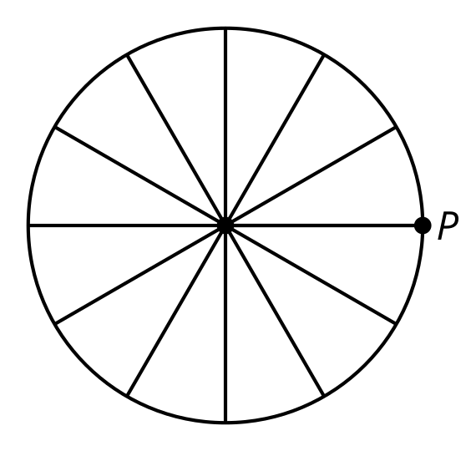
  - $\frac{2π}{3}$ radians
  - $2π$ radians
  - $3π$ radians
  - $6π$ radians
- A bicycle wheel is spinning in place. The vertical position of a point on the wheel, in inches, is described by the function $f\left(t\right)=13.5sin\left(5⋅2πt\right)+20$. Time $t$ is measured in seconds.
  - What is the meaning of 13.5 in this context?
  - What is the meaning of 5 in this context?
  - What is the meaning of 20 in this context?
- Each expression describes the vertical position, in feet off the ground, of a carriage on a Ferris wheel after $t$ minutes. Which function describes the largest Ferris wheel?
  - $100sin\left(\frac{2πt}{20}\right)+110$
  - $100sin\left(\frac{2πt}{30}\right)+110$
  - $200sin\left(\frac{2πt}{30}\right)+210$
  - $250sin\left(\frac{2πt}{20}\right)+260$
- Which trigonometric function has period 5?
  - $f\left(x\right)=sin\left(\frac{1}{5}x\right)$
  - $f\left(x\right)=sin\left(5x\right)$
  - $f\left(x\right)=sin\left(\frac{5}{2π}x\right)$
  - $f\left(x\right)=sin\left(\frac{2π}{5}x\right)$

  - What is the period of the function $f$ given by $f\left(t\right)=cos\left(4πt\right)$? Explain how you know.
  - Sketch a graph of $f$.
- 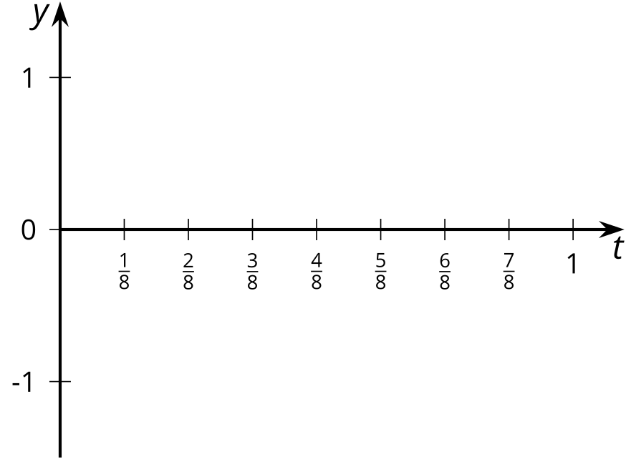
- Here is a graph of $y=cos\left(x\right)$.
- 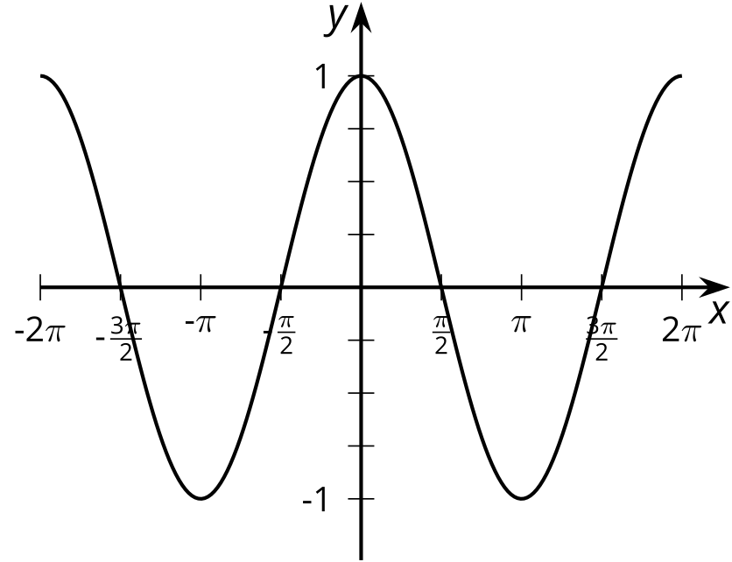
  - Sketch a graph of $cos\left(2x\right)$.
  - 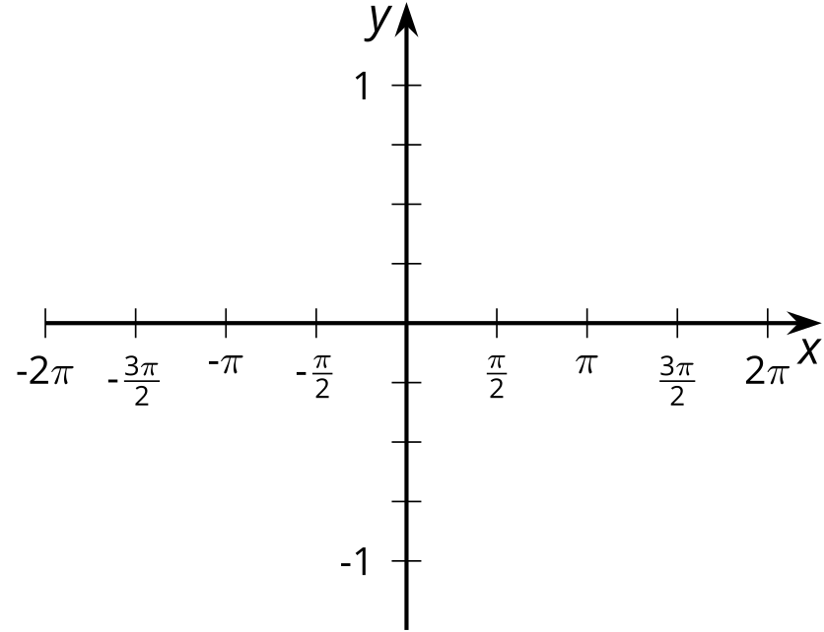
  - How do the two graphs compare?
- (From Unit 6, Lesson 15.)
- Here is a table that shows the values of functions $f$, $g$, and $h$ for some values of $x$.
- $x$ | - $f\left(x\right)$ | - $g\left(x\right)=f\left(ax\right)$ | - $h\left(x\right)=f\left(bx\right)$
- 0 | - -125 | - -125 | - -125
- 3 | - -8 | - -64 | - -42.875
- 6 | - 1 | - -27 | - -8
- 9 | - 64 | - -8 | - -0.125
- 12 | - 343 | - -1 | - 1
- 15 | - 1000 | - 0 | - 15.625
- 18 | - 2197 | - 1 | - 64
- 21 | - 4096 | - 8 | - 166.375
  - Use the table to determine the value of $a$ in the equation $g\left(x\right)=f\left(ax\right)$.
  - Use the table to determine the value of $b$ in the equation $h\left(x\right)=f\left(bx\right)$.
- (From Unit 5, Lesson 9.)
© CC BY 2019 by Illustrative Mathematics®

