Unit 7 Lesson 15: Quadratic Equations with Irrational Solutions

1 Roots of Squares (Warm up)

Student Task Statement
Here are some squares whose vertices are on a grid.
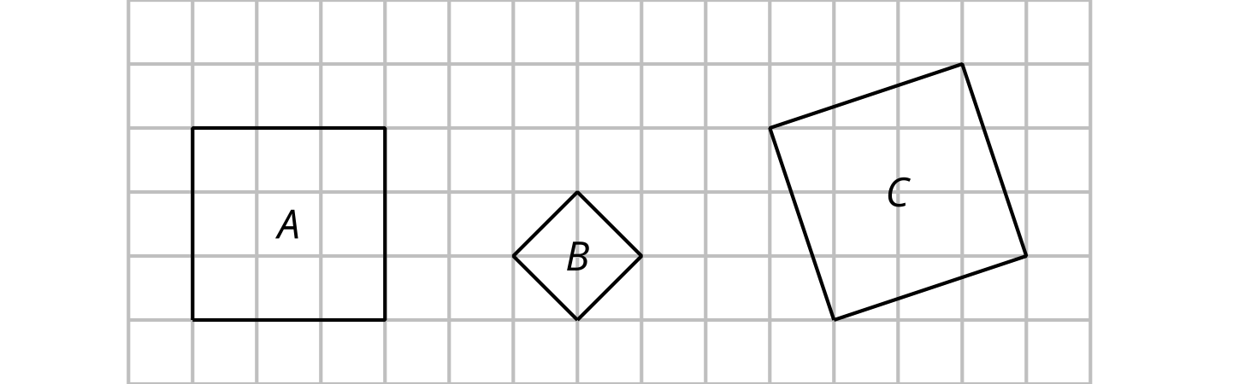
Find the area and the side length of each square.
square | area (square units) | side length (units)
A
B
C

2 Solutions Written as Square Roots

Student Task Statement
Solve each equation. Use the $±$ notation when appropriate.
- $x^{2}−13=\text{-}12$
- ${\left(x−6\right)}^{2}=0$
- $x^{2}+9=0$
- $x^{2}=18$
- $x^{2}+1=18$
- ${\left(x+1\right)}^{2}=18$

3 Finding Irrational Solutions by Completing the Square

Student Task Statement
Here is an example of an equation being solved by graphing and by completing the square.
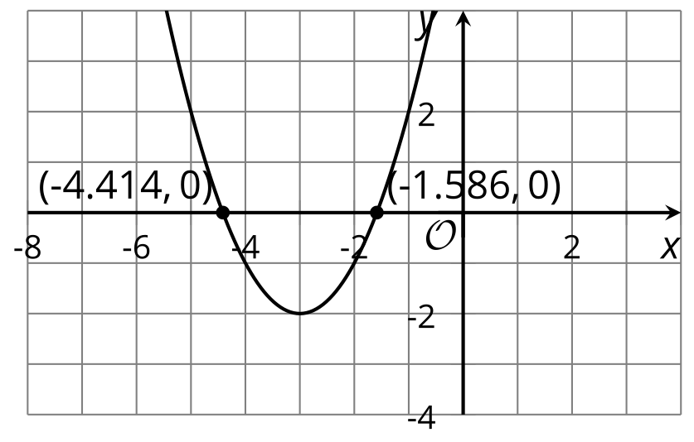
$\begin{matrix}x^{2}+6x+7 & =0 \\ x^{2}+6x+9 & =2 \\ {\left(x+3\right)}^{2} & =2 \\ x+3 & =±\sqrt{2} \\ x & =\text{-}3±\sqrt{2}\end{matrix}$
Verify: $\sqrt{2}$ is approximately 1.414. So $\text{-}3+\sqrt{2}≈\text{-}1.586$ and $\text{-}3−\sqrt{2}≈\text{-}4.414$.
For each equation, find the exact solutions by completing the square and the approximate solutions by graphing. Then, verify that the solutions found using the two methods are close. If you get stuck, study the example.
- $x^{2}+4x+1=0$
- $x^{2}−10x+18=0$
- $x^{2}+5x+\frac{1}{4}=0$
- $x^{2}+\frac{8}{3}x+\frac{14}{9}=0$
© CC BY 2019 by Illustrative Mathematics®

