Unit 4 Lesson 2: Partial Products in Diagrams

WU Which One Doesn't Belong: Diagrams to Find Products (Warm up)

Student Task Statement
Which one doesn't belong?
A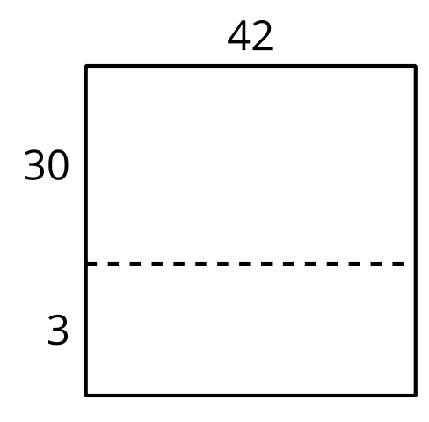
B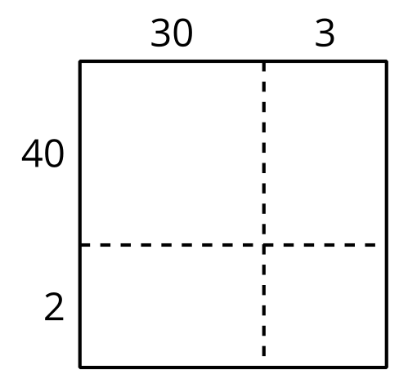
C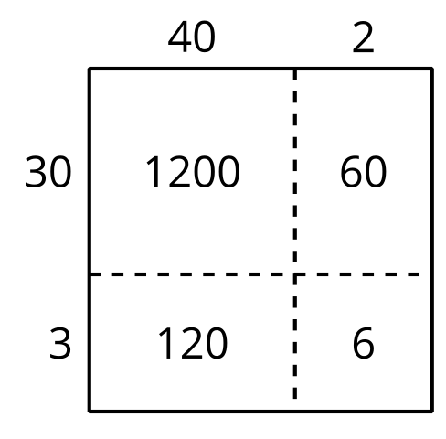
D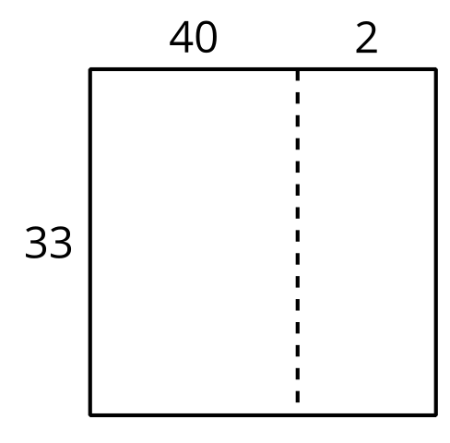

1 Decompose in Many Ways

Student Task Statement
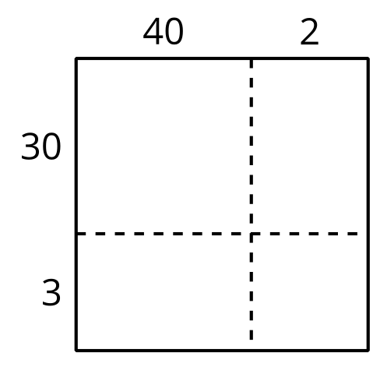
- Write the value of each product inside the rectangles.
- Find the value of $42×33$.
- This diagram represents $142×33$.
- 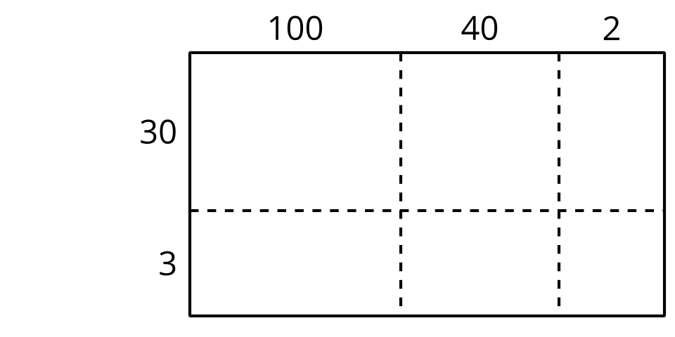
- Write the value of each product inside the rectangles.
- Find the value of $142×33$.

2 Calculate in Many Ways

Student Task Statement
Here are some different diagrams that represent $315×24$. For each diagram, write a multiplication expression inside each rectangle to represent the product.

- 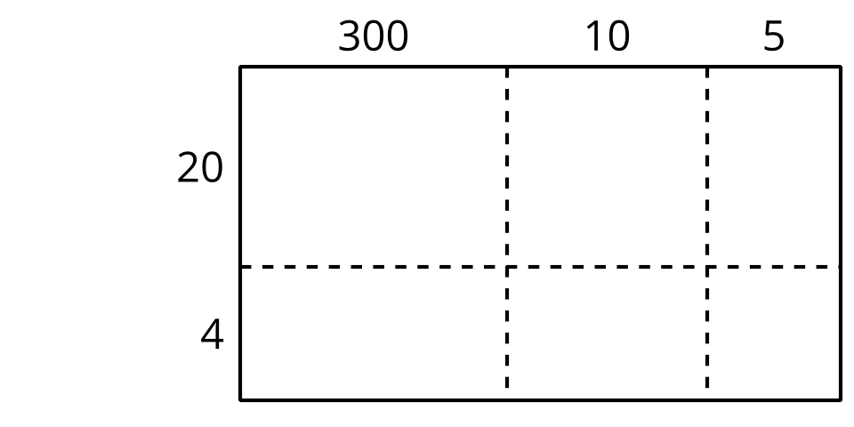

- 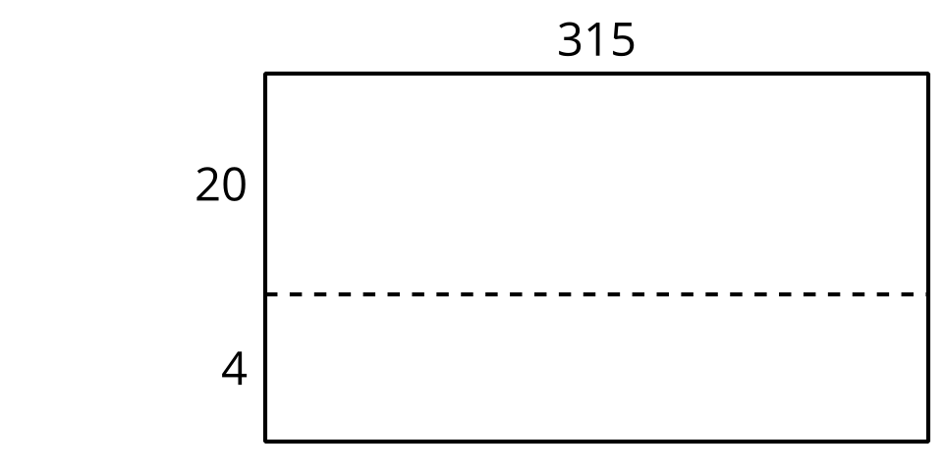

- 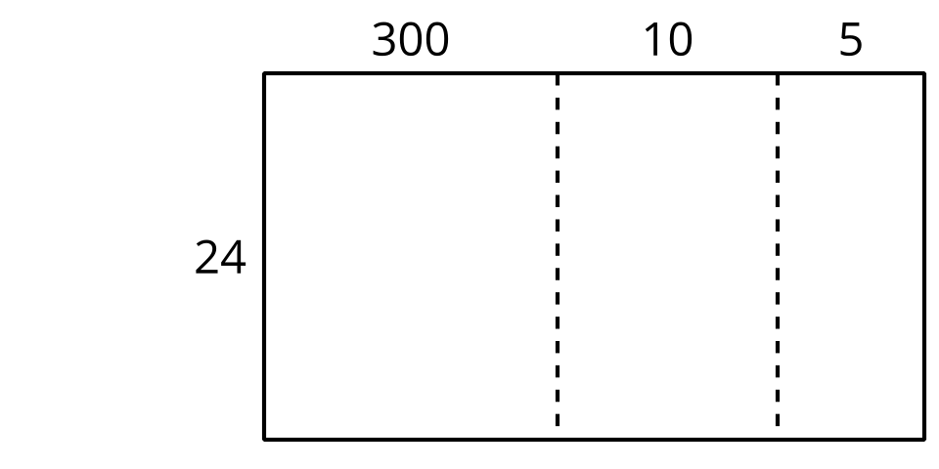
- Use one of the diagrams to find the value of $315×24$.
- Explain why you chose that diagram to find the product.
© CC BY 2021 Illustrative Mathematics®

