Unit 8 Lesson 13: Multiply Fractions Game Day

WU Number Talk: Multiply One Third (Warm up)

Student Task Statement
Find the value of each expression mentally.
- $\frac{1}{3}×3$
- $\frac{1}{3}×4$
- $\frac{1}{3}×\frac{6}{3}$
- $\frac{1}{3}×\frac{1}{4}$

1 Fraction Multiplication Compare

Student Task Statement
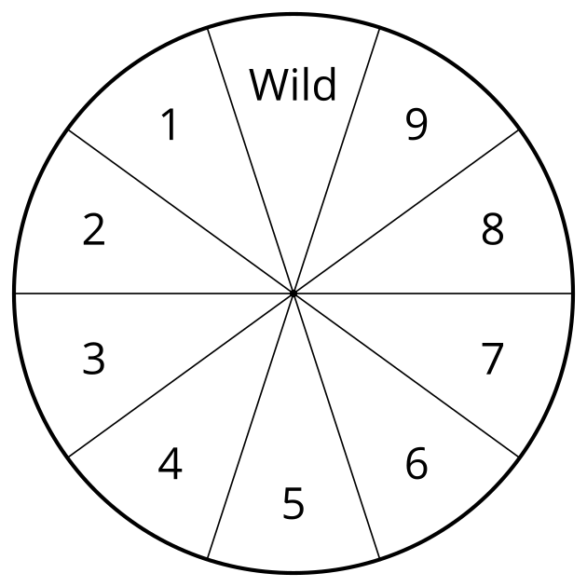
- Use the directions to play Fraction Multiplication Compare with your partner.
  - Spin the spinner.
  - Write the number you spun in one of the empty blank boxes. Once you write a number, you cannot change it.
  - Player two spins and writes the number on their game board.
  - Continue taking turns until all four blank boxes are filled.
  - Multiply your fractions.
  - The player with the greatest product wins.
  - Play again.
  - Round 1 1111111111 × 1111111111 = _
  - Round 2 1111111111 × 1111111111 = _
- What strategy do you use to decide where to write the numbers?

2 Fraction Multiplication Compare Round 2

Student Task Statement
- Use the directions to play Fraction Multiplication Compare with your partner.
  - Spin the spinner.
  - Write the number you spun in one of the four blank boxes.
  - Player two spins and writes the number on their game board.
  - Continue taking turns until all four blank boxes are filled.
  - Multiply your fractions.
  - The player with the smallest product wins.
  - Play again.
  - Round 1 1111111111 × 1111111111 = _
  - Round 2 1111111111 × 1111111111 = _
- What strategy did you use to choose where to write the numbers?
© CC BY 2021 Illustrative Mathematics®

