Lesson 6: Compare Reptile Lengths in Story Problems

Standards Alignments
Addressing | 2.MD.B.5, 2.NBT.B.5, 2.OA.A.1, 2.OA.B.2

Teacher-facing Learning Goals
- Solve addition and subtraction story problems about length.

Student-facing Learning Goals
- Let’s solve story problems about reptile lengths.

Lesson Purpose
The purpose of this lesson is for students to solve Compare story problems within 100 involving length.
In previous lessons, students measured lengths and determined how much longer one object is than another using centimeters. They have also developed strategies for adding and subtracting numbers within 100.
This lesson combines these skills. Students interpret story problems about length measurements whose solution requires addition and subtraction within 100. In each activity, students solve Compare problems in situations where the language of the problem may direct students to use an incorrect operation. Throughout the lesson, they are encouraged to make sense of and use tape diagrams to visualize the measurement contexts and make sense of the lengths and their relationships (MP1, MP2).
This lesson has a Student Section Summary.

Access for:

Students with Disabilities
- Action and Expression (Activity 1)

English Learners
- MLR8 (Activity 2)

Instructional Routines
MLR6 Three Reads (Activity 1), Number Talk (Warm-up)

Materials to Gather
- Base-ten blocks: Activity 1, Activity 2

Lesson Timeline
Warm-up | 10 min
Activity 1 | 20 min
Activity 2 | 15 min
Lesson Synthesis | 10 min
Cool-down | 5 min

Teacher Reflection Question
What representations have been most helpful for the students as they solve story problems? What do you notice in their work from today’s lesson that you might leverage in a future lesson?

Cool-down
(to be completed at the end of the lesson) 5min
Kiran and Han Compare Pets

Standards Alignments
Addressing | 2.MD.B.5, 2.OA.A.1

Student-facing Task Statement
Kiran’s pet snake is 47 cm long. It is 26 cm shorter than Han’s pet snake.
How long is Han’s pet snake?
- Circle the diagram that matches the story.
- 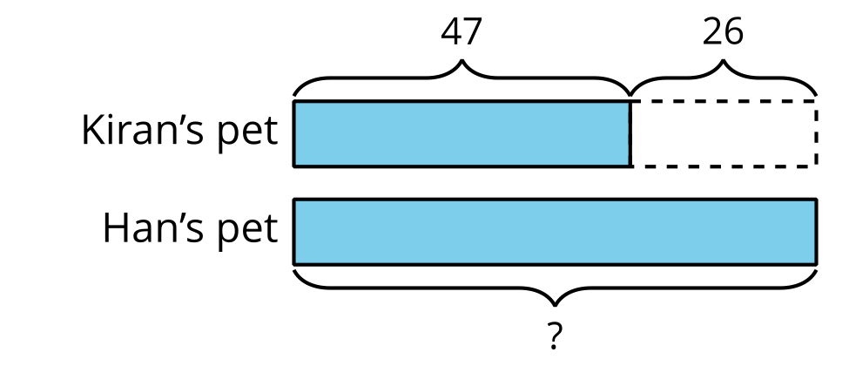
- 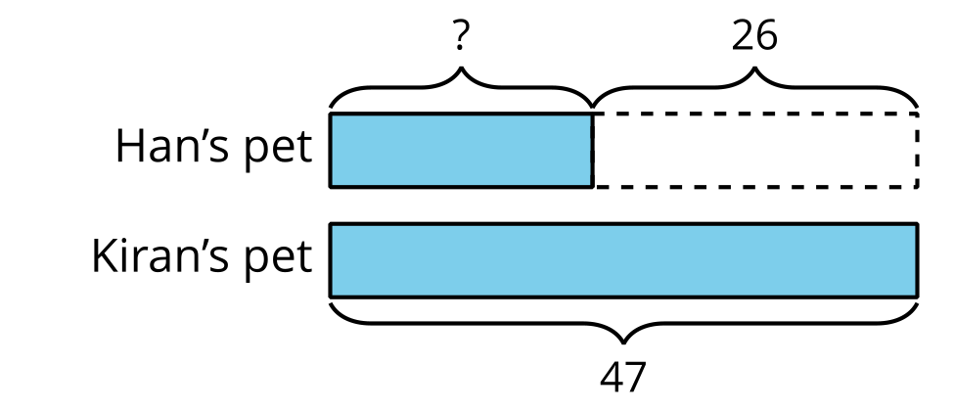
- Solve. Show your thinking.
- Han’s snake is _______________ cm long.

Student Responses
- Students circle the tape diagram showing Han's pet as the larger unknown.
- Han’s snake is 73 cm long. Sample response: $40+20=607+6=1360+10+3=7347+26=73$

