Lesson 3: Non-unit Fractions
- Let’s learn about non-unit fractions.

Warm-up: Notice and Wonder: More than One Part
What do you notice? What do you wonder?
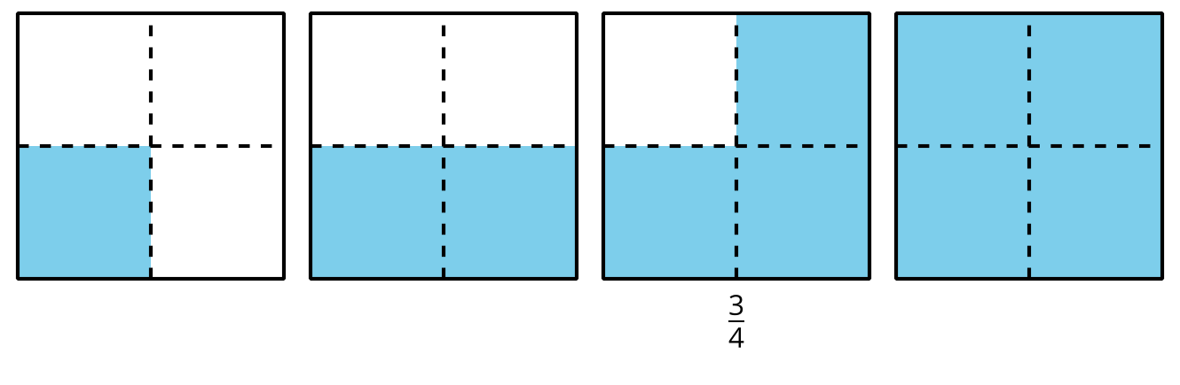

3.1: Write and Read Fractions
Each shape in each row of the table represents 1. Use the shaded parts to complete the missing information in the table. Be prepared to explain your reasoning.
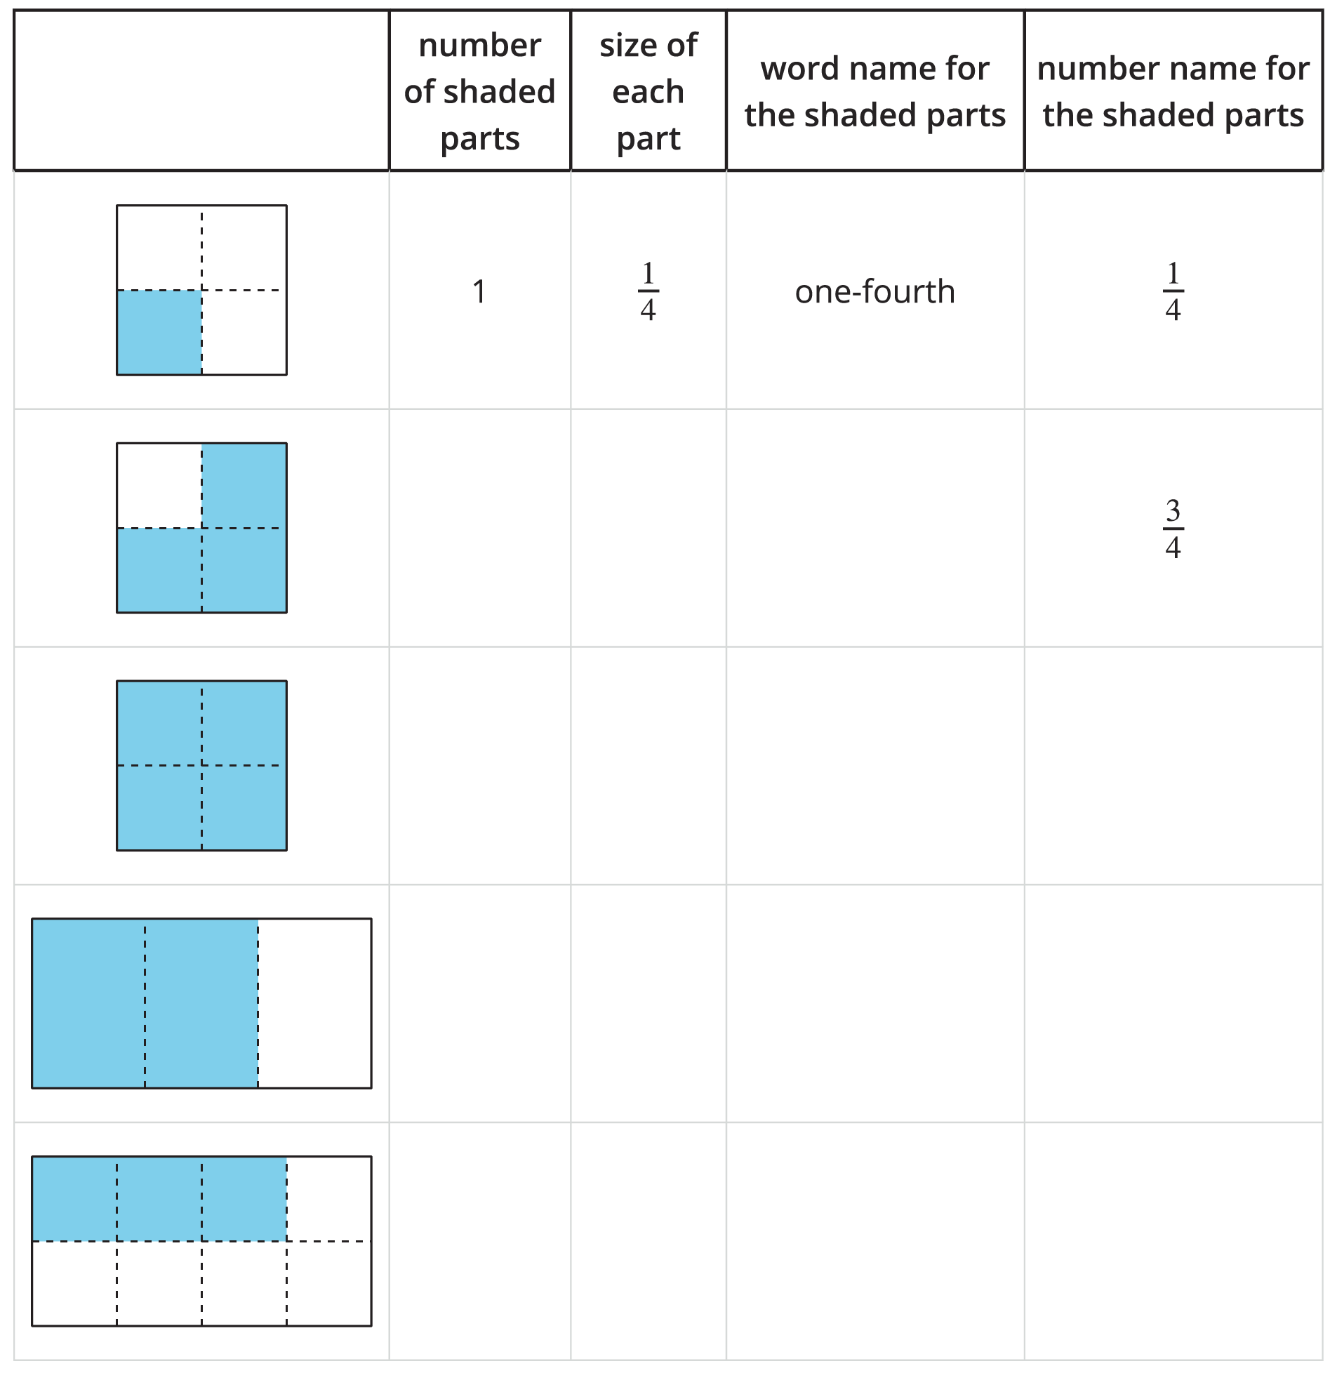
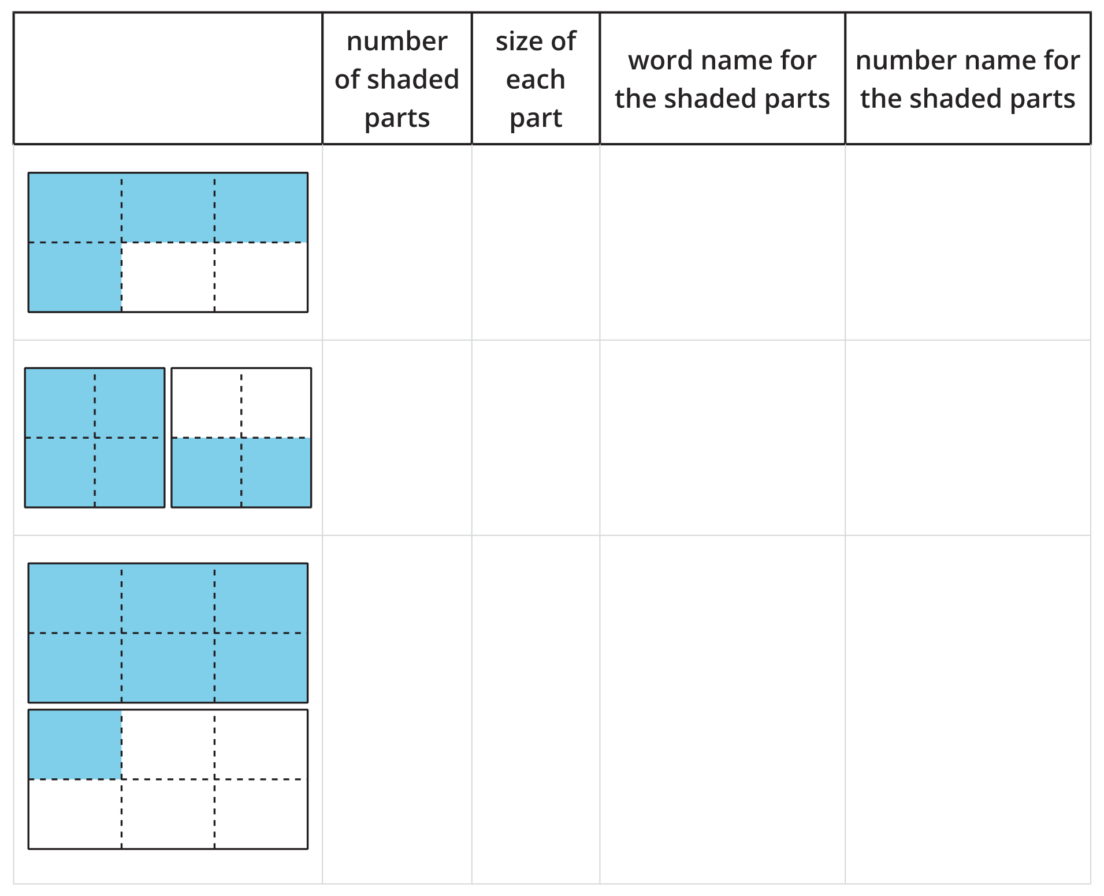

3.2: Fraction Match
Your teacher will give you a set of cards for playing Fraction Match. Two cards are a match if one is a diagram and the other a number, but they have the same value.
- To play Fraction Match:
  - Arrange the cards face down in an array.
  - Take turns choosing 2 cards. If the cards match, keep them and go again. If not, return them to where they were, face down. You can’t keep more than 2 matches on each turn.
  - After all the matches have been found, the player with the most cards wins.
- Use the cards your teacher gives you to create 4 new pairs of cards to add to the set.
- Play another round of Fraction Match using all the cards.
© CC BY 2021 Illustrative Mathematics®

