Unit 6 Lesson 17: Puppies and Tulips

WU Notice and Wonder: Puppies and Tulips (Warm up)

Student Task Statement
What do you notice?
What do you wonder?
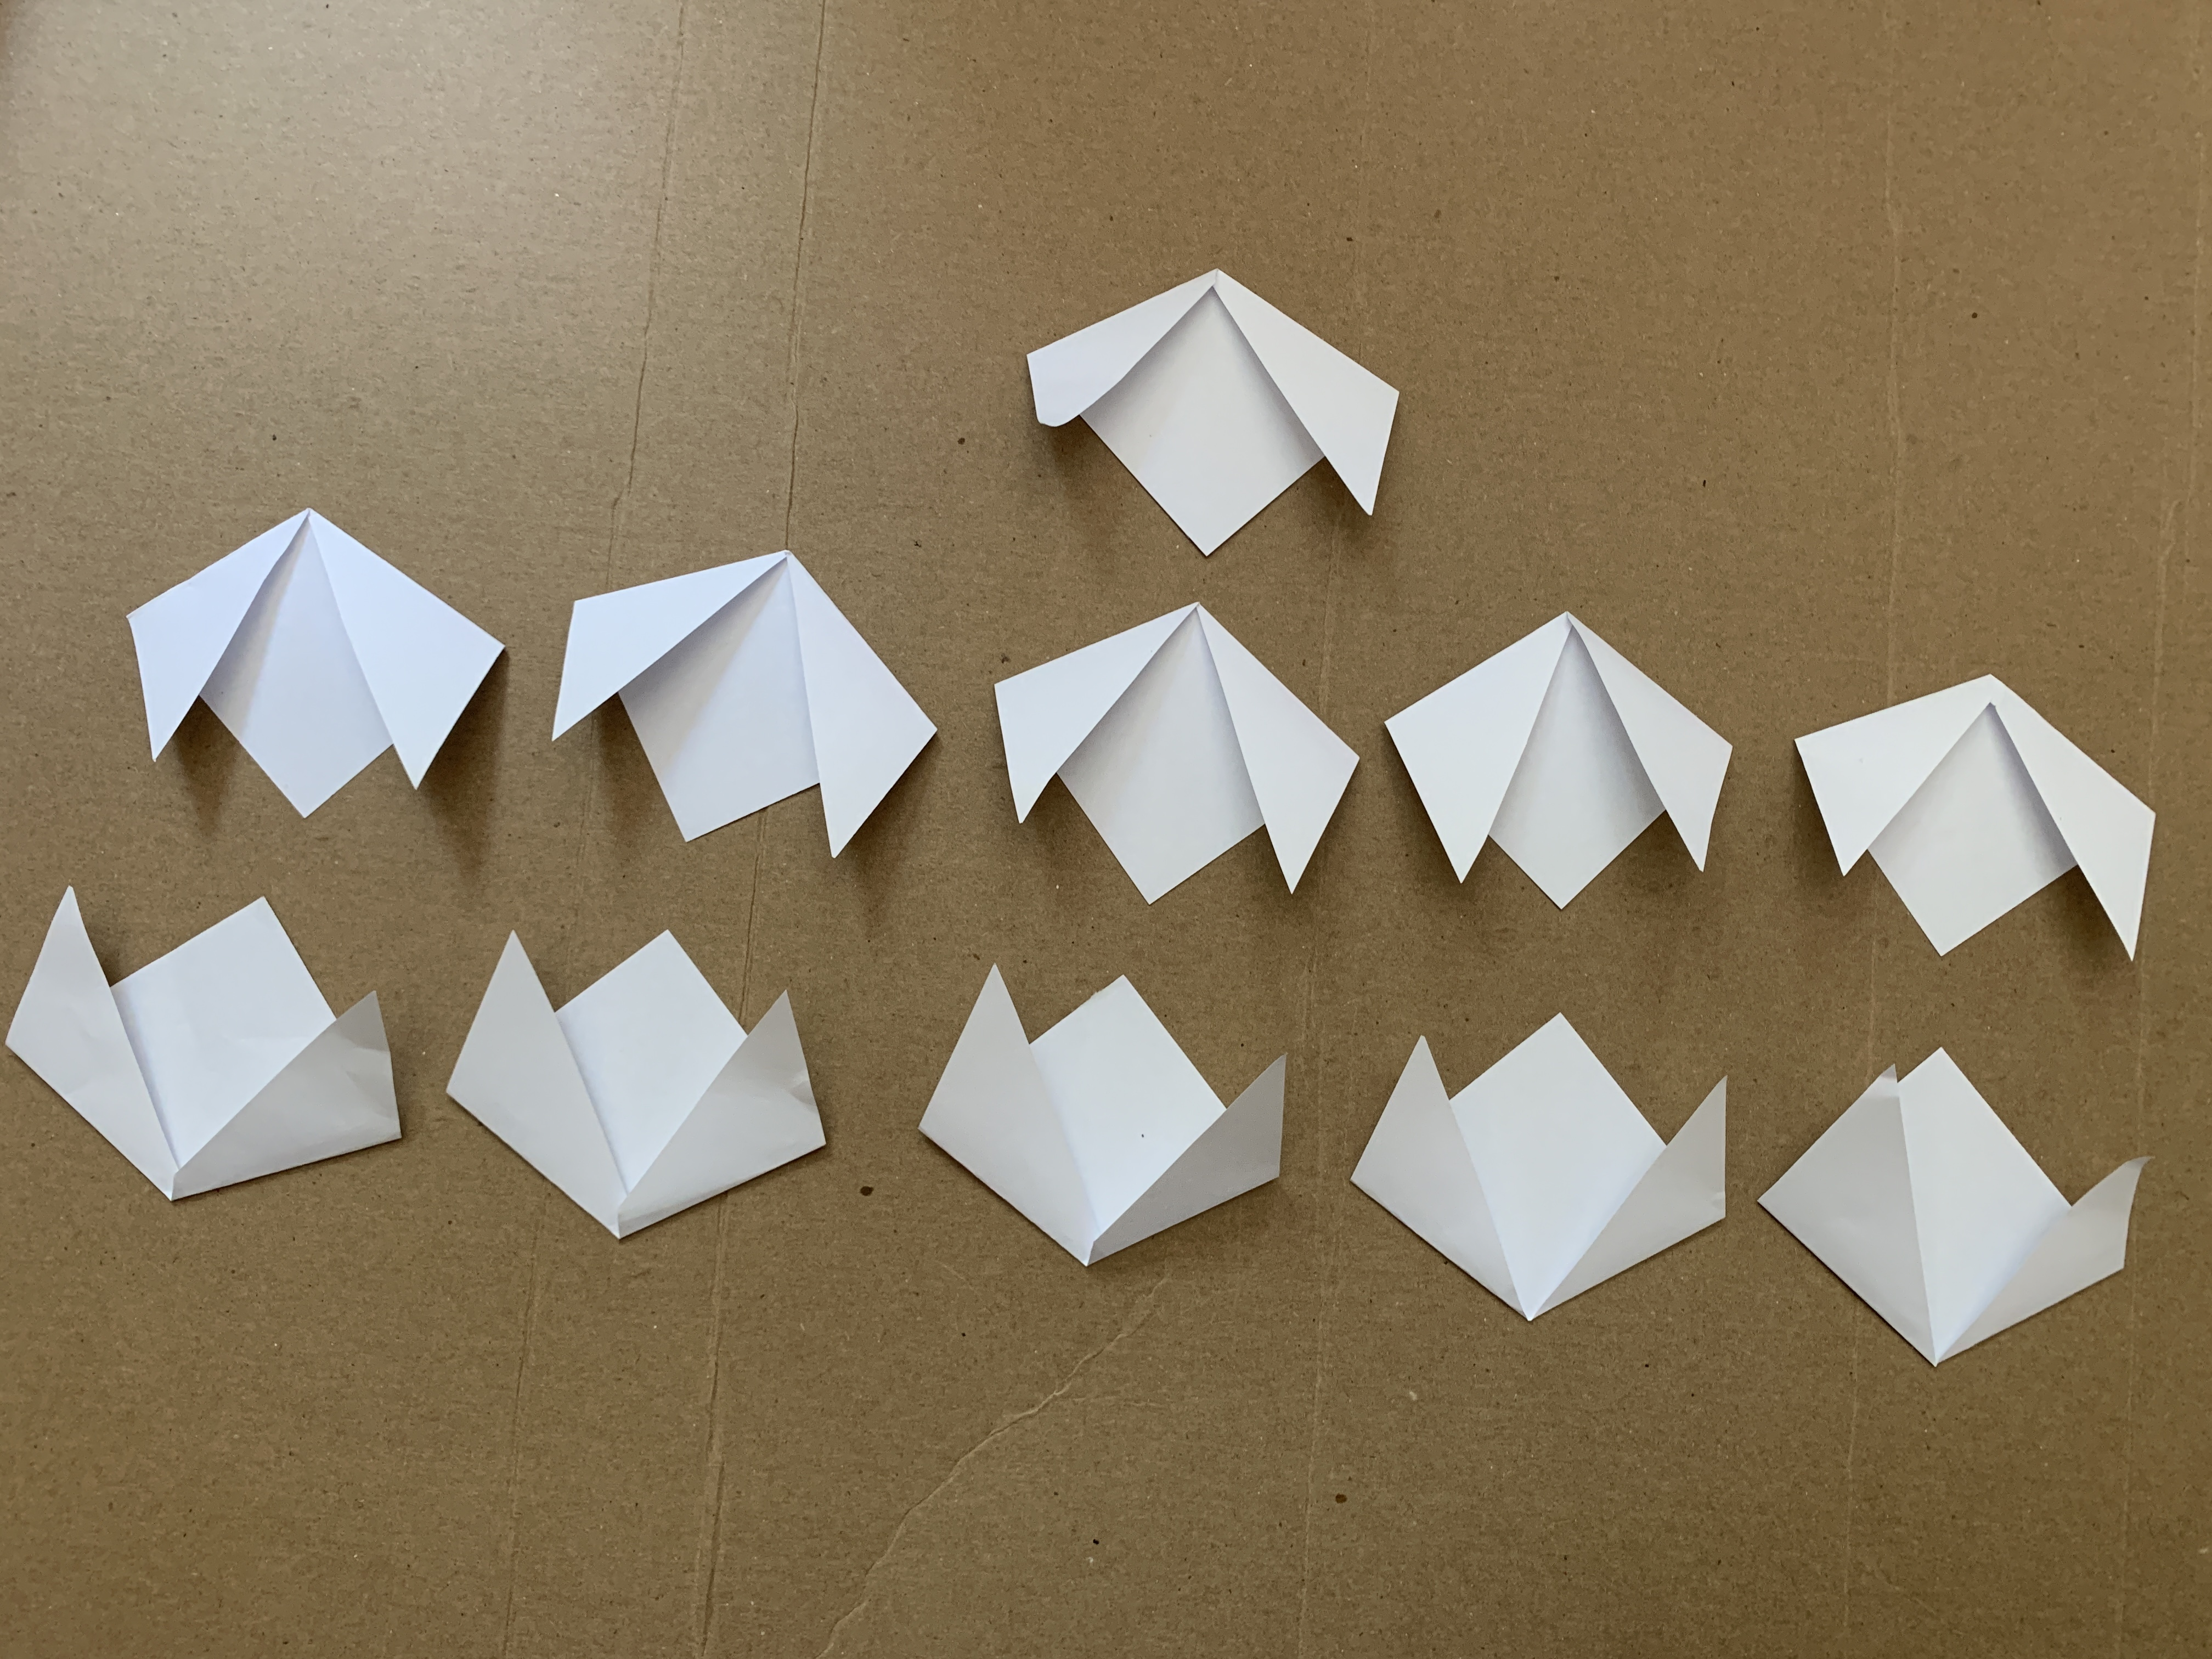

1 Puppy and Tulip Stories

Student Task Statement
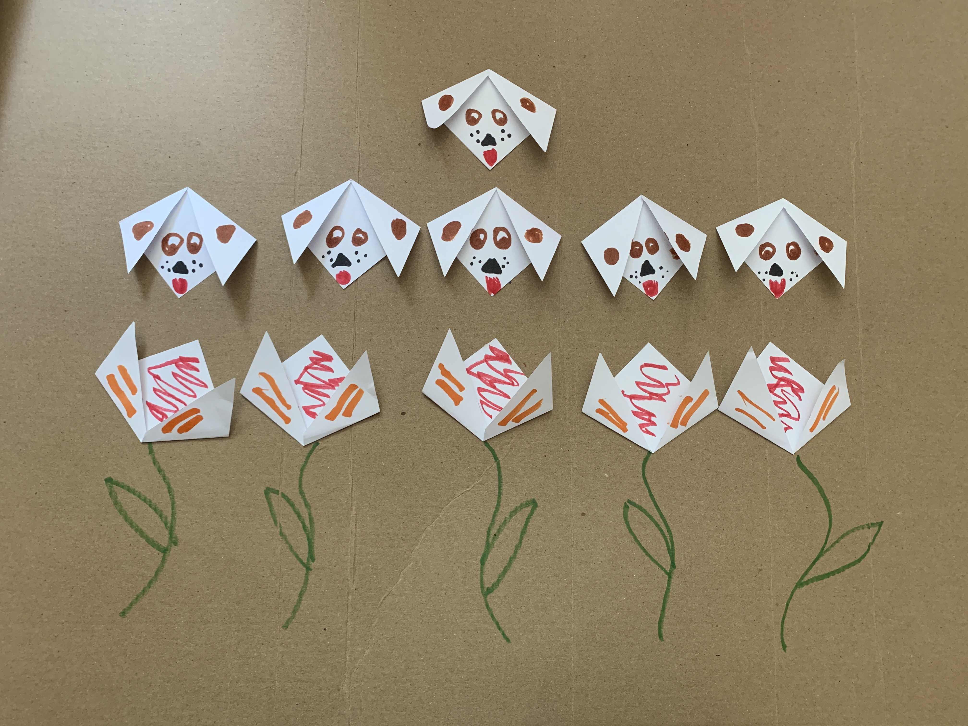
- For each paper you fold, decide if it is a puppy or a tulip:
  - Total: ____________
  - Tulips: ____________
  - Puppies: ____________
- Complete the 2 sentences that apply to your story.
  - There are ______ fewer puppies than tulips.
  - There are _____ tulips.
  - How many puppies are there?
  - There are ____________ fewer tulips than puppies.
  - There are ____________tulips.
  - How many puppies are there?
  - There are ____________ more tulips than puppies.
  - There are ____________tulips.
  - How many puppies are there?
  - There are ____________ more puppies than tulips.
  - There are ____________ tulips.
  - How many puppies are there?

2 Act it Out

Student Task Statement
Group A: Read your problems to your partner group.
Group B:
- Act out and solve the problems.
Show your thinking using drawings, numbers, or words.
- Write an equation to represent each story problem.
- What do you notice about the story problems and the equations you wrote?
- Switch roles.
© CC BY 2021 Illustrative Mathematics®

