Unit 8 Lesson 2: Relate Addition and Subtraction

WU Number Talk: Connect Addition and Subtraction (Warm up)

Student Task Statement
Find the value of each expression mentally.
- $5+4$
- $4+5$
- $9−4$
- $9−5$

1 Cube Tower Addition and Subtraction

Student Task Statement
Write an addition and a subtraction equation to match the connecting cubes.

- 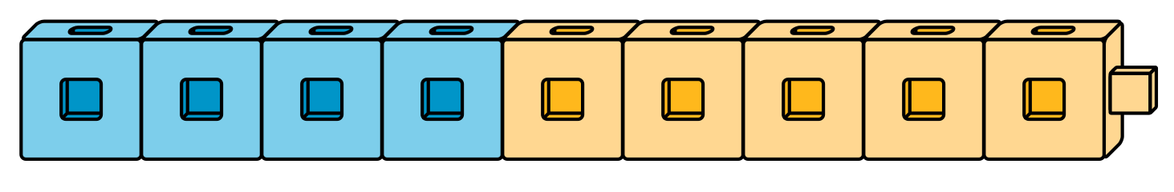

- 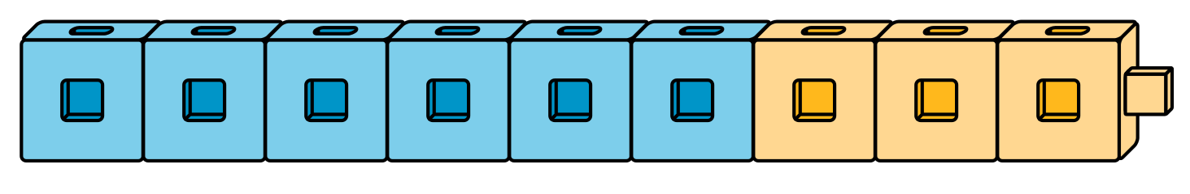

2 Find the Unknown Number

Student Task Statement
Find the number that makes each equation true.
Explain to your partner how you found it.
- 4+aaaiaaai=9
- 9−5=aaaiaaai
- aaaiaaai+5=8
- 8−3=aaaiaaai
- 7−4=aaaiaaai
- 8=2+aaaiaaai
- 8−aaaiaaai=4

3 Differences I've Got

Student Task Statement
Color the differences you know the value of from memory.
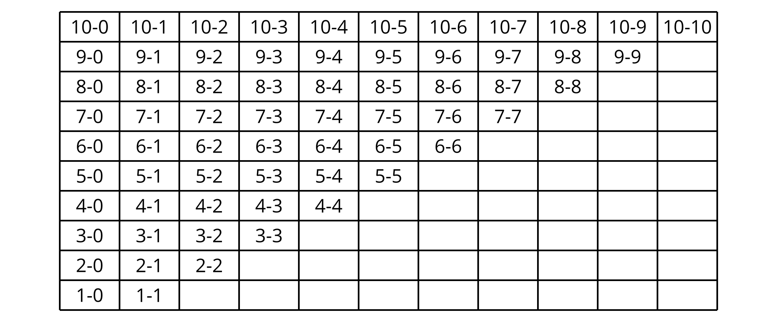
Write each difference that is not colored, on an index card.
Write an addition equation on the card that can help you find the value of the difference.
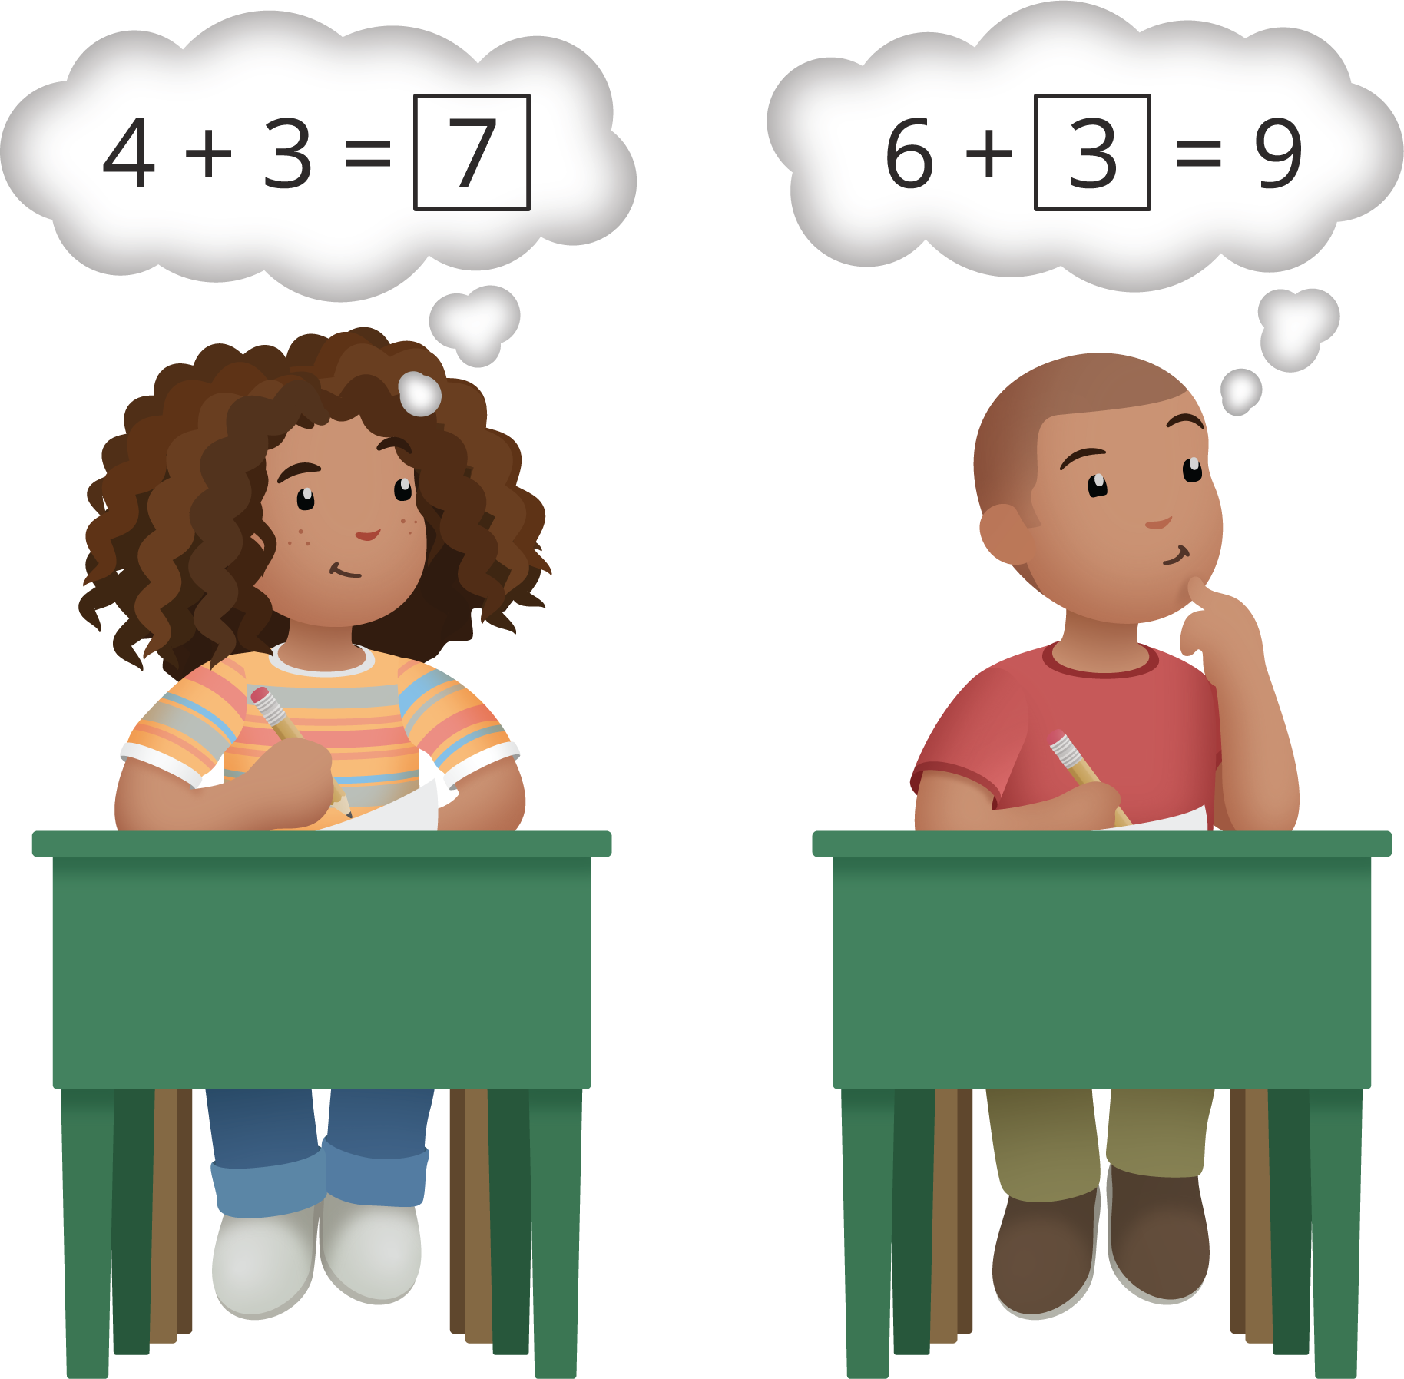
© CC BY 2021 Illustrative Mathematics®

