Unit 6 Lesson 1: Measure in Halves of an Inch

WU What Do You Know About Inches? (Warm up)

Student Task Statement
What do you know about inches?

1 Measure Around the Room

Student Task Statement
Use the ruler from your teacher to measure the length of objects in the room. Be prepared to discuss your reasoning.
object | length (inches)
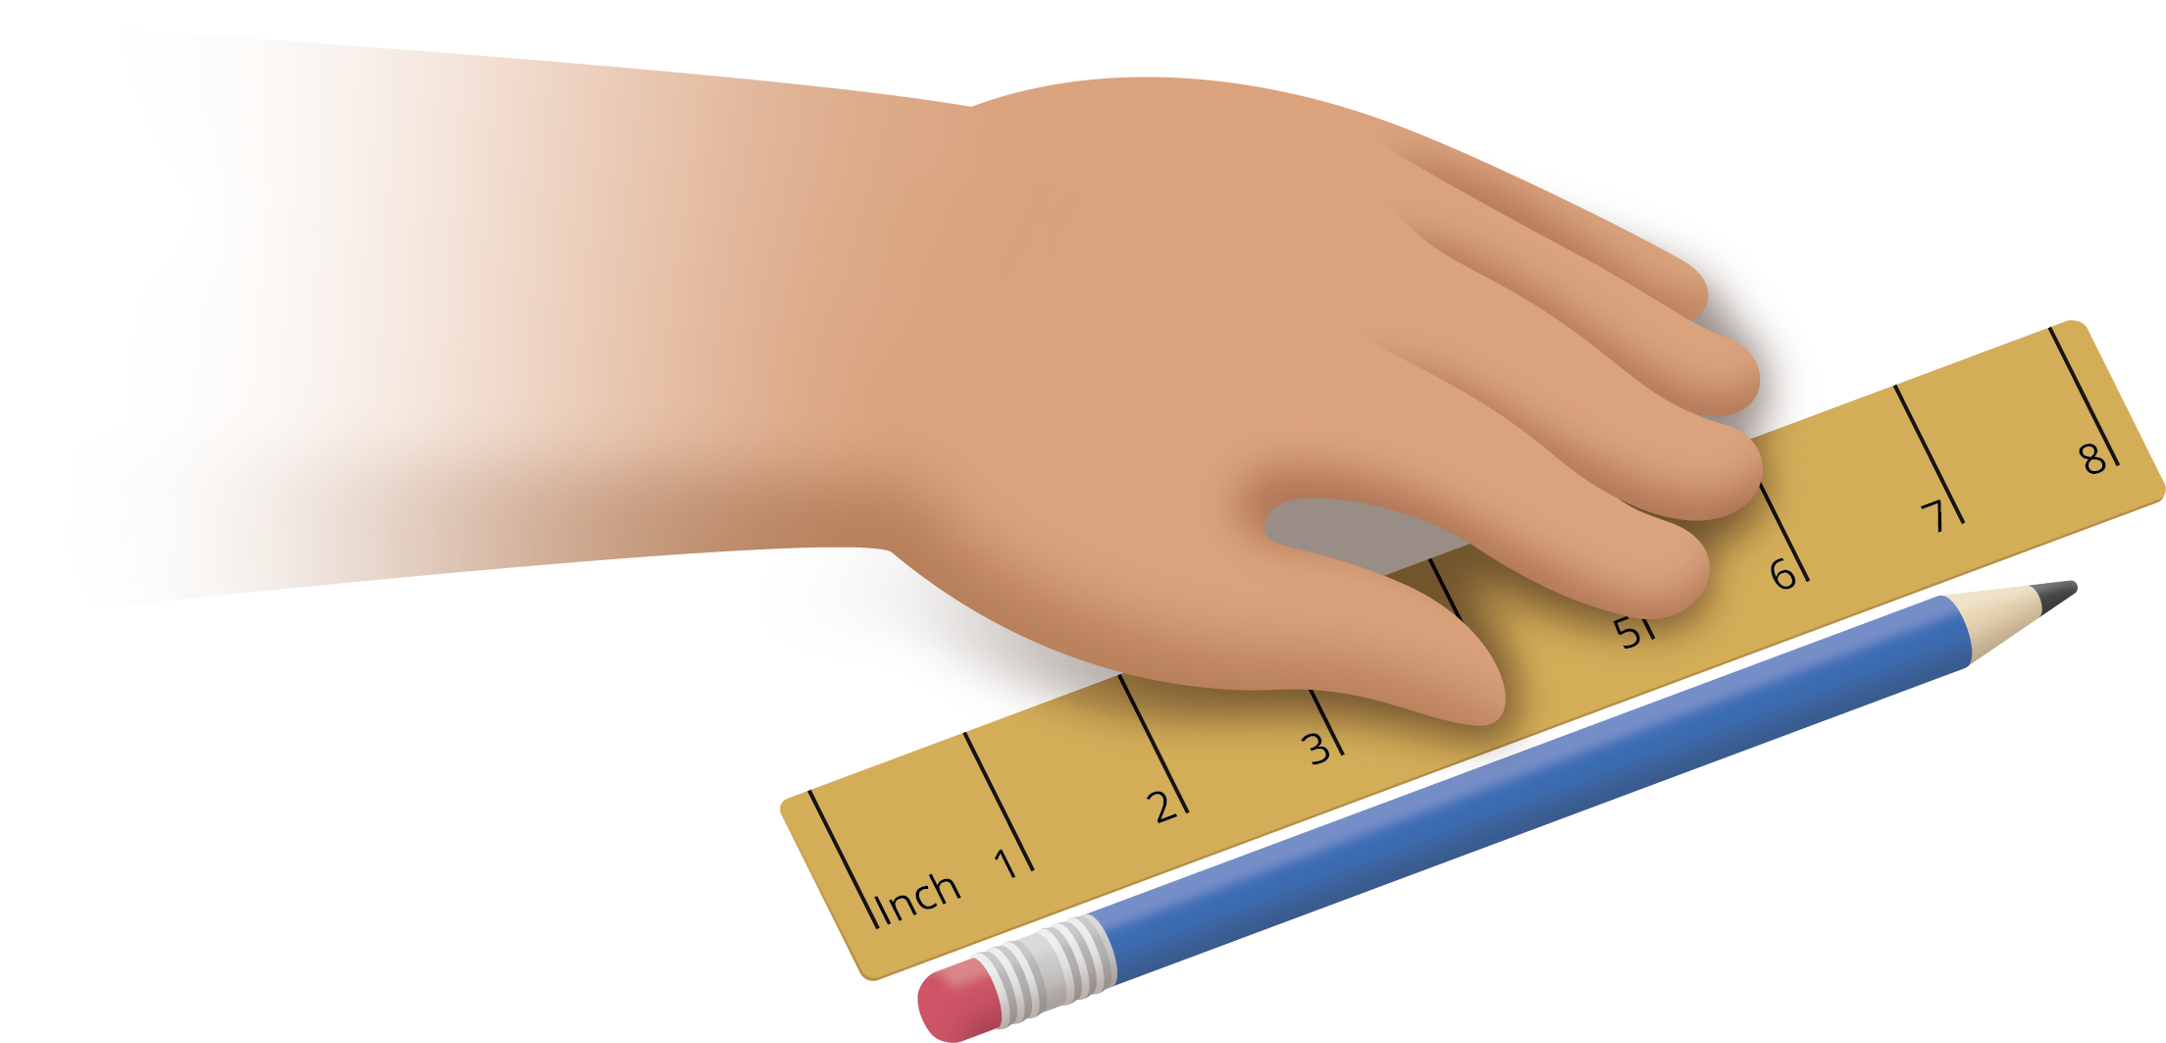

2 Partition Inches into Halves

Student Task Statement
You will need one ruler from an earlier activity.
- Work with your partner to partition every inch on the ruler into halves of an inch.
- Use the ruler marked with halves of an inch to measure some lengths around the room.
object | length (inches)
© CC BY 2021 Illustrative Mathematics®

