Unit 3 Lesson 15: An Assortment of Fractions

WU Which One Doesn't Belong: Halves, Fourths, Sixths, and Eights (Warm up)

Student Task Statement
Which one doesn't belong?
A
$1\frac{1}{2}$
B
$\frac{4}{4}+\frac{2}{4}$
C
$\frac{12}{8}$
D
$\frac{4}{6}$

1 All the Way to the Top

Student Task Statement
Priya, Kiran, and Lin are using large playing bricks to make towers. Here are the heights of their towers so far:
- Priya: $21\frac{1}{4}$ inches
- Kiran: $32\frac{3}{8}$ inches
- Lin : $55\frac{1}{2}$ inches
For each question, show your reasoning.
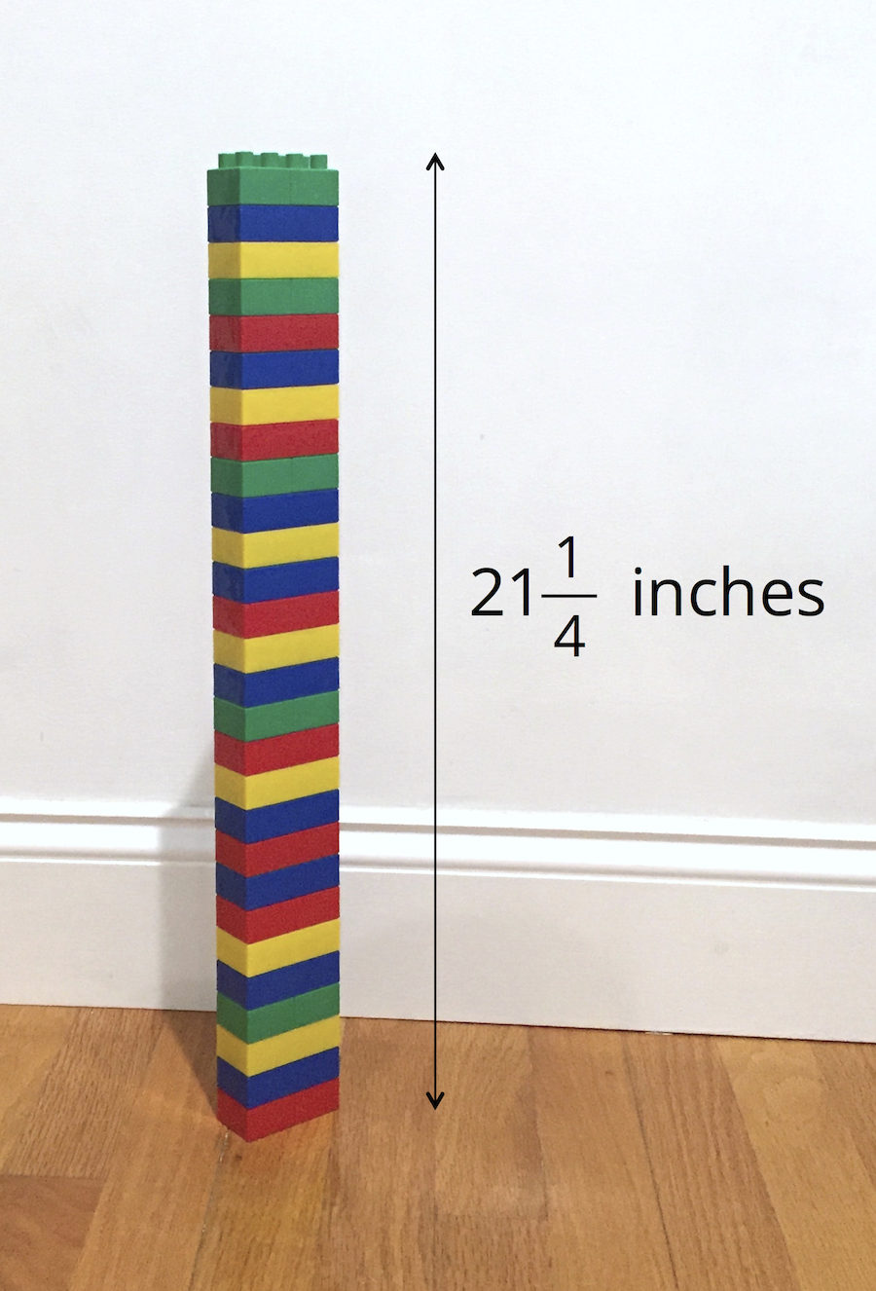
- How much taller is Lin’s tower compared to:
  - Priya’s tower?
  - Kiran’s tower?
- They are playing in a room that is 109 inches tall. Priya says that if they combine their towers to make a super tall tower, it would be too tall for the room and they’ll have to remove one brick.
- Do you agree with Priya? Explain your reasoning.

2 Stacks of Blocks

Student Task Statement
Andre is building a tower out of foam blocks. The blocks come in three different thicknesses: $\frac{1}{2}$ foot, $\frac{1}{3}$ foot, and $\frac{1}{6}$ foot.
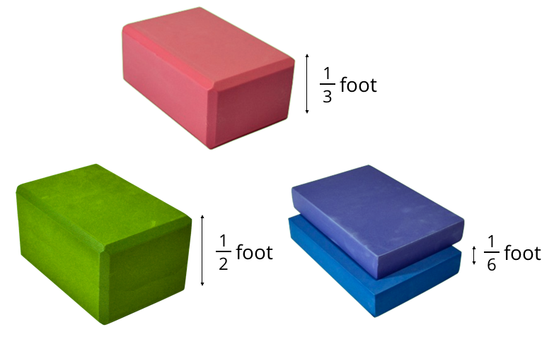
- Andre stacks one block of each size. Will that stack be more than 1 foot tall? Explain or show how you know.
- Can Andre use only the $\frac{1}{6}$ -foot and $\frac{1}{3}$-foot blocks to make a stack that is $1\frac{1}{2}$ feet tall? If you think so, show one or more ways. If not, explain why not.
- Can Andre use only the $\frac{1}{6}$-foot and $\frac{1}{2}$-foot blocks to make a stack that is $1\frac{1}{3}$ feet tall? If so, show one or more ways. If not, explain why not.

Activity Synthesis
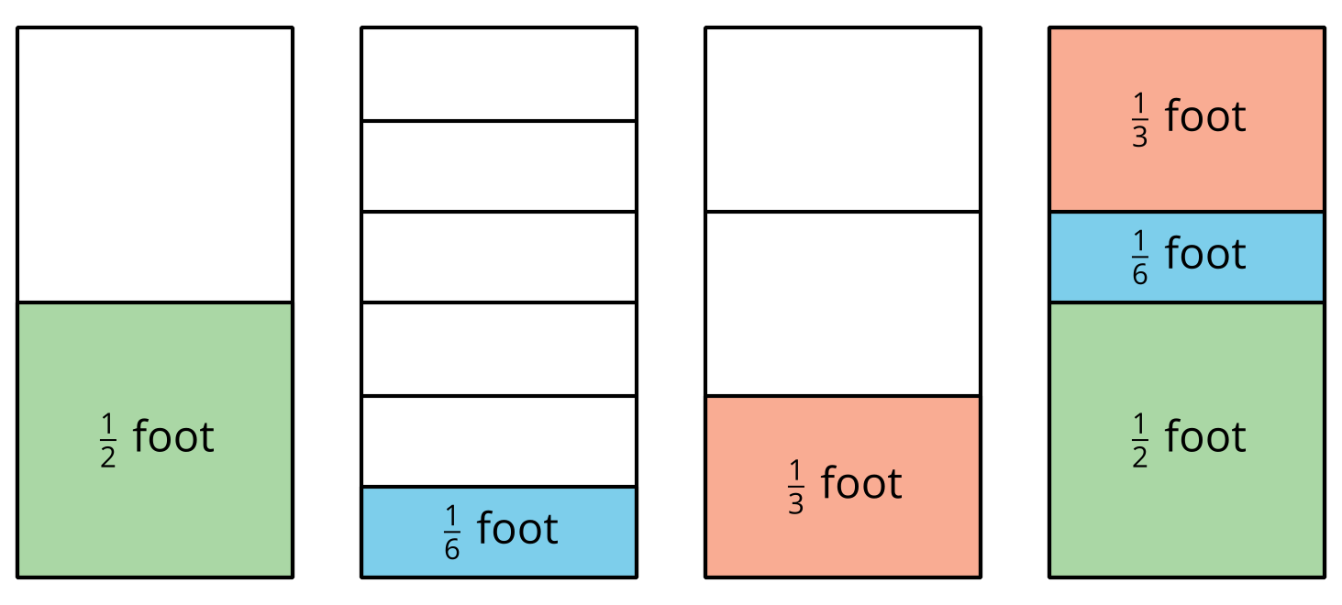
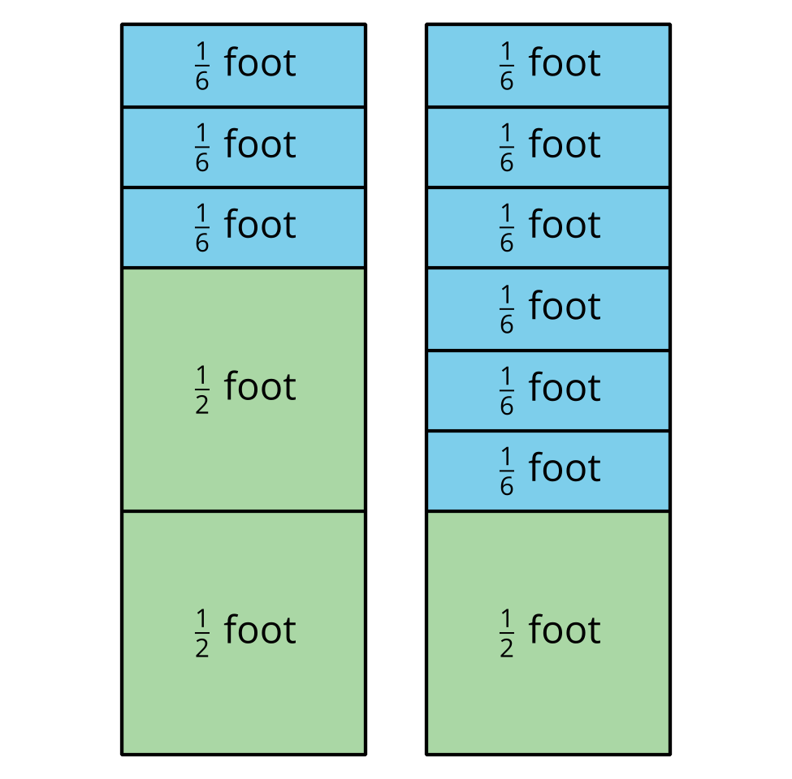
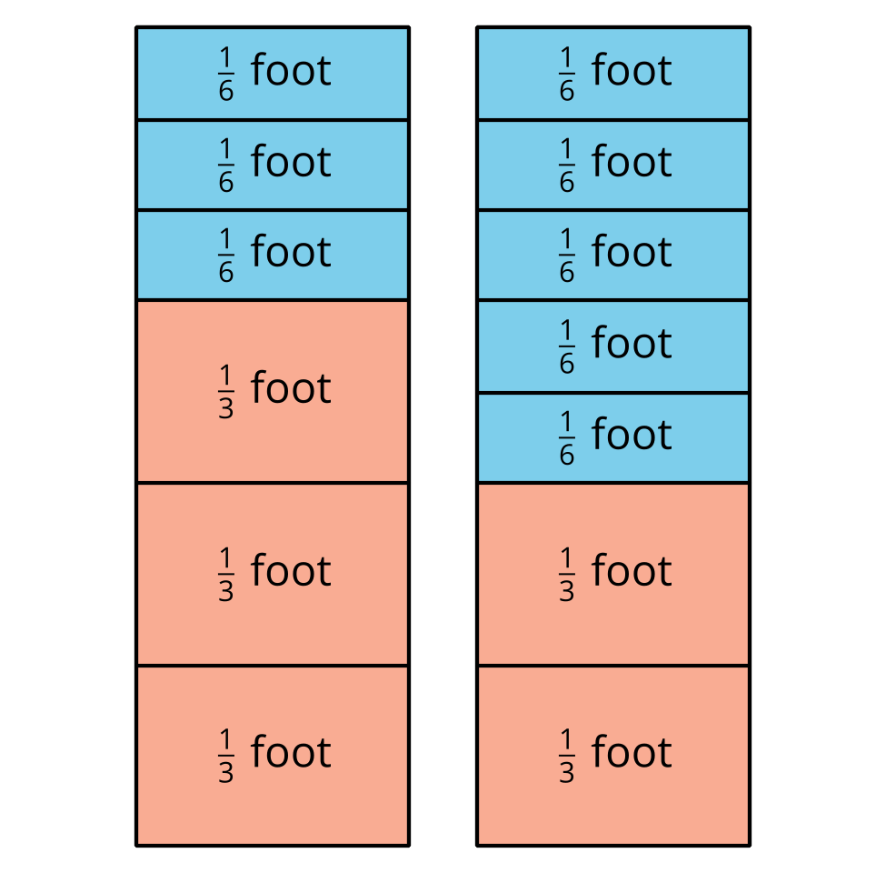
© CC BY 2021 Illustrative Mathematics®

