Unit 5 Lesson 12: Exploring Circumference

1 Which Is Greater? (Warm up)

Student Task Statement
Clare wonders if the height of the toilet paper tube or the distance around the tube is greater. What information would she need in order to solve the problem? How could she find this out?

2 Measuring Circumference and Diameter

Student Task Statement
Your teacher will give you several circular objects.
- Measure the diameter and the circumference of the circle in each object to the nearest tenth of a centimeter. Record your measurements in the table.
- object | - diameter (cm) | - circumference (cm)
- Plot the diameter and circumference values from the table on the coordinate plane. What do you notice?
- 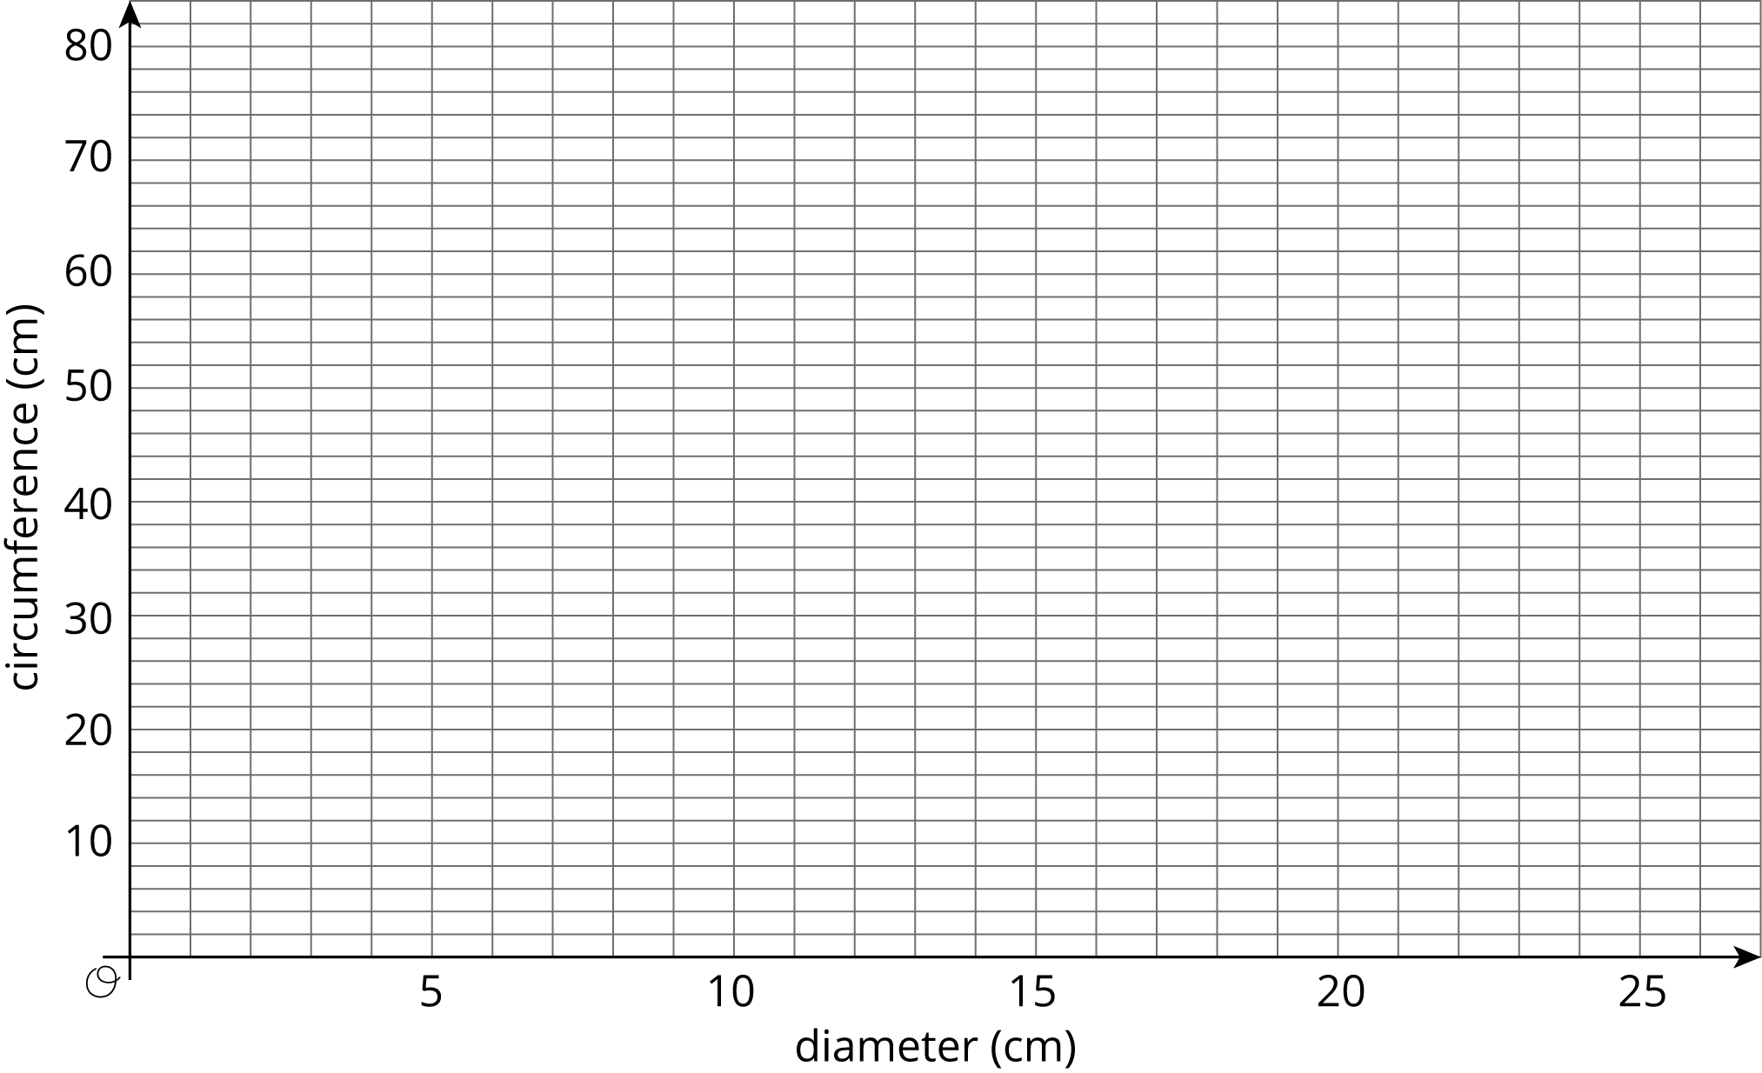
- Plot the points from two other groups on the same coordinate plane. Do you see the same pattern that you noticed earlier?

3 Calculating Circumference and Diameter

Student Task Statement
Here are five circles. One measurement for each circle is given in the table.
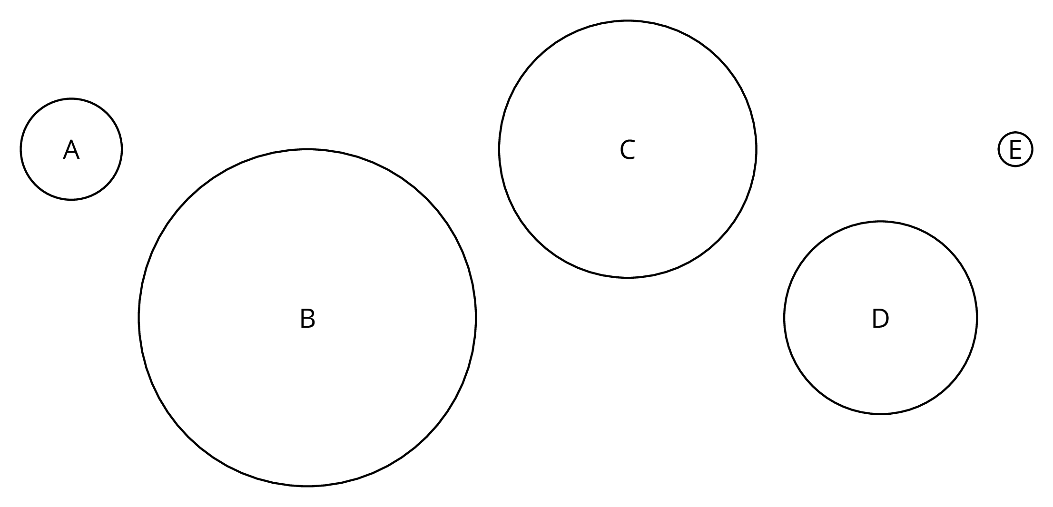
Use the constant of proportionality estimated in the previous activity to complete the table.
 | diameter (cm) | circumference (cm)
circle A | 3
circle B | 10
circle C |  | 24
circle D |  | 18
circle E | 1

© CC BY Open Up Resources. Adaptations CC BY IM.

