Lesson 8: Compare Matching Images
- Let’s figure out what we have more and fewer of.

8.1: Are There Enough?
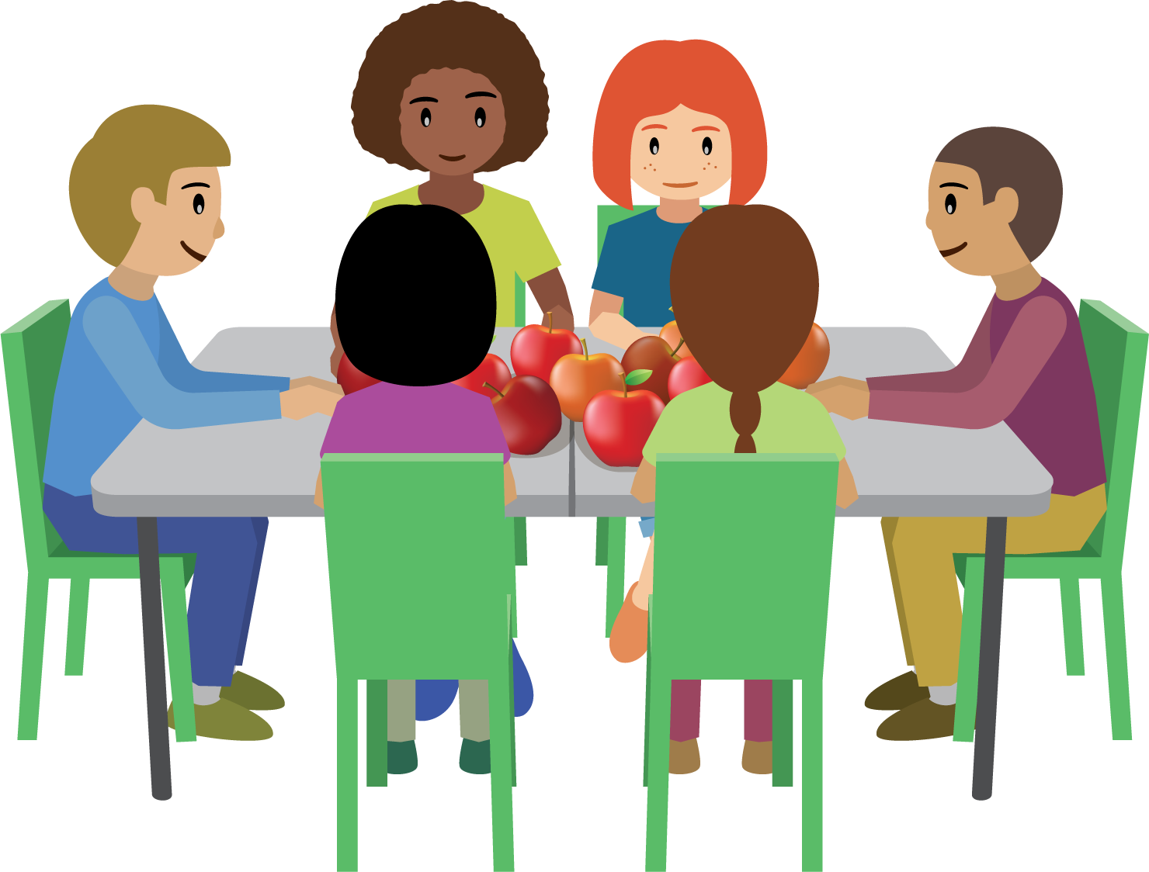

- 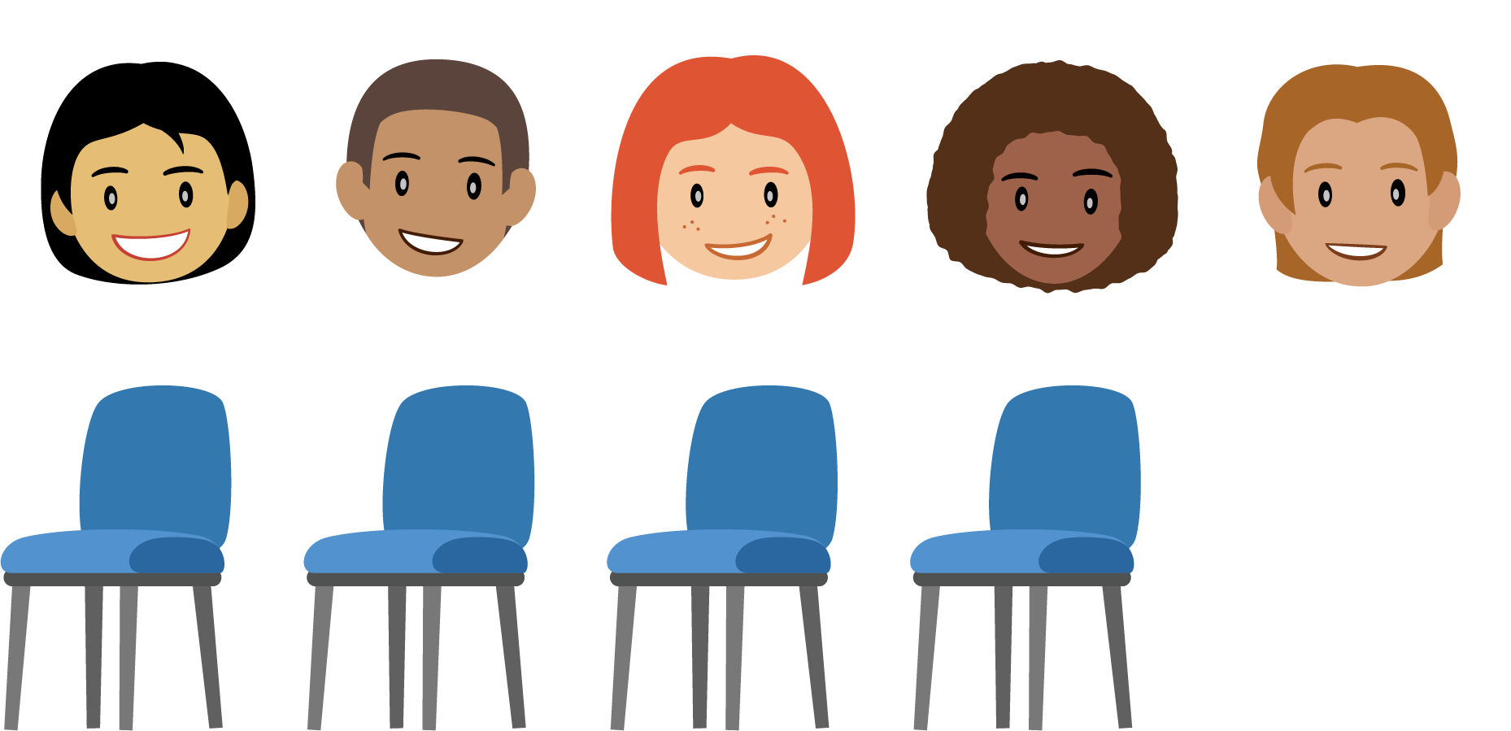

- 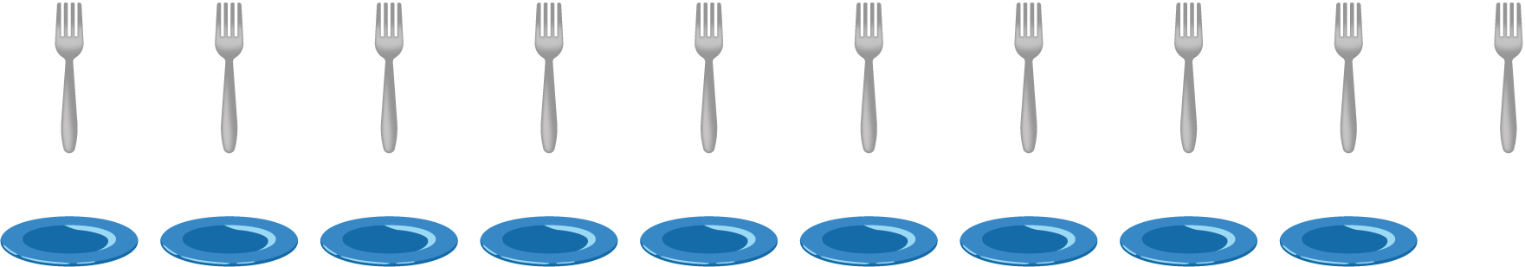

- 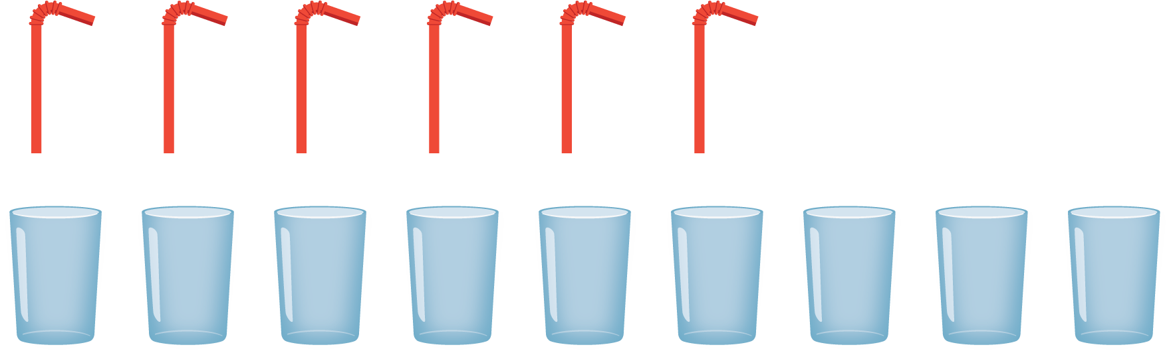

8.2: Comparing Images That Aren’t Matched

- 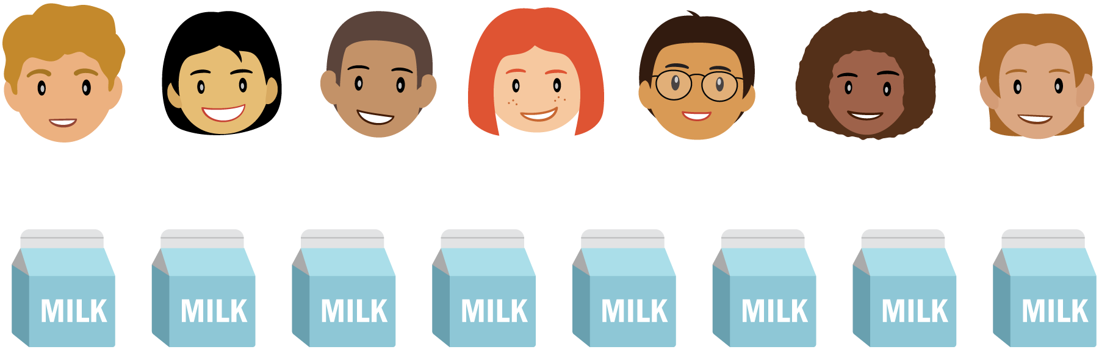

- 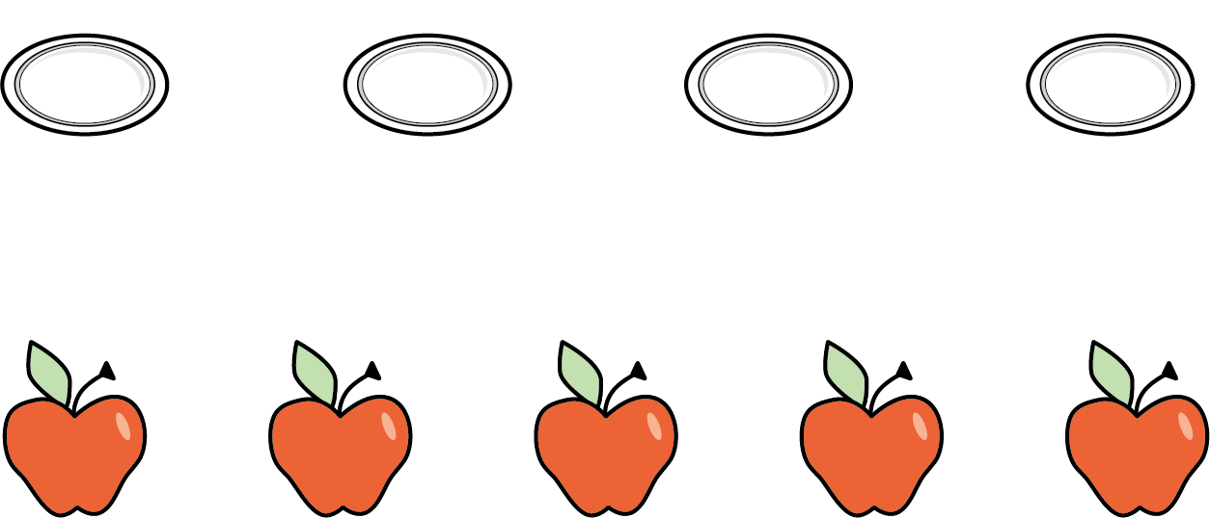

- 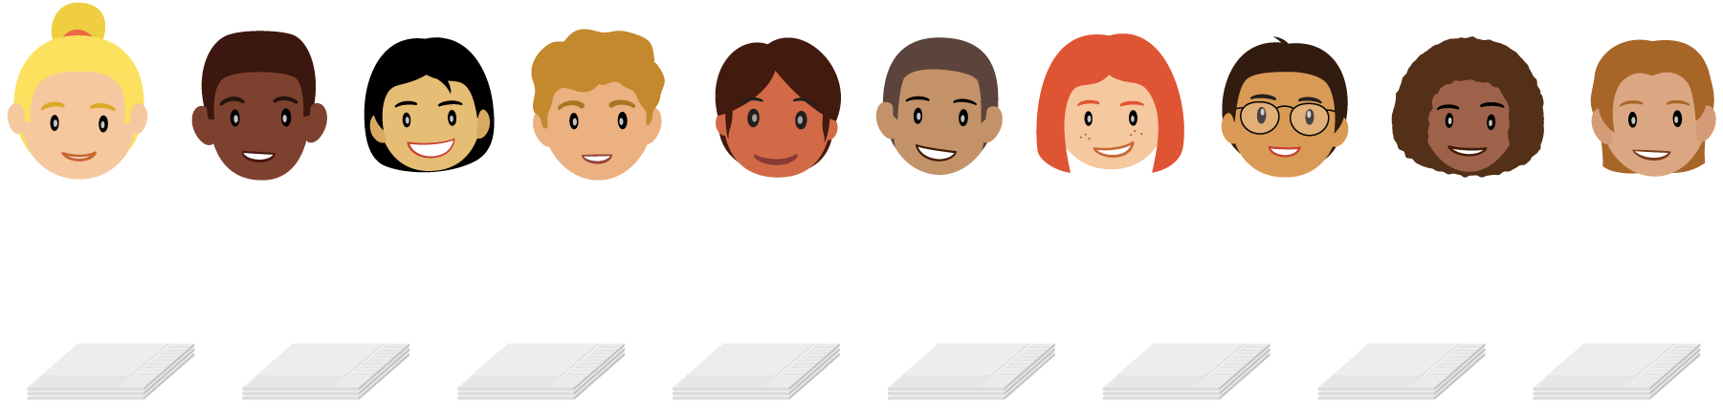

- 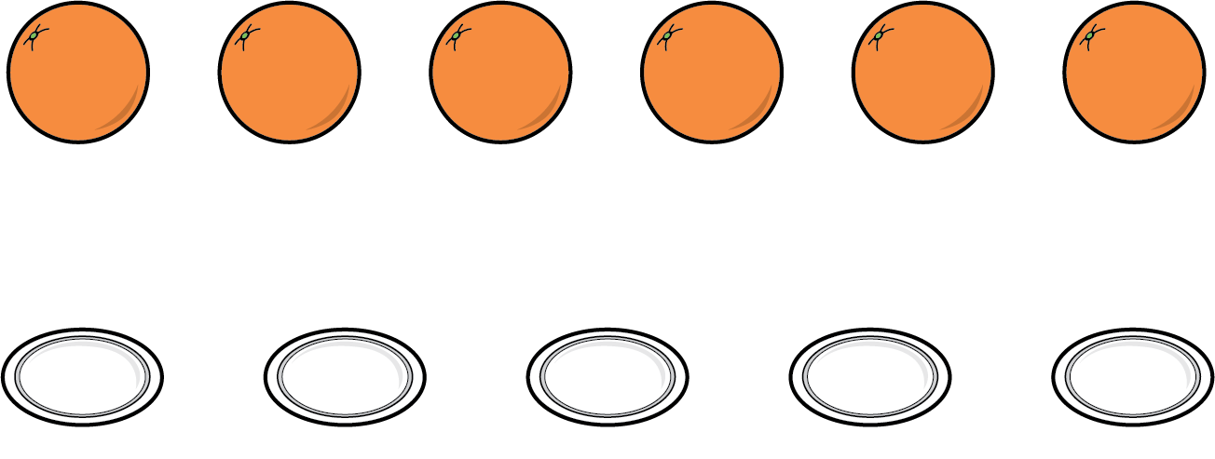

8.3: Centers: Choice Time
Choose a center.
Math Stories
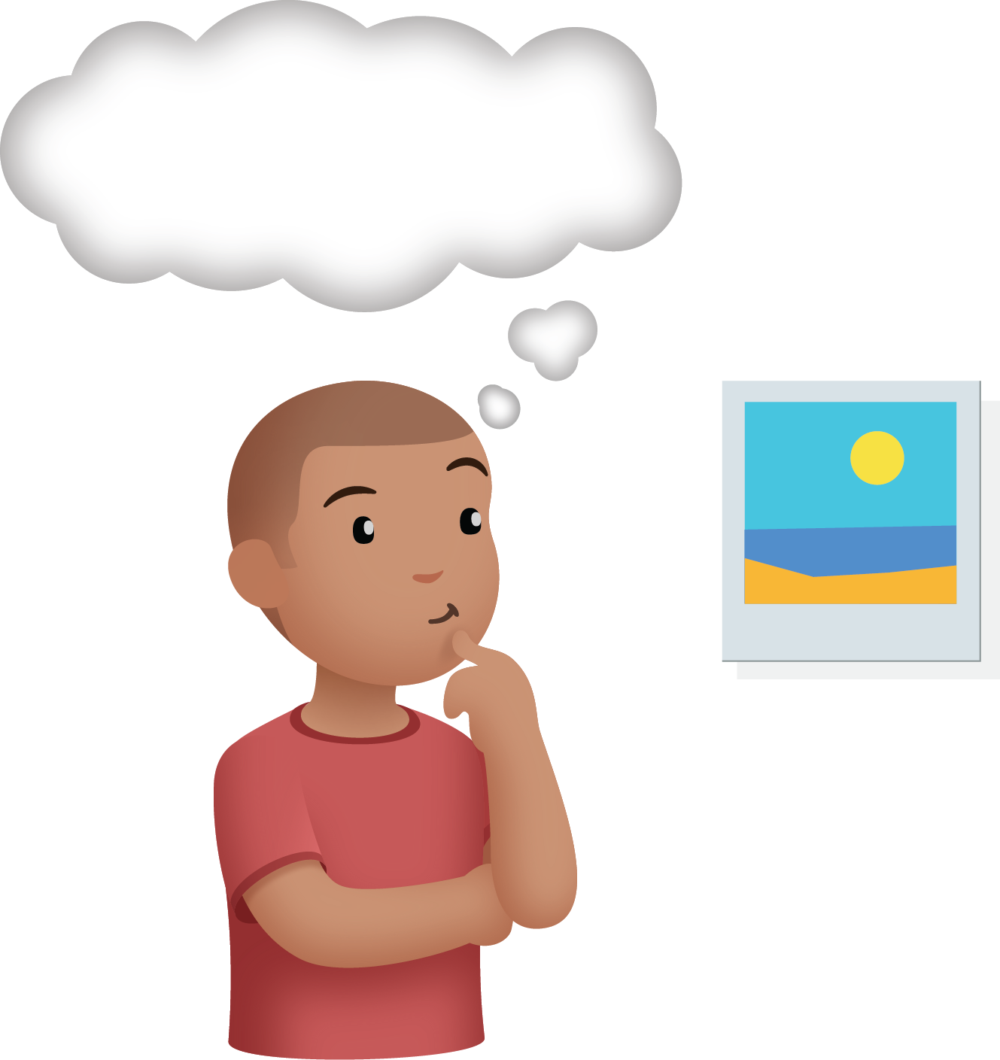
Connecting Cubes
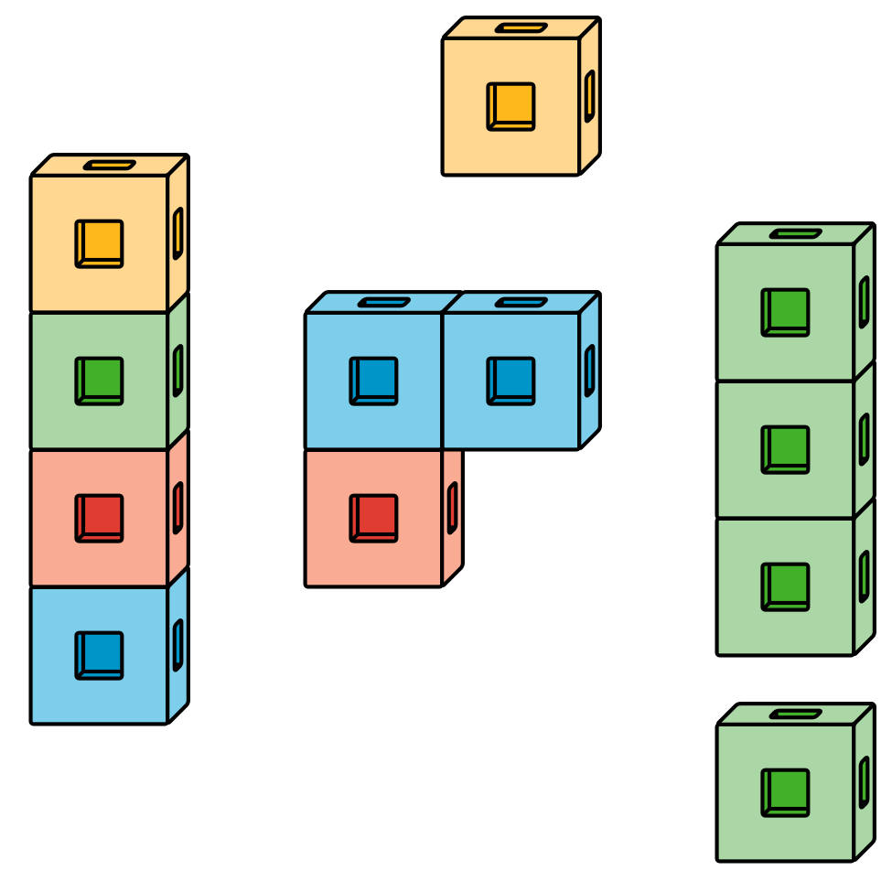
Number Race
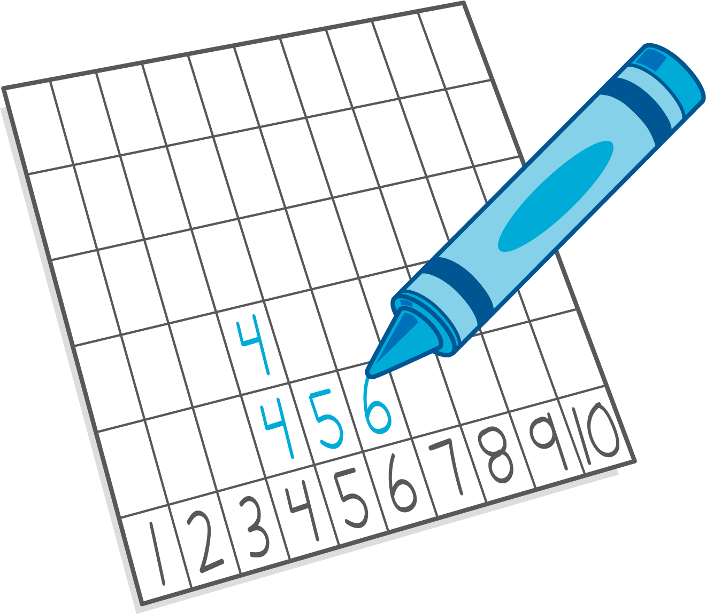
© CC BY 2021 Illustrative Mathematics®

