Unit 6 Lesson 2: Keep Track of Objects

WU Number Talk: Add and Subtract 0 and 1 (Warm up)

Student Task Statement
Find the value of each expression.
- $3+0$
- $3+1$
- $3−1$
- $2−0$

1 Counting Collections

Student Task Statement

2 Different Ways to Keep Track

Student Task Statement

3 Centers: Choice Time

Student Task Statement
Choose a center.
Number Race
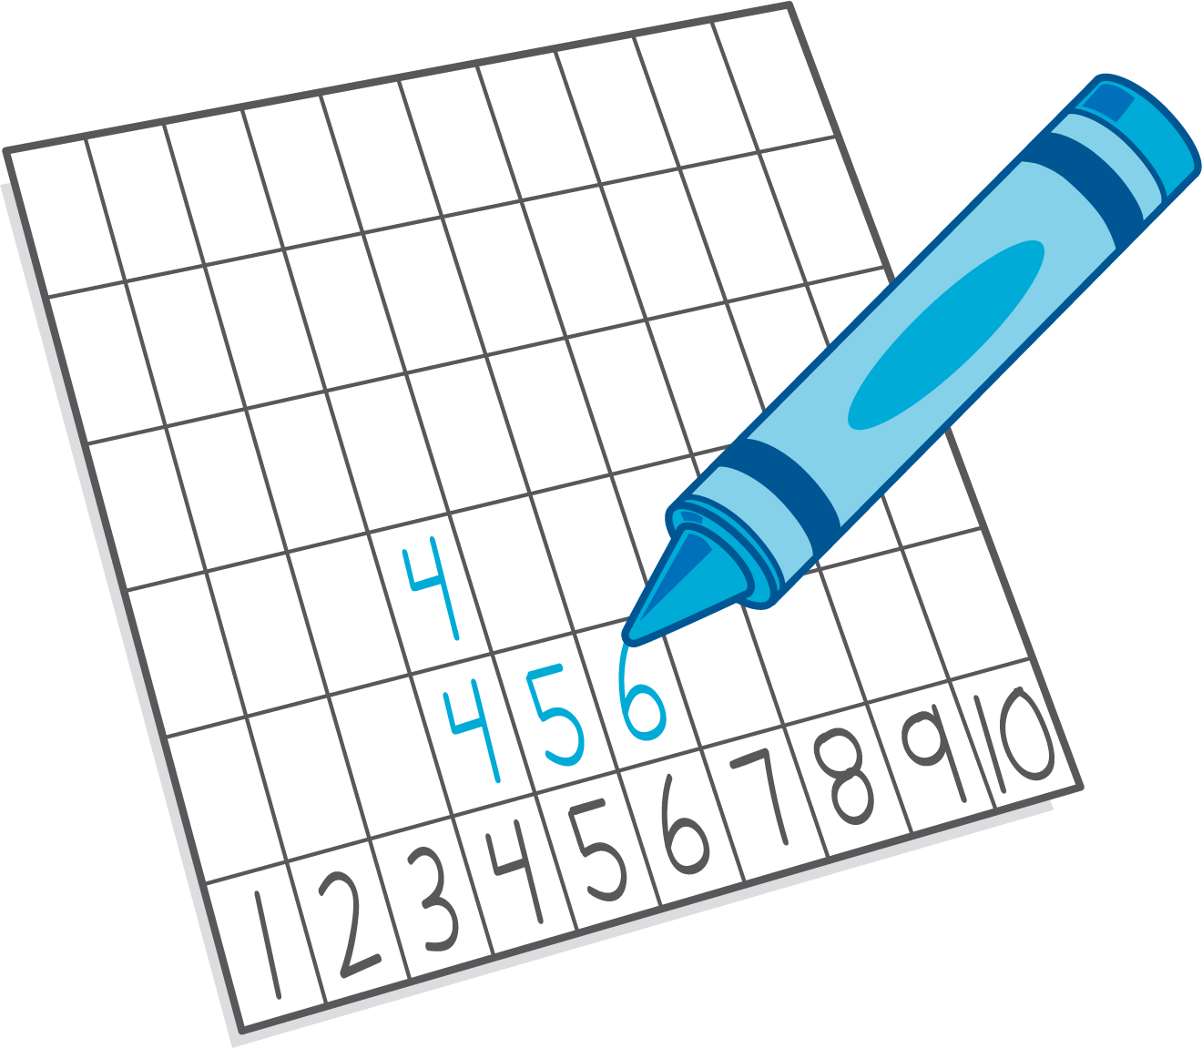
Subtraction Towers
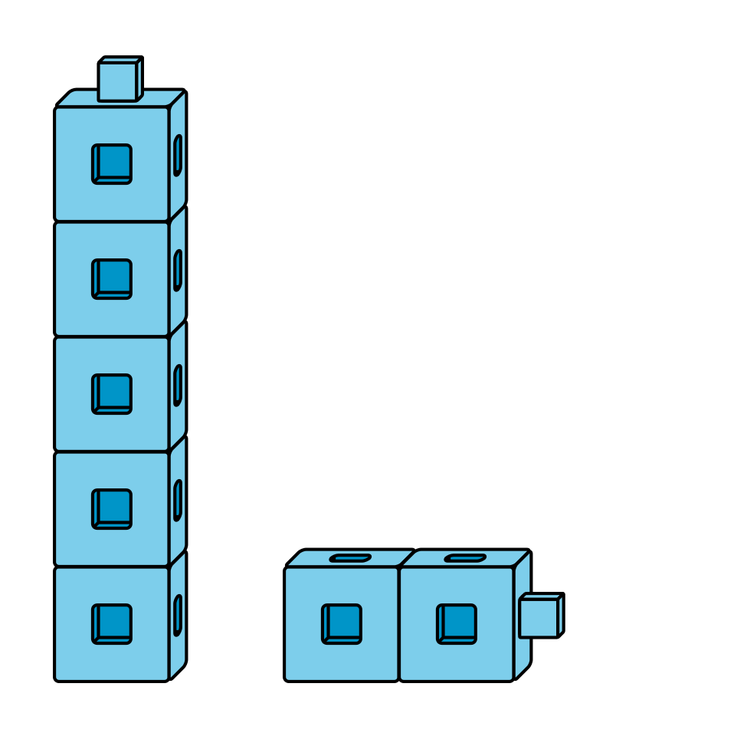
5-frames
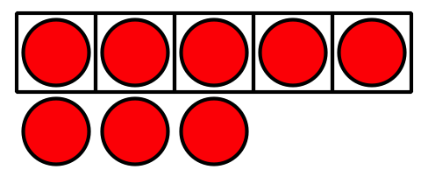
© CC BY 2021 Illustrative Mathematics®

