Lesson 17 Practice Problems
- Here is the graph of a trigonometric function.
- Which equation has this graph? Select all that apply.
- 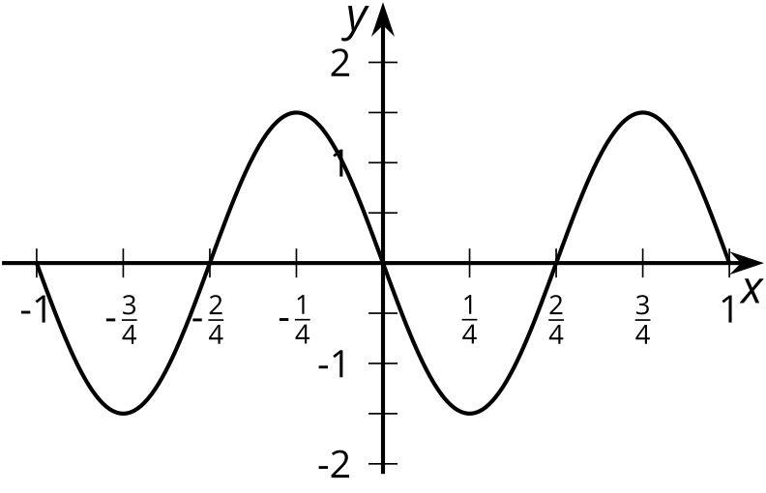
  - $y=\frac{3}{2}cos\left(2πx−\frac{π}{2}\right)$
  - $y=\text{-}\frac{3}{2}sin\left(2πx\right)$
  - $y=\frac{3}{2}cos\left(2πx\right)$
  - $y=\frac{3}{2}cos\left(2πx+\frac{π}{2}\right)$
  - $y=\frac{3}{2}sin\left(2πx+π\right)$
- Here is the graph of a trigonometric function.
- Which equation has this graph?
- 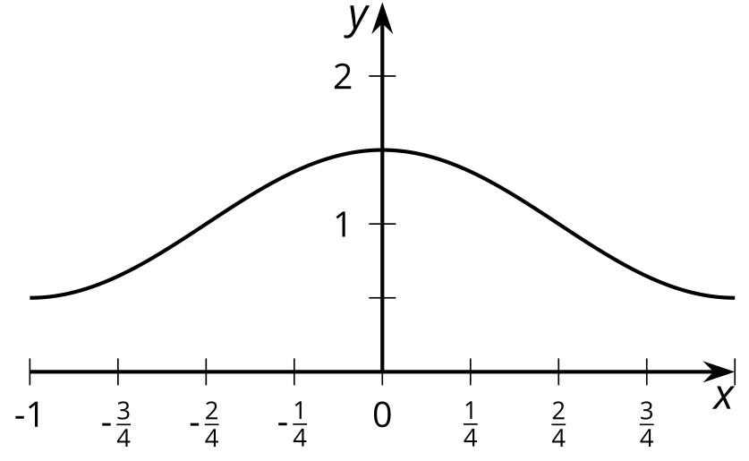
  - $y=cos\left(x\right)+1$
  - $y=\frac{1}{2}cos\left(x\right)+1$
  - $y=\frac{1}{2}cos\left(π⋅x\right)+1$
  - $y=\frac{1}{2}cos\left(2π⋅x\right)+1$
- Here is the graph of a trigonometric function.
- 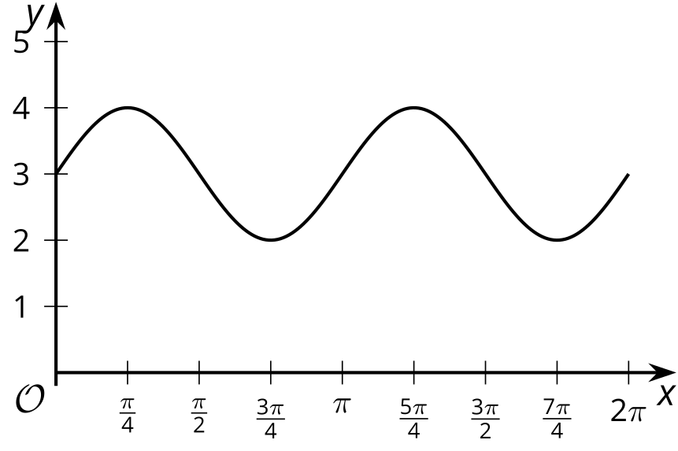
  - Find a trigonometric function $f$ that has this graph. Explain your reasoning.
  - The graph is translated right by $\frac{π}{2}$ so it has a minimum value at $x=0$, then stretched horizontally so its period is 3 times greater than the period of $f$. Find a trigonometric function $g$ that has this new graph. Explain your reasoning.
- The function $f$ is given by $f\left(x\right)=4+2sin\left(πx\right)$. The graph of $g$ is the graph of $f$ translated left by $\frac{π}{2}$ and translated vertically by -1. Which expression defines $g$?
  - $5+2sin\left(πx+\frac{π}{2}\right)$
  - $3+2sin\left(πx+\frac{π}{2}\right)$
  - $3+2sin\left(π\left(x−\frac{π}{2}\right)\right)$
  - $3+2sin\left(π\left(x+\frac{π}{2}\right)\right)$
- Here are graphs of trigonometric functions $f$ and $g$. What transformations can be applied to the graph of $f$ to get the graph of $g$? Make sure to list them in the order they are applied.
- 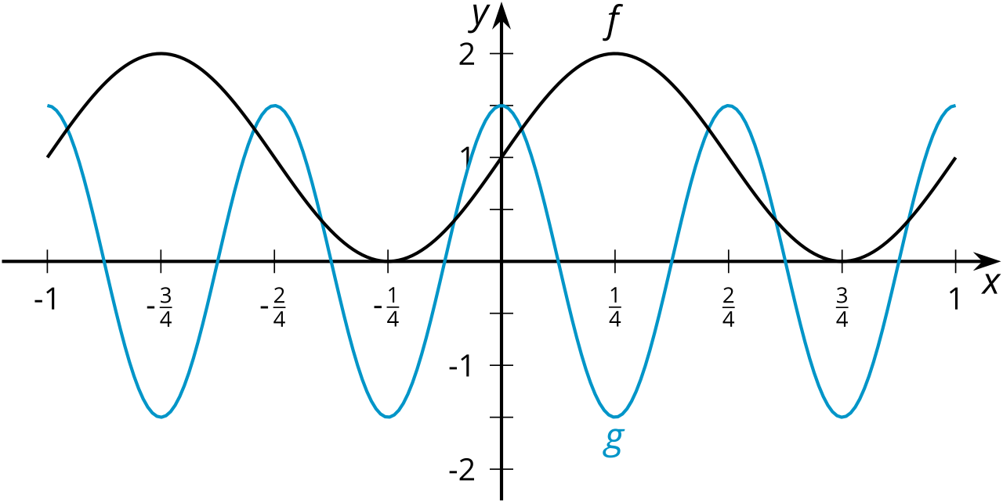

- The table shows the vertical position of a point at the tip of a windmill blade after the blade has rotated through different angles. The point starts at the location furthest to the right.
  - How long is the windmill blade? Explain how you know.
  - What is the height of the windmill? Explain how you know.
- rotation angle  of windmill | - vertical position  of $P$ in feet
- $\frac{π}{6}$ | - 11.25
- $\frac{π}{3}$ | - 10 + $\frac{2.5\sqrt{3}}{2}$
- $\frac{π}{2}$ | - 12.5
- $π$ | - 10
- $\frac{3π}{2}$ | - 7.5
- (From Unit 6, Lesson 13.)
- The function $f$ is given by $f\left(θ\right)=6+5cos\left(θ+\frac{π}{2}\right)$. Which of the following are true of $f$? Select all that apply.
  - The amplitude of $f$ is 6.
  - The function $f$ takes its maximum value when $x=0$.
  - The midline of $f$ is 6.
  - The graph of $f$ is the same as the graph of $g\left(θ\right)=6+5cos\left(θ\right)$ translated to the right by $\frac{π}{2}$.
  - The graph of $f$ is the same as the graph of $g\left(θ\right)=6+5cos\left(θ\right)$ translated to the left by $\frac{π}{2}$.
- (From Unit 6, Lesson 14.)
© CC BY 2019 by Illustrative Mathematics®

