Unit 7 Lesson 1: Being Skeptical

1 Notice and Wonder: Headlines (Warm up)

Student Task Statement
A graph and 2 headlines from a website are shown.
What do you notice? What do you wonder?
- 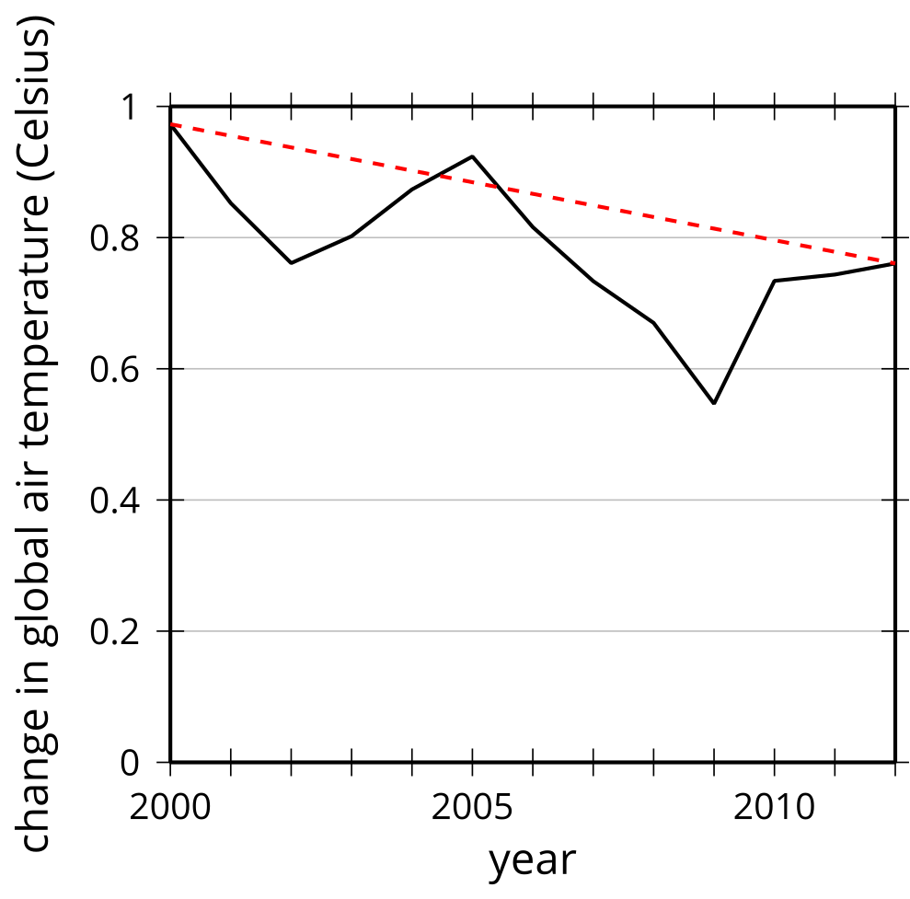
- “80% of Dentists Recommend Acme Toothpaste”
- “Pythagoras Brand Rulers Measure 20% Better”

Activity Synthesis
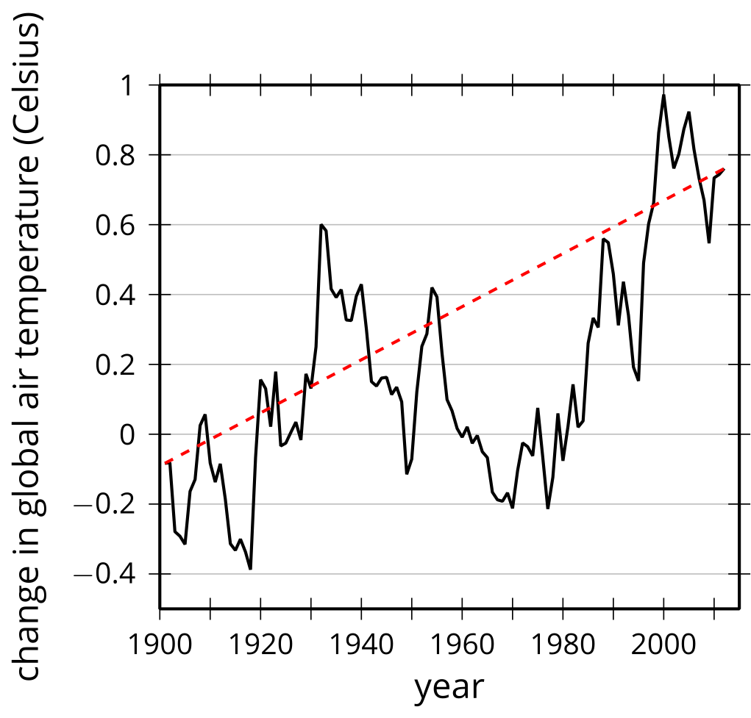

2 Take Turns: Statistical Design

Student Task Statement
One partner reads the statistical question and study design to the other partner. The reader should then sort the item into the type of study described:
- Survey
- Observational study
- Experimental study
The other partner should decide whether the study is good or bad and explain their reasoning. After the discussion, switch roles and have the other partner read the next statistical question and study design aloud. Take turns until no questions remain.
- Why are students missing so much school in the district? A district administrator selects 300 student names at random from the enrollment list and sends a letter to each student’s home. The letter includes a page to be returned to their school signed by a parent or guardian. The page asks, “How many days has your student missed school this year?” and “What are the reasons for missing school on those days?”
- Why are students missing so much school in the district? A district administrator chooses one of the elementary schools in the district and asks the principal to provide information about the number of absences and the excuse notes provided to the school.
- What type of sweetener do flies prefer? A scientist puts the same amount of each sweetener into different bowls of water and counts the number of flies that drink from each bowl in 4 hours.
- What type of sweetener do flies prefer? A scientist divides the flies into different groups and gives each group only water with a certain type of sweetener in it for 3 days. The scientist then does a test on each group to see how well the flies can fly through a maze.
- Is there a link between dark chocolate and weight loss when compared to milk chocolate? A nutritionist asks 5 friends to eat dark chocolate along with their usual food for 6 months and 5 other friends to eat milk chocolate along with their usual food for 6 months. The nutritionist then compares their weight after the 6 months to their weight before eating the different chocolates.
- Is there a link between dark chocolate and weight loss when compared to milk chocolate? A nutritionist gathers 60 people, selected at random, then randomly assigns half of the group to eat a single dark chocolate bar after dinner each night and the other half to eat a single milk chocolate bar after dinner each night for 6 months. Everyone is to keep track of the other food they eat in an app provided. The nutritionist then compares each person’s weight after the 6 months to their weight before eating the different chocolates accounting for the other calories consumed.
- Do voters in the district favor a sales tax increase of 1% to fund the parks and recreation department? A politician sends a letter to 300 voters in the district asking, “Would you pay extra money on your essential groceries to hire more government workers to plant flowers around the town?”
- Do voters in the district favor a sales tax increase of 1% to fund the parks and recreation department? A politician sends a letter to 300 voters selected at random in the district asking, “Would you be in favor of a 1% increase in sales tax to fund the parks and recreation department in town?”
© CC BY 2019 by Illustrative Mathematics®

