Unit 4 Lesson 3: Partial Products in Algorithms

WU Which One Doesn't Belong: Multiplying Large Numbers (Warm up)

Student Task Statement
Which one doesn't belong?
A
B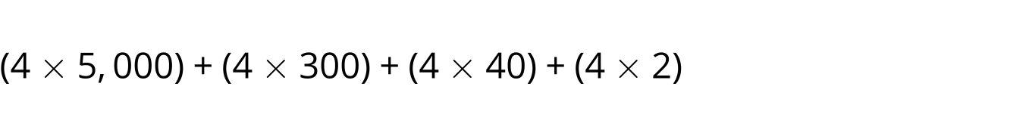
C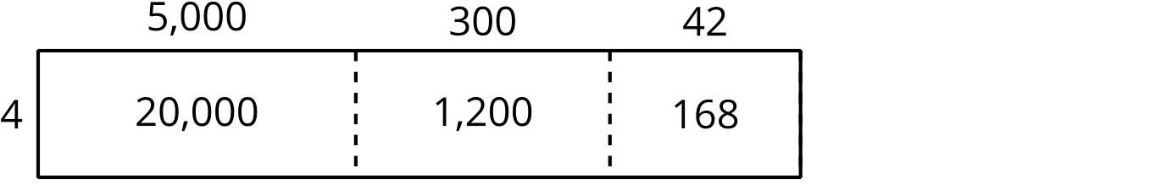
D

1 Partial Products Everywhere

Student Task Statement
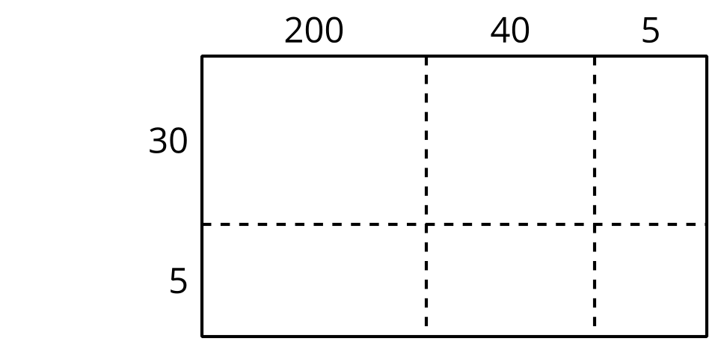
- Take turns picking out a set of expressions that are equal to $245×35$ when added together. Use the diagrams if they are helpful.
- Explain how you know the sum of your expressions is equal to $245×35$.
- What is the value of $245×35$? Explain or show your reasoning.

2 Record Partial Products

Student Task Statement
Andre
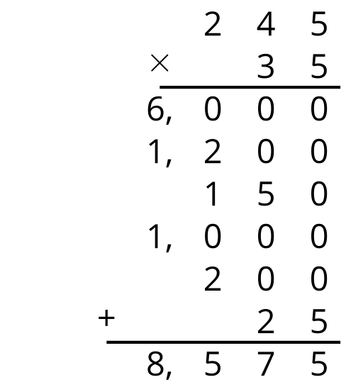
Clare
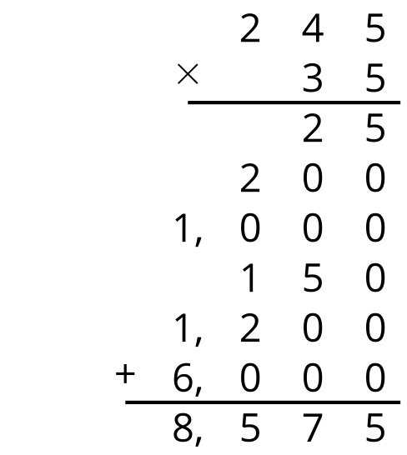
- How are Andre’s and Clare’s strategies the same? How are they different?
- Create a list of equations to match the partial products Andre and Clare found.
© CC BY 2021 Illustrative Mathematics®

