Unit 5 Lesson 17: Multiply Decimals and Whole Numbers

WU True or False: Place Value Products (Warm up)

Student Task Statement
Decide if each statement is true or false. Be prepared to explain your reasoning.
- $100×0.01=1$
- $10×0.1=0.01$
- $10×0.01=0.1$

1 Multiply Decimals By Whole Numbers

Student Task Statement
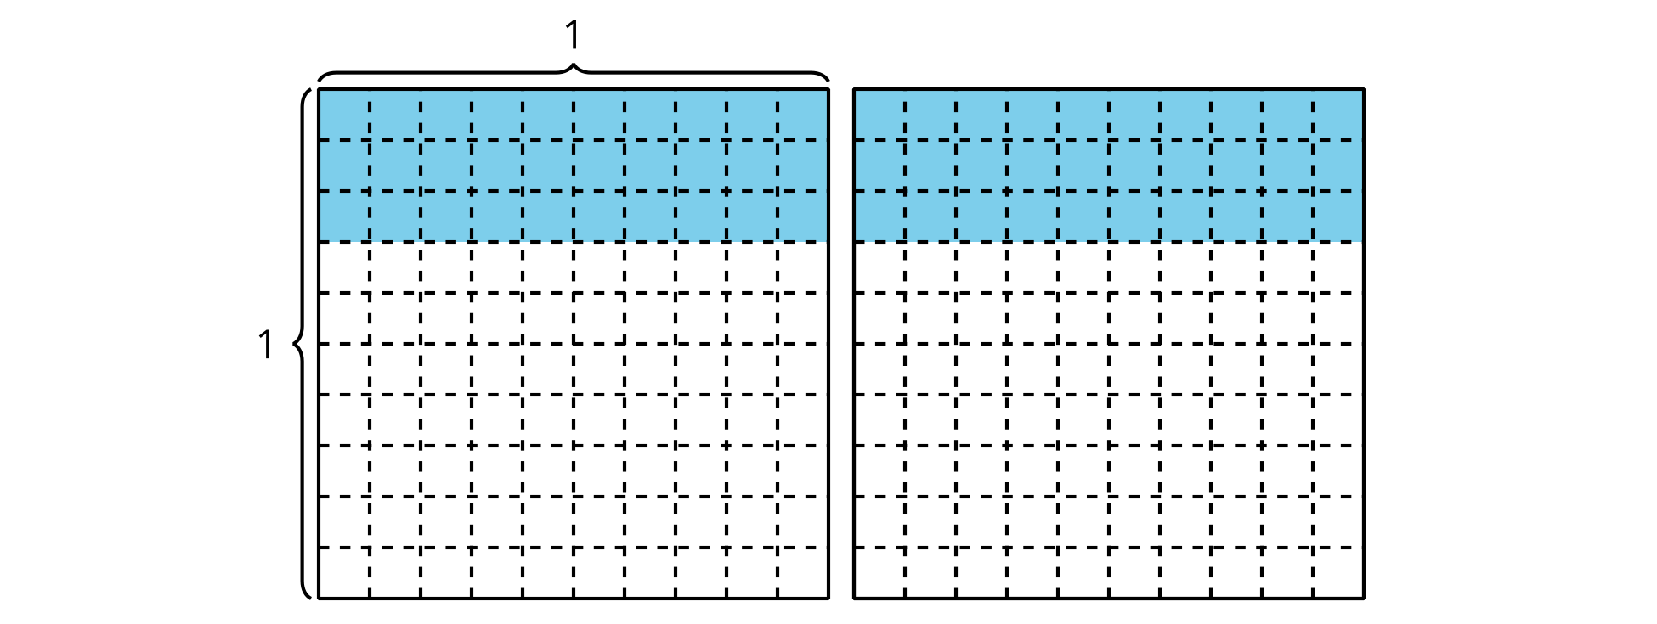
Find the value of each expression in a way that makes sense to you. Explain or show your reasoning. Use the grids, if needed.
- $2×0.7$
- 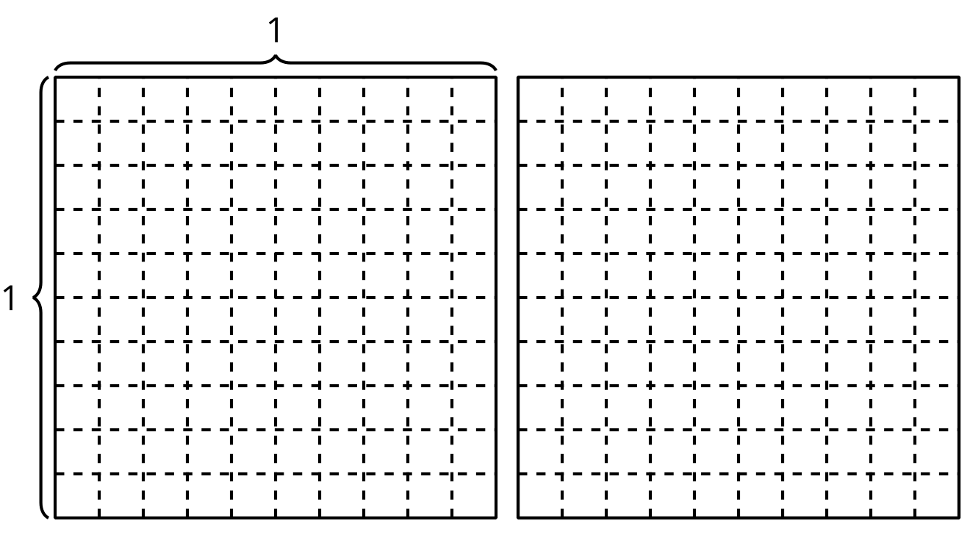
- $2×0.08$
- $2×0.78$

2 Using Whole Number Products

Student Task Statement
- Find the value of each expression. Explain or show your reasoning.
  - $3×0.5$
  - $5×0.3$
  - $7×0.02$
- Kiran wrote this explanation to describe the strategy he used to multiply a whole number by some tenths:
- “I just turn the numbers into whole numbers, multiply them, and call them tenths.” (Pause for teacher directions.)
- Can you use Kiran’s reasoning to find the value of $6×0.07?$ Explain your reasoning.
© CC BY 2021 Illustrative Mathematics®

