Lesson 4: Build Fractions from Unit Fractions
- Let’s build other fractions from unit fractions.

Warm-up: Number Talk: 3 and Another Factor
Find the value of each expression mentally.
- $3×3$
- $7×3$
- $10×3$
- $3×17$

4.1: Introduce Secret Fractions
The goal of the game is to be the first to build 2 secret fractions with unit fractions.
- Make two stacks: one for secret fractions and one for unit fractions. Place all cards face down.
- Each player draws 2 secret fraction cards. These are the fractions you are trying to make with your unit fractions.
- On your turn, you can make one of these moves:
  - Pick up 1 unit fraction card.
  - Trade both of your secret fractions for 2 new secret fractions from the stack.
- When you have enough unit fractions to make one of your secret fractions, shade your gameboard to represent your secret fraction. Then, pick a new secret fraction.
- The first player to make 2 secret fractions wins.
Gameboard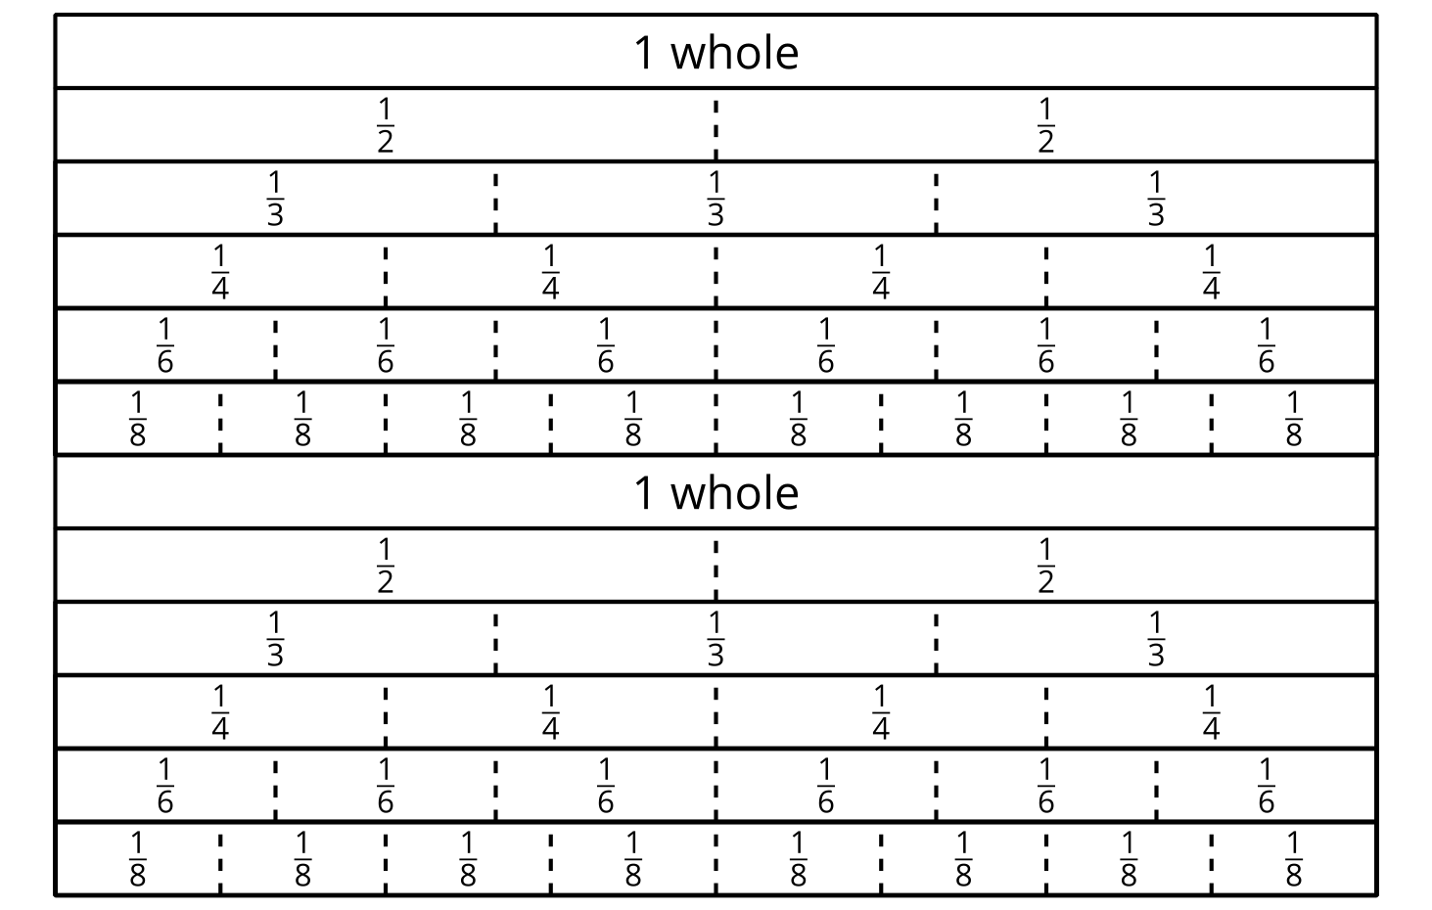

4.2: Represent Fraction Situations
Here are four situations about playing Pilolo and four diagrams. Each diagram represents the length of a street where the game is played.
Represent each situation on a diagram. Be prepared to explain your reasoning.
- A student walks $\frac{4}{8}$ the length of the street and hides a rock.
- A student walks $\frac{2}{3}$ the length of the street and hides a penny.
- A student walks $\frac{3}{4}$ the length of the street and hides a stick.
- A student walks $\frac{5}{6}$ the length of the street and hides a penny.
- This diagram represents the location of a hidden stick.
- About what fraction of the length of the street did the student walk to hide it? Be prepared to explain how you know.

Section Summary
Section Summary
In this section, we learned how to partition shapes into halves, thirds, fourths, sixths, and eighths, and how to describe each of those parts in words and using a number.
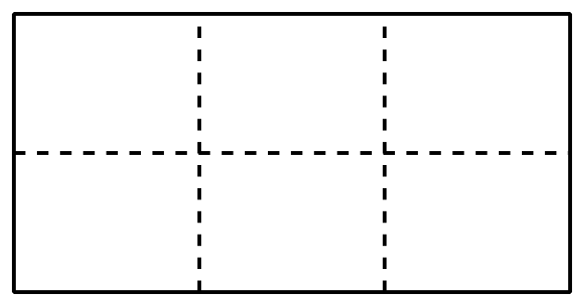
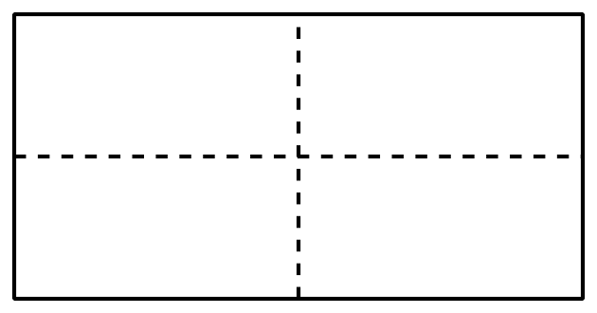
The numbers we use to describe these equal-sized parts are fractions.
A fraction like $\frac{1}{4}$ is read “one-fourth” because it represents one of the 4 equal parts in a whole.
A fraction like $\frac{3}{4}$ is read “three-fourths” because it represents 3 parts that are each one-fourth or $\frac{1}{4}$ in size.
Fractions that refer to only one of the equal parts in a whole— like $\frac{1}{2}$, $\frac{1}{3}$, $\frac{1}{8}$—are called unit fractions.
We learned that the bottom part of the fraction tells us how many equal parts we partitioned the whole into. The top part of the fraction tells us how many of the equal parts are being described.
© CC BY 2021 Illustrative Mathematics®

