Lesson 9: More, Fewer, or the Same
- Let’s figure out if there are more, fewer, or the same number of images.

9.3: Introduce Bingo, Images
Choose a center.
Bingo
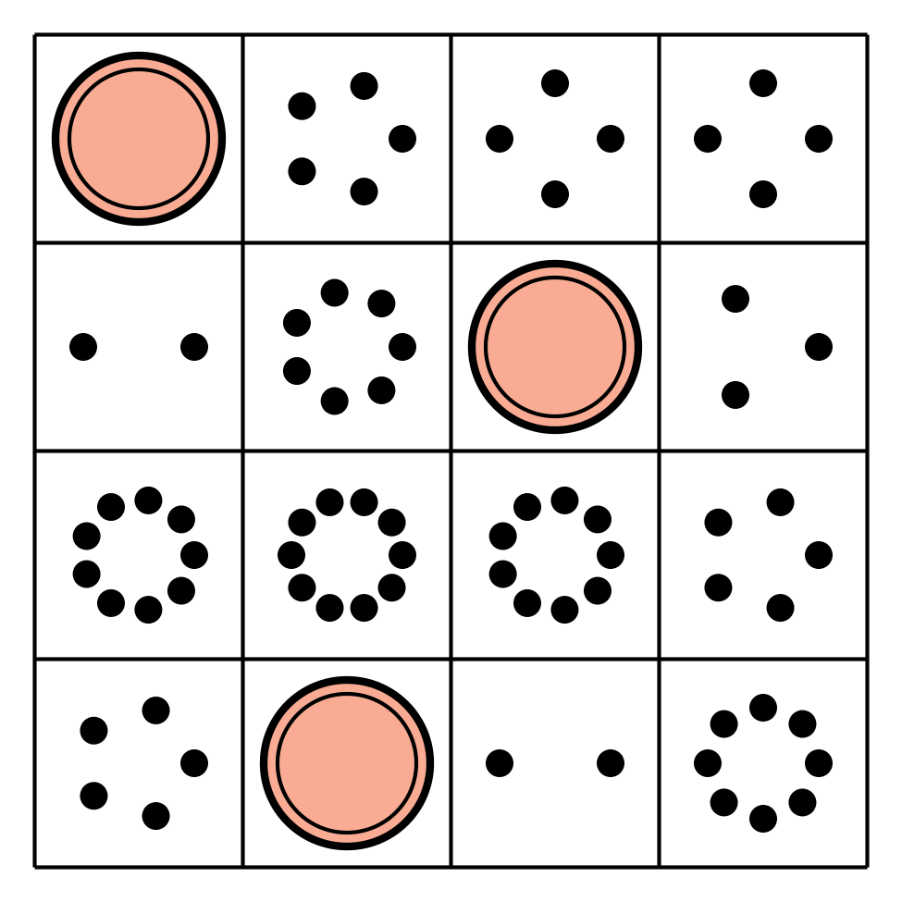
Math Stories
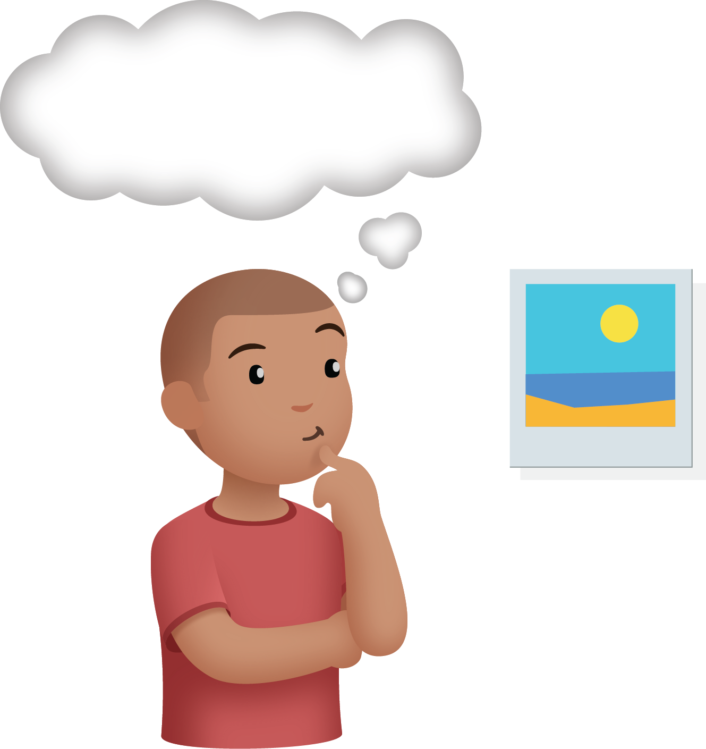
Connecting Cubes
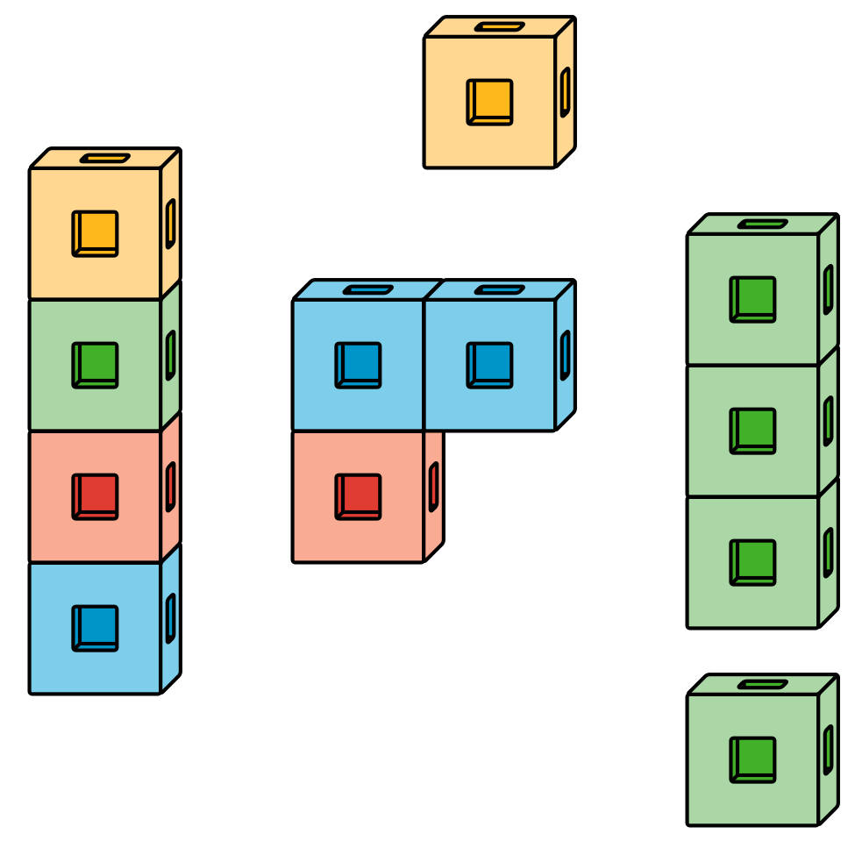
Number Race
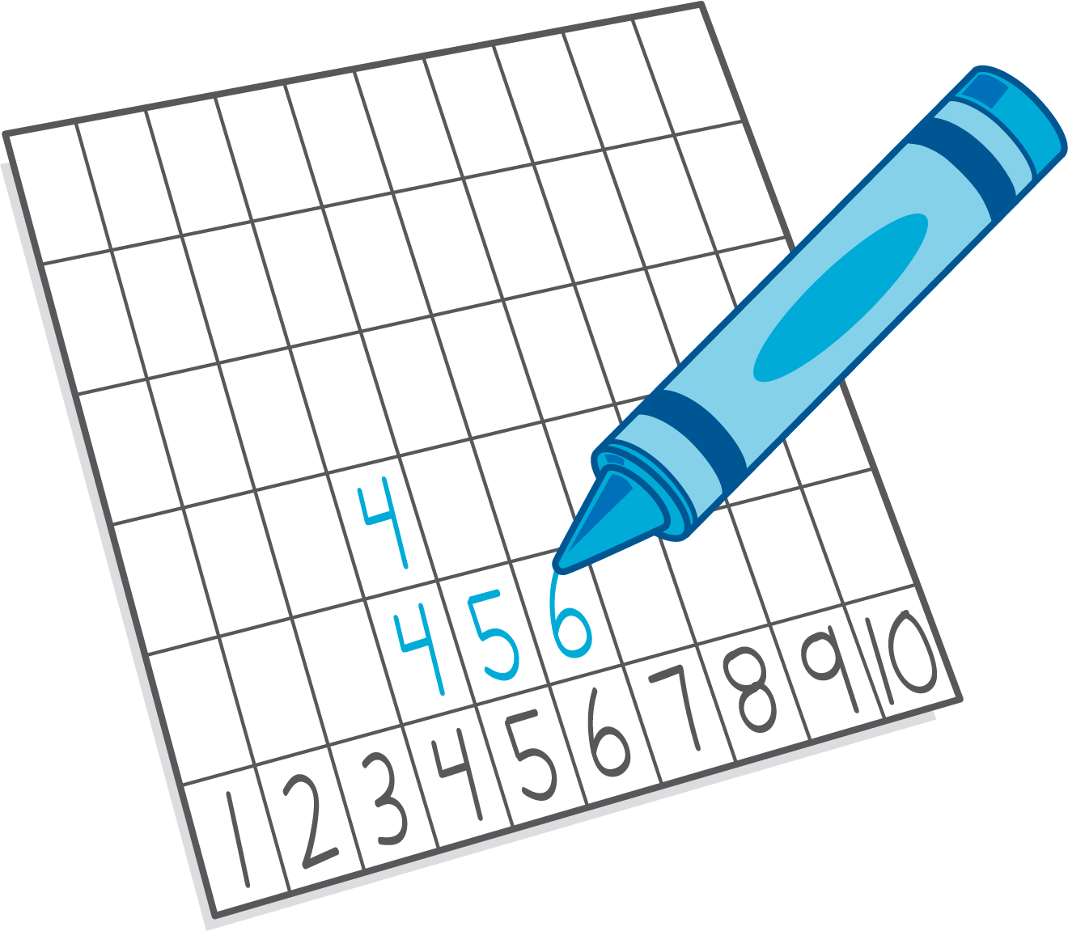
© CC BY 2021 Illustrative Mathematics®

