Unit 6 Lesson 3: Count Carefully

WU Notice and Wonder: Pile of Connecting Cubes (Warm up)

Student Task Statement
What do you notice?
What do you wonder?
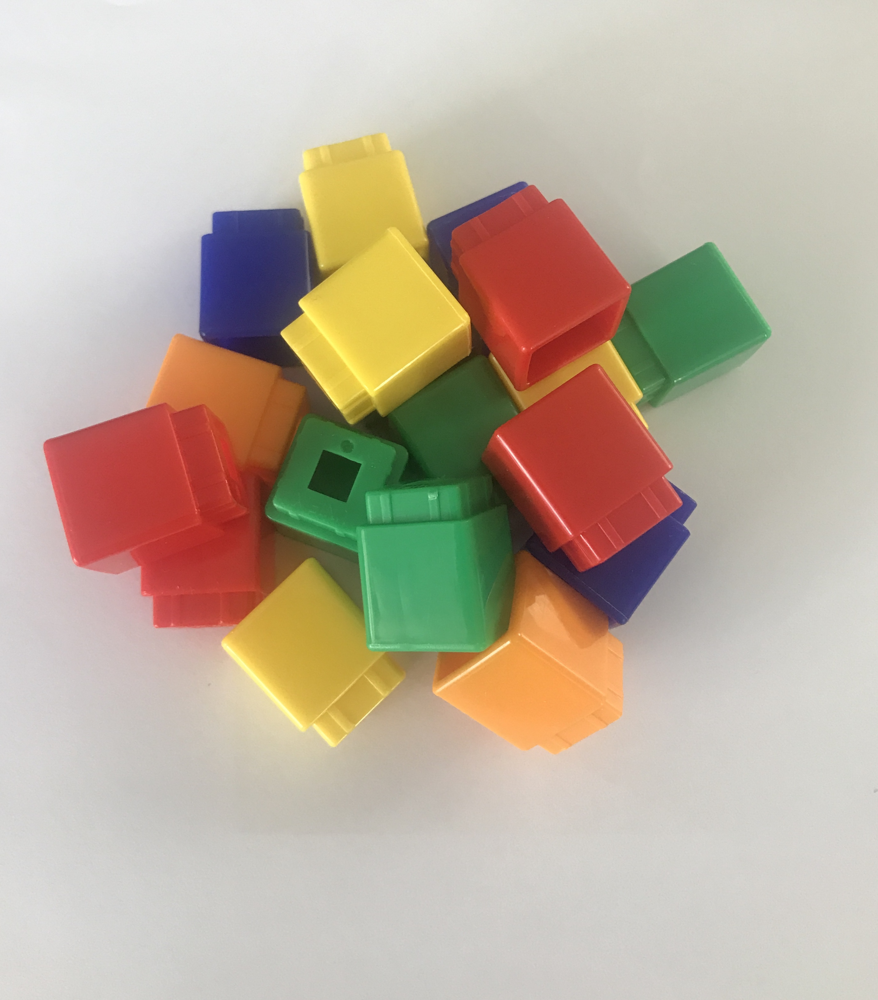

1 Counting Collections

Student Task Statement

2 Count Carefully with Friends

Student Task Statement
Clare, Andre, and Noah all counted these cubes.
Clare says there are 15 cubes.
Andre says there are 16 cubes.
Noah says there are 17 cubes.
Can they all be right?

3 Introduce Find the Pair, Make 5

Student Task Statement
Choose a center.
Find the Pair
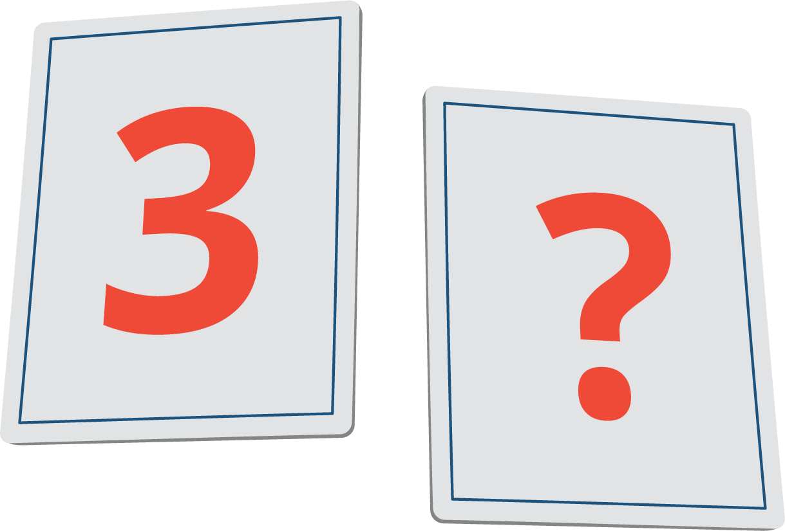
Number Race
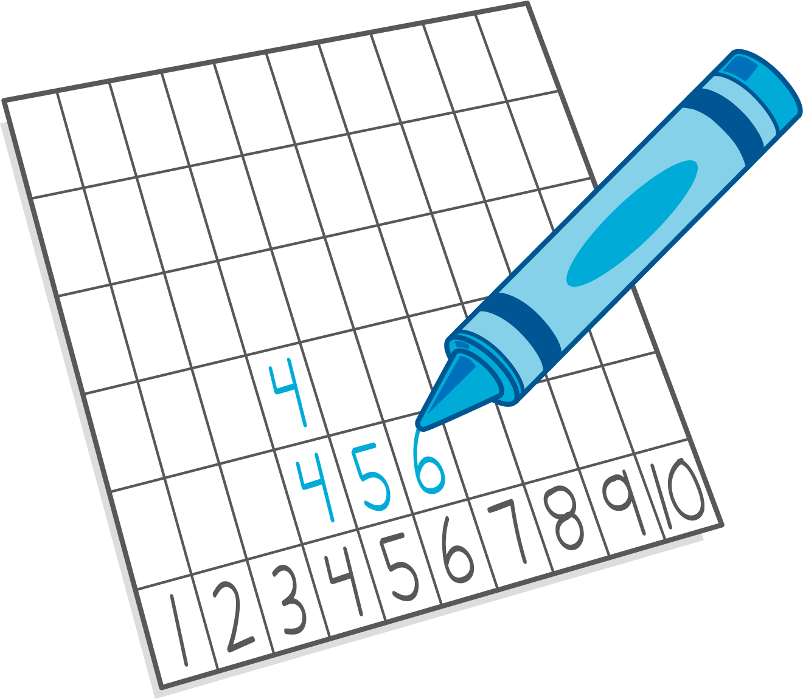
Subtraction Towers
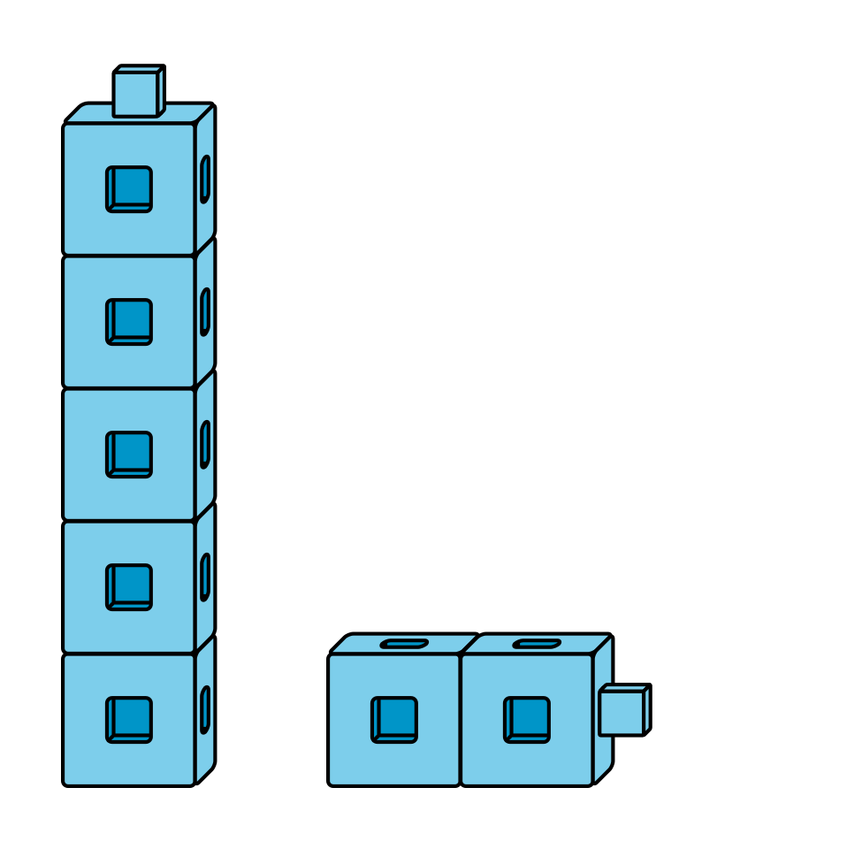
5-frames
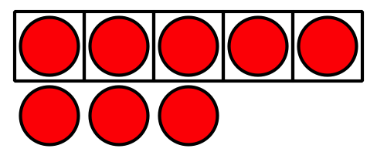
© CC BY 2021 Illustrative Mathematics®

