Lesson 9: Comparing Graphs
- Let’s compare graphs of functions to learn about the situations they represent.

9.1: Population Growth
This graph shows the populations of Baltimore and Cleveland in the 20th century. $B\left(t\right)$ is the population of Baltimore in year $t$. $C\left(t\right)$ is the population of Cleveland in year $t$.
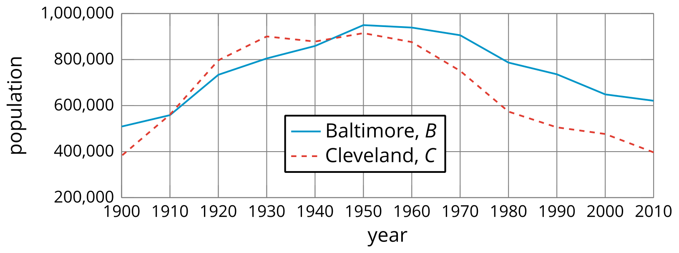
- Estimate $B\left(1930\right)$ and explain what it means in this situation.
- Here are pairs of statements about the two populations. In each pair, which statement is true? Be prepared to explain how you know.
  - $B\left(2000\right)>C\left(2000\right)$ or $B\left(2000\right)<C\left(2000\right)$
  - $B\left(1900\right)=C\left(1900\right)$ or $B\left(1900\right)>C\left(1900\right)$
- Were the two cities’ populations ever the same? If so, when?

9.2: Wired or Wireless?
$H\left(t\right)$ is the percentage of homes in the United States that have a landline phone in year $t$. $C\left(t\right)$ is the percentage of homes with only a cell phone. Here are the graphs of $H$ and $C$.
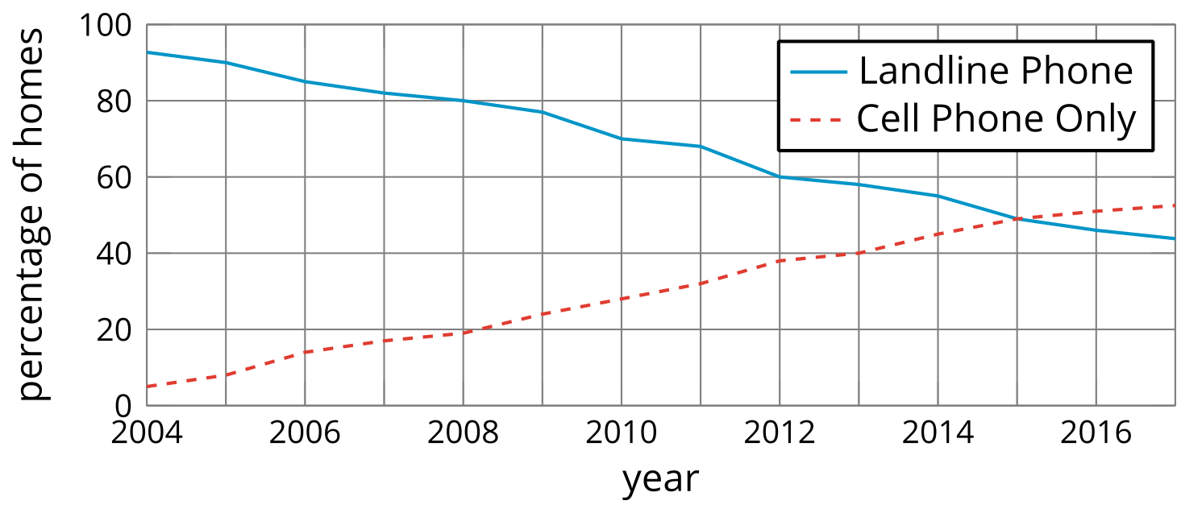
- Estimate $H\left(2006\right)$ and $C\left(2006\right)$. Explain what each value tells us about the phones.
- What is the approximate solution to $C\left(t\right)=20$? Explain what the solution means in this situation.
- Determine if each equation is true. Be prepared to explain how you know.
  - $C\left(2011\right)=H\left(2011\right)$
  - $C\left(2015\right)=H\left(2015\right)$
- Between 2004 and 2015, did the percentage of homes with landlines decrease at the same rate at which the percentage of cell-phones-only homes increased? Explain or show your reasoning.

Are you ready for more?
- Explain why the statement $C\left(t\right)+H\left(t\right)≤100$ is true in this situation.
- What value does $C\left(t\right)+H\left(t\right)$ appear to take between 2004 and 2017? How much does this value vary in that interval?

9.3: Audience of TV Shows
The number of people who watched a TV episode is a function of that show’s episode number. Here are three graphs of three functions—$A,B$, and $C$—representing three different TV shows.

Show A
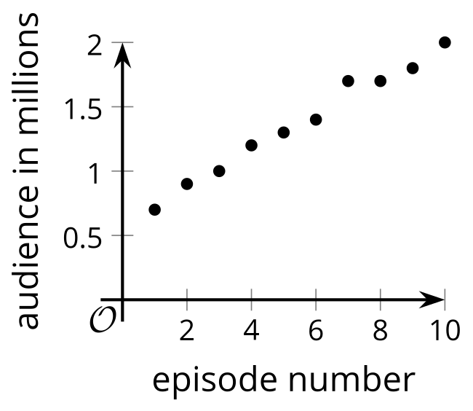

Show B
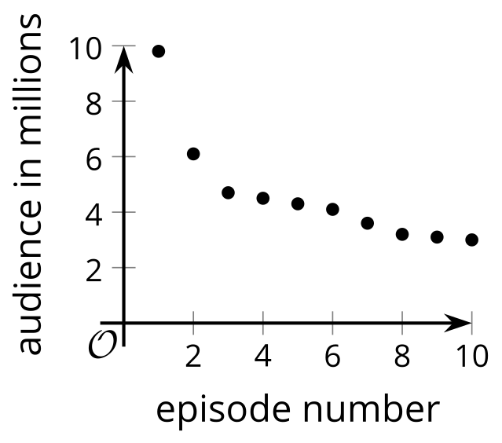

Show C
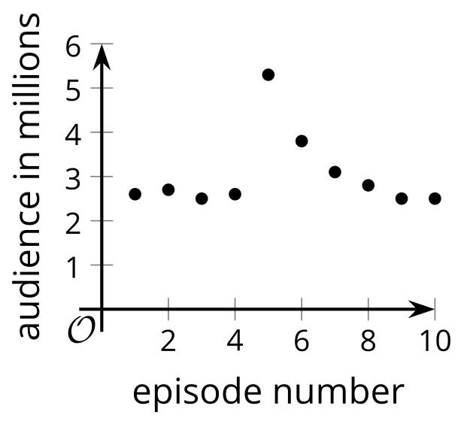
- Match each description with a graph that could represent the situation described. One of the descriptions has no corresponding graph.
  - This show has a good core audience. They had a guest star in the fifth episode that brought in some new viewers, but most of them stopped watching after that.
  - This show is one of the most popular shows, and its audience keeps increasing.
  - This show has a small audience, but it’s improving, so more people are noticing.
  - This show started out huge. Even though it feels like it crashed, it still has more viewers than another show.
- Which is greatest, $A\left(7\right)$, $B\left(7\right)$, or $C\left(7\right)$? Explain what the answer tells us about the shows.
- Sketch a graph of the viewership of the fourth TV show that did not have a matching graph.
- 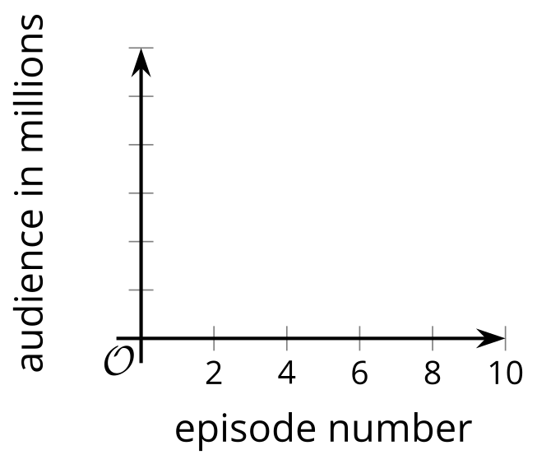

9.4: Functions $f$ and $g$
- Here are graphs that represent two functions, $f$ and $g$.
- Decide which function value is greater for each given input. Be prepared to explain your reasoning.
  - $f\left(2\right)$ or $g\left(2\right)$
  - $f\left(4\right)$ or $g\left(4\right)$
  - $f\left(6\right)$ or $g\left(6\right)$
  - $f\left(8\right)$ or $g\left(8\right)$
- 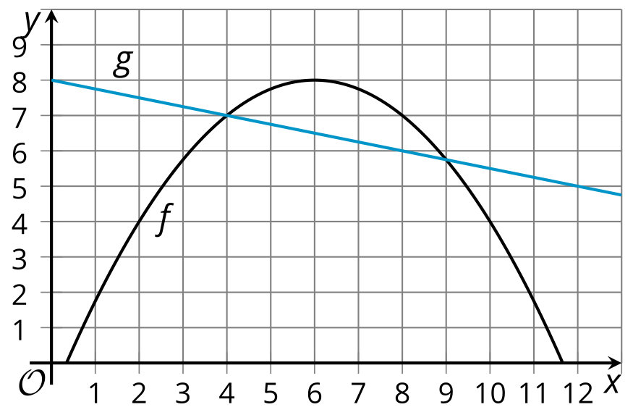
- ​​​​​
- Is there a value of $x$ at which the equation $f\left(x\right)=g\left(x\right)$ is true? Explain your reasoning.
- Identify at least two values of $x$ at which the inequality $f\left(x\right)<g\left(x\right)$ is true.

Lesson 9 Summary
Graphs are very useful for comparing two or more functions. Here are graphs of functions $C$ and $T$, which give the populations (in millions) of California and Texas in year $x$.
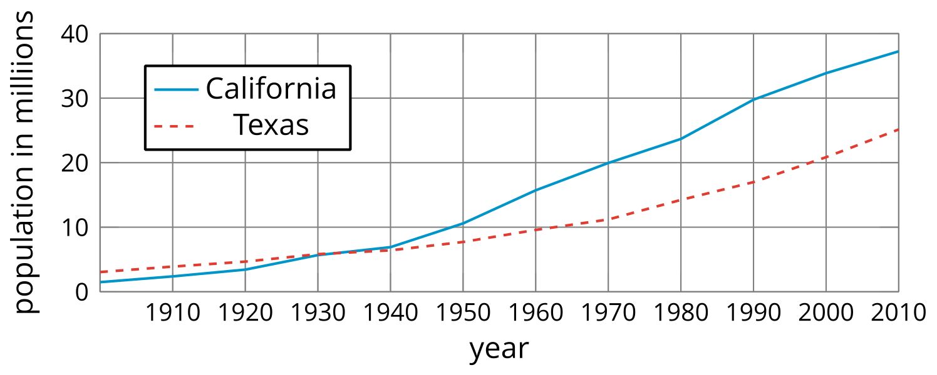
What can we tell about the  populations? | How can we tell? | How can we convey this  with function notation?
In the early 1900s, California had a smaller population than Texas. | The graph of $C$ is below the graph of $T$ when $x$ is 1900. | $C\left(1900\right)<T\left(1900\right)$
Around 1935, the two states had the same population of about 5 million people. | The graphs intersect at about $\left(1935,5\right)$. | $C\left(1935\right)=5$ and $T\left(1935\right)=5$, and $C\left(1935\right)=T\left(1935\right)$
After 1935, California has had more people than Texas. | When $x$ is greater than 1935, the graph of $C\left(x\right)$ is above that of $T\left(x\right)$ . | $C\left(x\right)>T\left(x\right)$ for $x>1935$
Both populations have increased over time, with no periods of decline. | Both graphs slant upward from left to right.
From 1900 to 2010, the population of California has risen faster than that of Texas. California had a greater average rate of change. | If we draw a line to connect the points for 1900 and 2010 on each graph, the line for $C$ has a greater slope than that for $T$. | 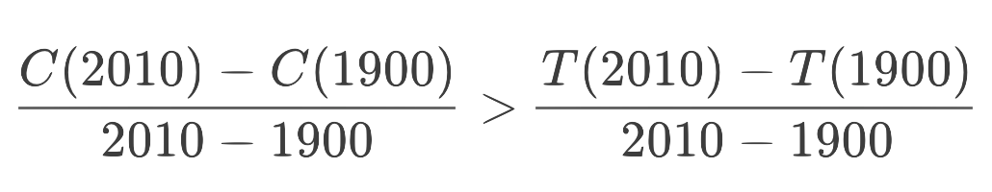
© CC BY 2019 by Illustrative Mathematics®

