Unit 4 Lesson 4: Standard Algorithm: One-digit and Multi-digit Numbers with Composing

WU Number Talk: Partial Product (Warm up)

Student Task Statement
Find the value of each product mentally.
- $3×3$
- $3×20$
- $3×600$
- $3×623$

1 Compose with the Standard Algorithm

Student Task Statement
Here is how Han calculated $318×3$ using partial products.
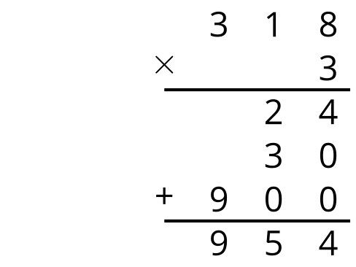
Here is how Elena calculated $318×3$ using the standard algorithm.
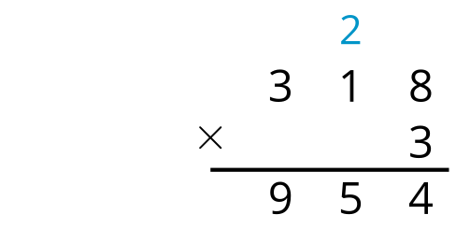
- What does the 2 in Elena’s calculation represent? Explain or show your reasoning.
- What does the 5 in Elena’s solution represent? Explain or show your reasoning.

2 Use the Standard Algorithm

Student Task Statement
Calculate each product using Elena’s strategy.
- $3,​615×4$
- $16,​023×3$
- $27,​326×3$
- $10,​215×6$
© CC BY 2021 Illustrative Mathematics®

