Lesson 5: To the Number Line
- Let’s learn about fractions on the number line.

Warm-up: Notice and Wonder: Two Number Lines
What do you notice? What do you wonder?

5.1: Card Sort: Number Lines
Your teacher will give you a set of cards that show number lines. Sort the cards into categories of your choosing. Be prepared to explain the meaning of your categories.
A
B
C
D
E
F
G
H
I

5.2: Fold and Label the Number Line
- Andre and Clare are talking about how to label fractions on the number line.
- Andre says $\frac{1}{2}$ can be labeled like this:
- Clare says $\frac{1}{2}$ can be labeled like this:
- 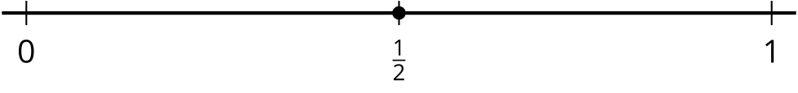
- How could each student’s labeling make sense?
- Your teacher will give you a set of number lines. Cut your number lines apart so that you can fold each one.
- As you fold, discuss your strategies with your partner.
  - Fold one of the number lines into halves. Draw tick marks to show the halves. Label the number $\frac{1}{2}$.
  - Fold one of the number lines into thirds. Draw tick marks to show the thirds. Label the number $\frac{1}{3}$.
  - Fold one of the number lines into fourths. Draw tick marks to show the fourths. Label the number $\frac{1}{4}$.
  - Fold one of the number lines into sixths. Draw tick marks to show the sixths. Label the number $\frac{1}{6}$.
  - Fold one of the number lines into eighths. Draw tick marks to show the eighths. Label the number $\frac{1}{8}$.
© CC BY 2021 Illustrative Mathematics®

