Unit 8 Lesson 4: Change Unknown Story Problems

WU How Many Do You See: Numbers to 20 (Warm up)

Student Task Statement
How many do you see?
How do you see them?
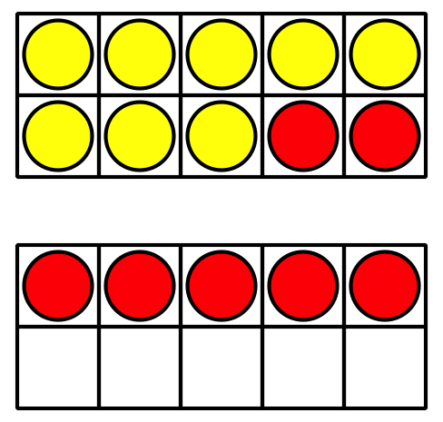
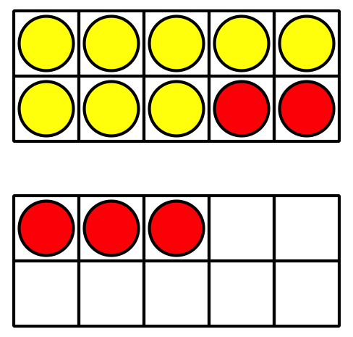
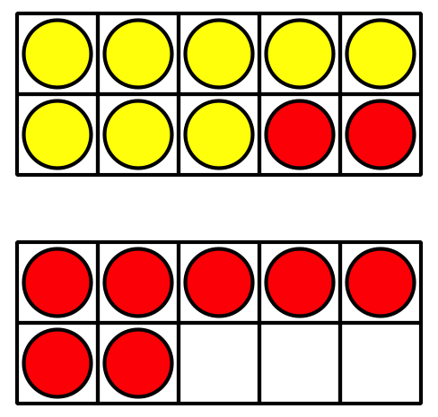

1 Field Trip to the Aquarium

Student Task Statement
Solve each problem.
Show your thinking using drawings, numbers, or words.
- Clare saw 8 sea turtles swimming together in the tank.
- Some more turtles joined them.
Now there are 15 turtles in the tank.
How many turtles joined the group?
- 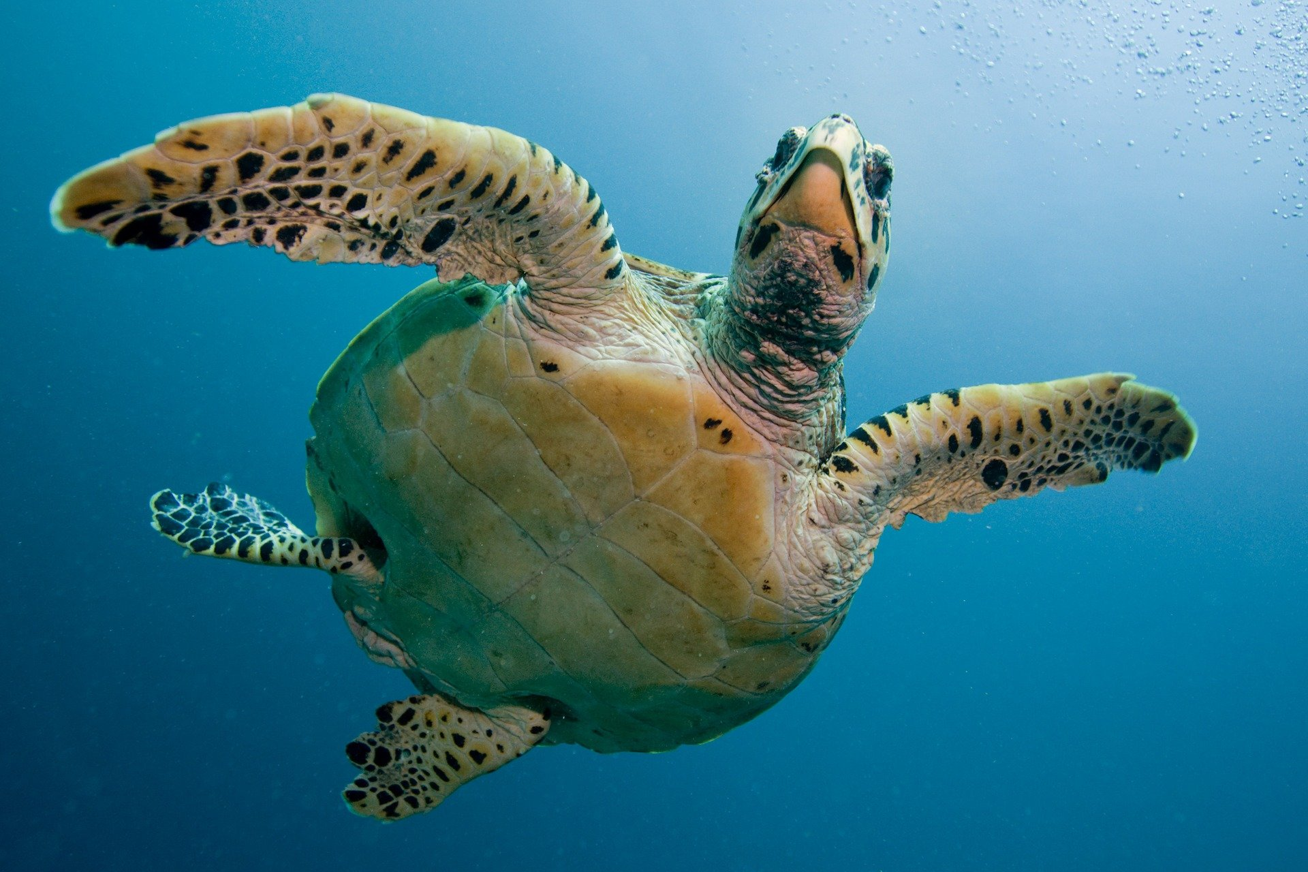
- There were 17 penguins sitting on the rocks.
Some of the penguins went back into the water.
Now there are 5 penguins sitting on the rocks.
How many penguins went back into the water?
- The seal trainer brought out a bucket of 20 fish to feed to the seals.
The seals ate some of the fish.
Now there are 3 fish left in the bucket.
How many fish did the seals eat?
- In the touch pools, Tyler felt 6 stingrays.
Then he felt some sea stars.
Tyler felt 14 animals all together.
How many sea stars did Tyler feel?

2 Find the Unknown Number

Student Task Statement
Clare watched 16 bullfrogs at the aquarium.
Then some of them swam away.
Now Clare can only see 9 bullfrogs.
How many bullfrogs swam away?
Andre wrote 16−3=9, but he doesn’t know how to find the unknown number.
Show Andre how you would find the unknown number.
Show your thinking using drawings, numbers, or words.
© CC BY 2021 Illustrative Mathematics®

