Unit 6 Lesson 3: Measure in Halves and Fourths of an Inch

WU Notice and Wonder: Rulers (Warm up)

Student Task Statement
Look at the rulers you have been using to measure and the ruler your teacher gave you.
What do you notice? What do you wonder?

1 Halves and Quarters

Student Task Statement
- Kiran and Jada are discussing the length of a worm.
- 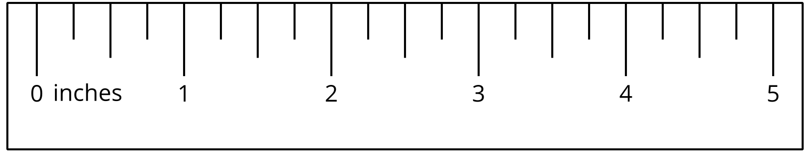
  - Kiran says that the worm is $4\frac{2}{4}$ inches long.
  - Jada says that the worm is $4\frac{1}{2}$ inches long.
- Use the ruler to explain how both of their measurements are correct.
- Measure the length of the following worms.
- A
- B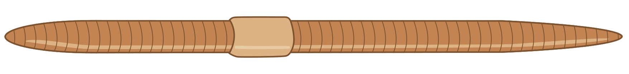
- C
- D

2 Measure and Describe

Student Task Statement
- Use the ruler you received today to measure some objects around the room.
- Find at least 1 object whose length is a whole number of inches and at least 3 objects whose lengths are not whole numbers.
- object | - length
- Trade lists with another group. Find a length that could be written a different way.
- object | - length | - equivalent length
© CC BY 2021 Illustrative Mathematics®

