Lesson 3: Grid Moves

3.1: Notice and Wonder: The Isometric Grid
What do you notice? What do you wonder?

3.2: Transformation Information
Your teacher will give you tracing paper to carry out the moves specified. Use $A^{′}$, $B^{′}$, $C^{′}$, and $D^{′}$ to indicate vertices in the new figure that correspond to the points $A$, $B$, $C$, and $D$ in the original figure.
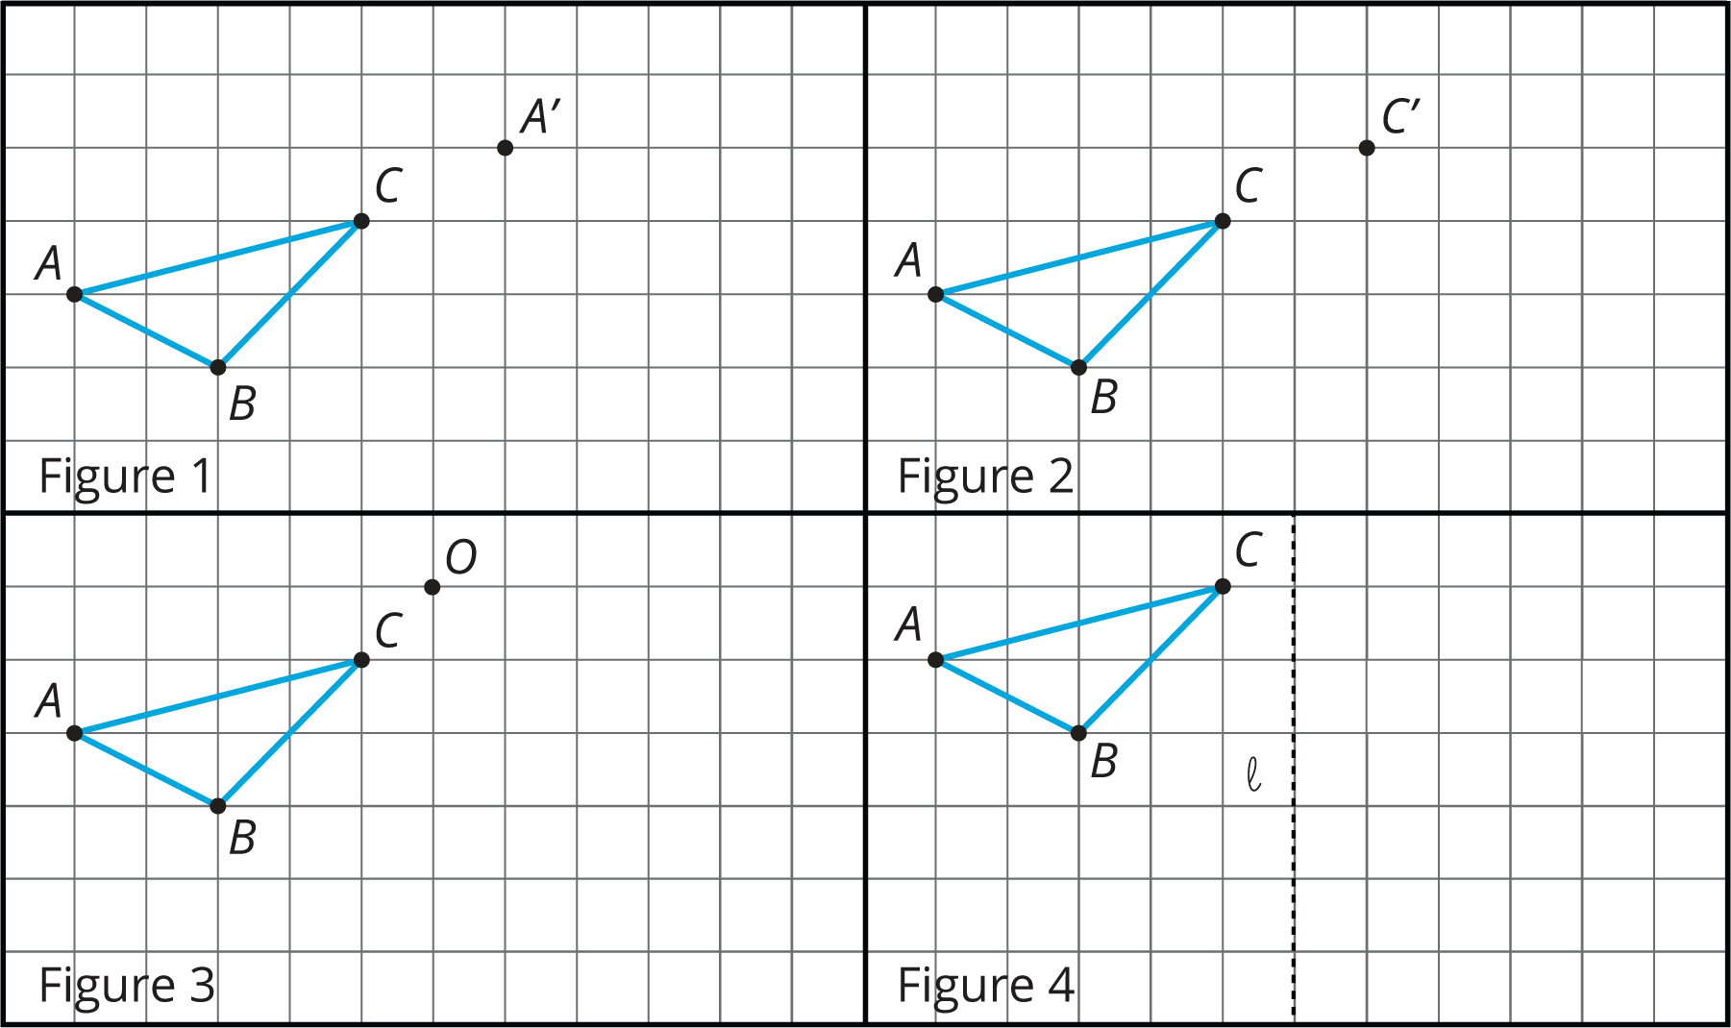
- In Figure 1, translate triangle $ABC$ so that $A$ goes to $A^{′}$.
- In Figure 2, translate triangle $ABC$ so that $C$ goes to $C^{′}$.
- In Figure 3, rotate triangle $ABC$ ${90}^{∘}$ counterclockwise using center $O$.
- In Figure 4, reflect triangle $ABC$ using line $ℓ$.
- 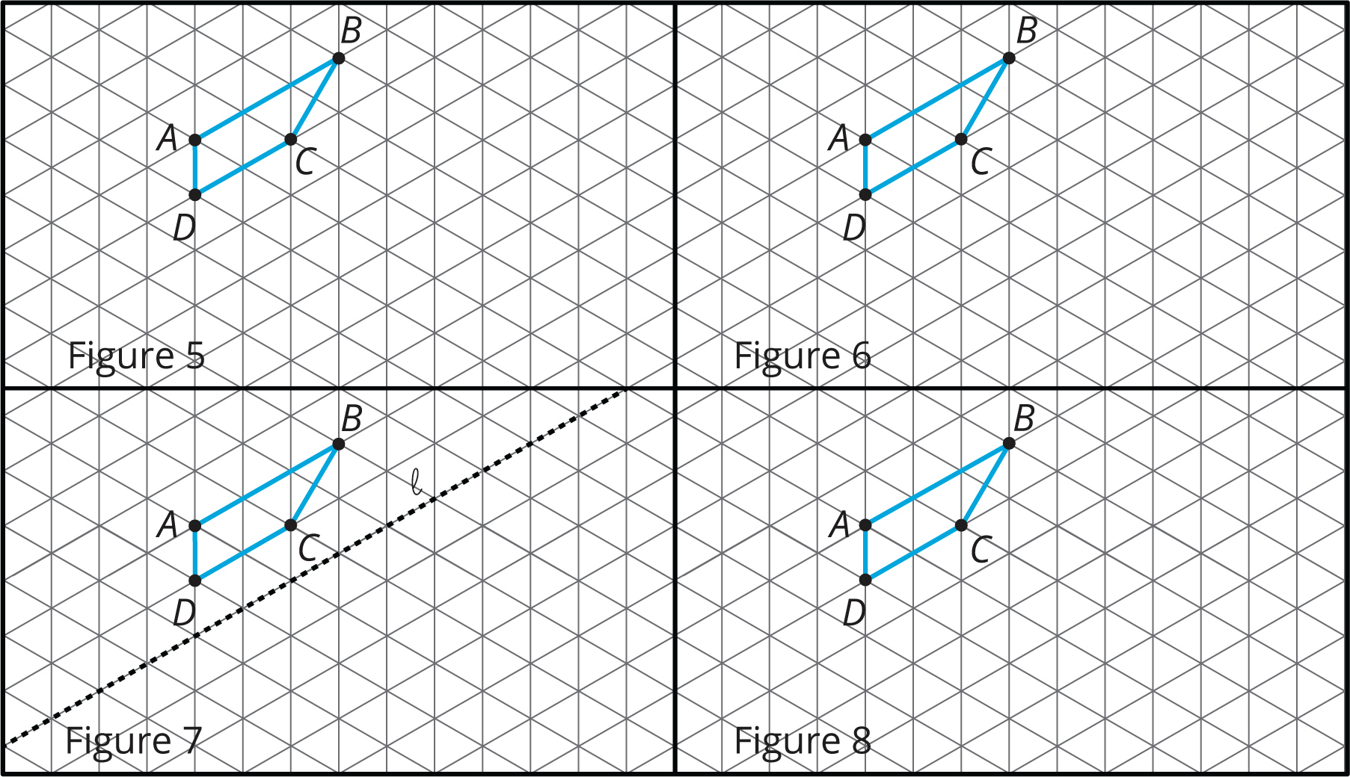
- In Figure 5, rotate quadrilateral $ABCD$ ${60}^{∘}$ counterclockwise using center $B$.
- In Figure 6, rotate quadrilateral $ABCD$ ${60}^{∘}$ clockwise using center $C$.
- In Figure 7, reflect quadrilateral $ABCD$ using line $ℓ$.
- In Figure 8, translate quadrilateral $ABCD$ so that $A$ goes to $C$.

Are you ready for more?
The effects of each move can be “undone” by using another move. For example, to undo the effect of translating 3 units to the right, we could translate 3 units to the left. What move undoes each of the following moves?
- Translate 3 units up
- Translate 1 unit up and 1 unit to the left
- Rotate 30 degrees clockwise around a point $P$
- Reflect across a line $ℓ$

Lesson 3 Summary
When a figure is on a grid, we can use the grid to describe a transformation. For example, here is a figure and an image of the figure after a move.
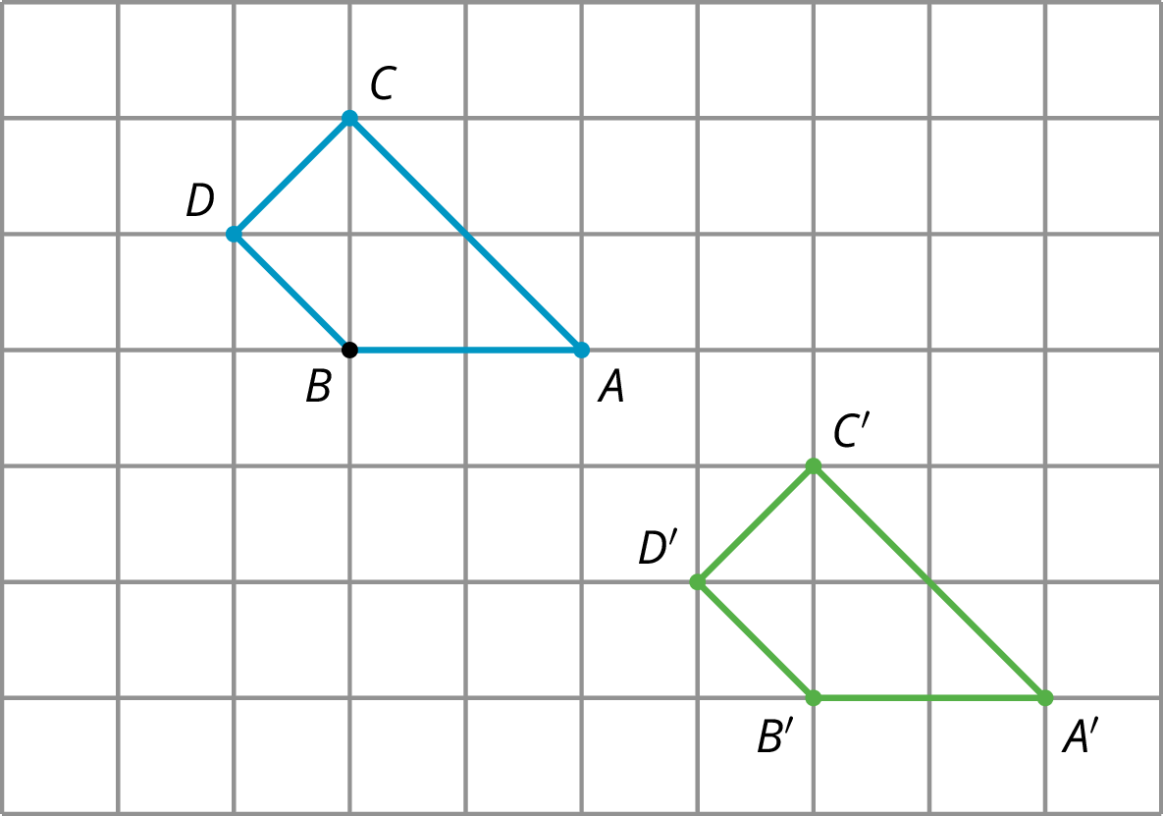
Quadrilateral $ABCD$ is translated 4 units to the right and 3 units down to the position of quadrilateral $A^{′}B^{′}C^{′}D^{′}$.
A second type of grid is called an isometric grid. The isometric grid is made up of equilateral triangles. The angles in the triangles all measure 60 degrees, making the isometric grid convenient for showing rotations of 60 degrees.
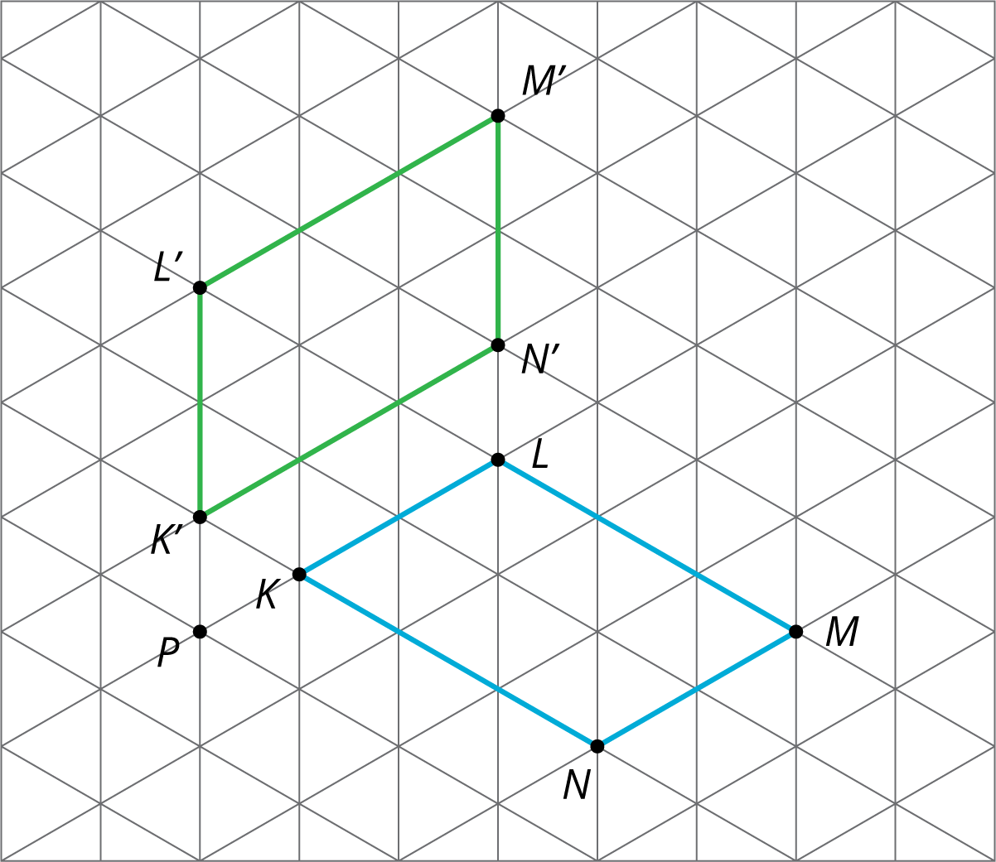
Here is quadrilateral $KLMN$ and its image $K^{′}L^{′}M^{′}N^{′}$ after a 60-degree counterclockwise rotation around a point $P$.
© CC BY Open Up Resources. Adaptations CC BY IM.

