Unit 4 Lesson 15: Finding Input Values and Function Values

1 Inches to Feet and Back (Warm up)

Student Task Statement
There are 12 inches in 1 foot.
Complete the table by converting the lengths to the other unit.
inches | feet
36
18
 | 4
 | 6.3
105

2 Building Square Planters

Student Task Statement
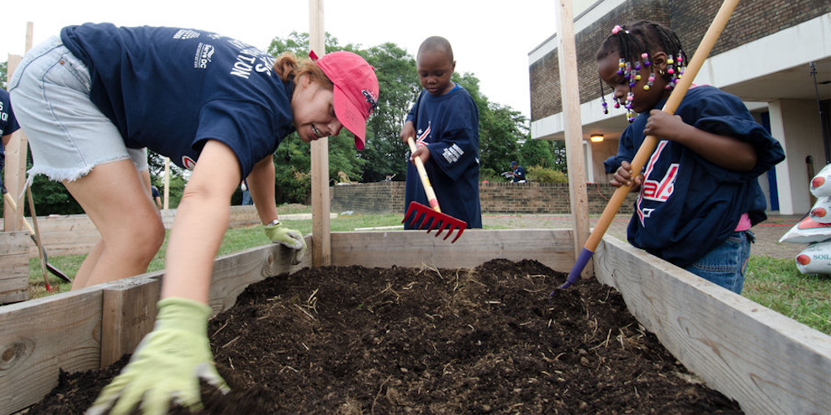
For a class project, students are building an outdoor square planter from pieces of wood, then filling it with soil. The amount of soil needed is based on the area within the square.
- Mai has boards of wood that are 2 meters long. What is the area of the largest square planter she could make?
- Tyler has boards of wood that are 5 feet long. What is the area of the largest square planter he could make?
- Lin has boards of wood that are 53 inches long. What is the area of the largest square planter she could make?
- Elena has enough soil to fill 36 square feet in a planter. What length boards should she cut to make the square planter that can hold all the soil?
- Andre has enough soil to fill 16 square meters in a planter. What length boards should he cut to make the square planter that can hold all the soil?
- If a student has boards of wood that are $s$ feet long, what is the area of the largest square planter they can build? Write the solution as an equation involving $f(s)$.

3 Inputs and Outputs from Graphs

Student Task Statement
The graph represents $y=f(x)$.
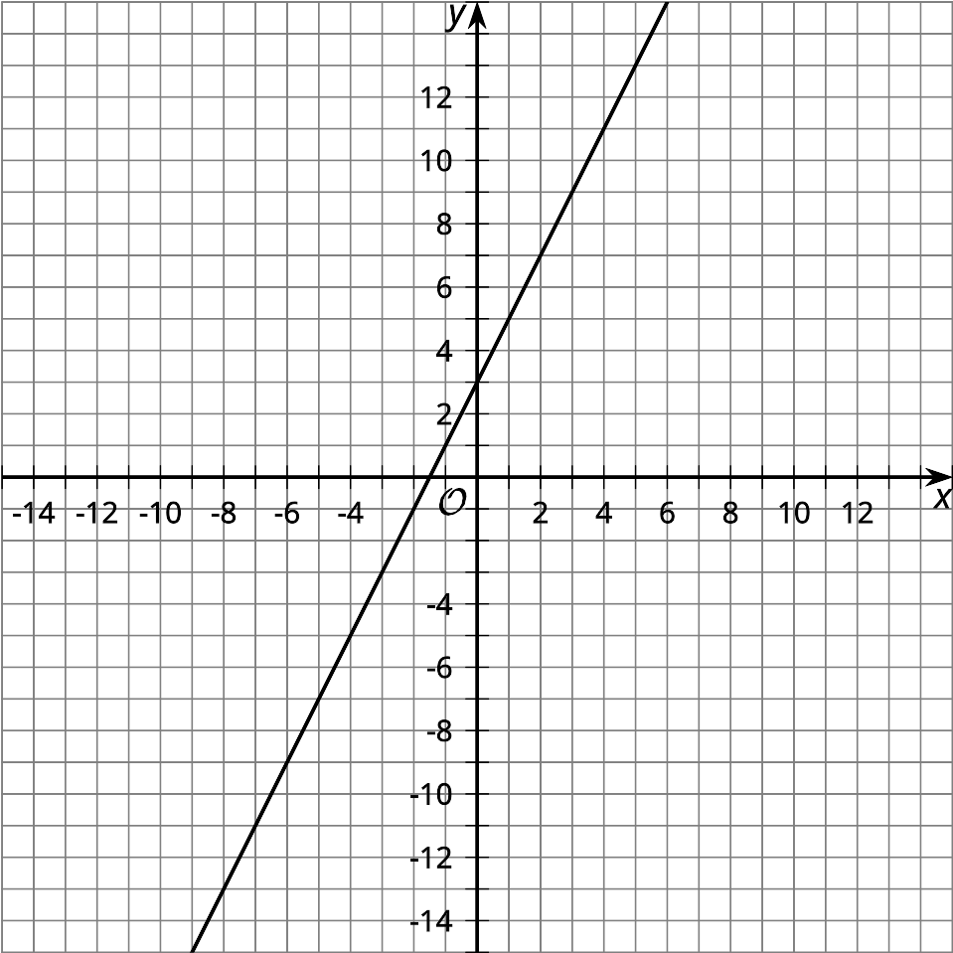
- Use the graph to find the values.
  - $f(2)$
  - $f(\text{-}1)$
  - $f(5)$
  - $f(0)$
- Use the graph to find the value of $x$ that makes these true.
  - $f(x)=11$
  - $f(x)=9$
  - $f(x)=\text{-}1$
  - $f(x)=5$
© CC BY 2019 by Illustrative Mathematics

