Lesson 3: Plot More Points
- Let’s locate and name points on the coordinate grid.

Warm-up: Notice and Wonder: Points with Zero
What do you notice? What do you wonder?
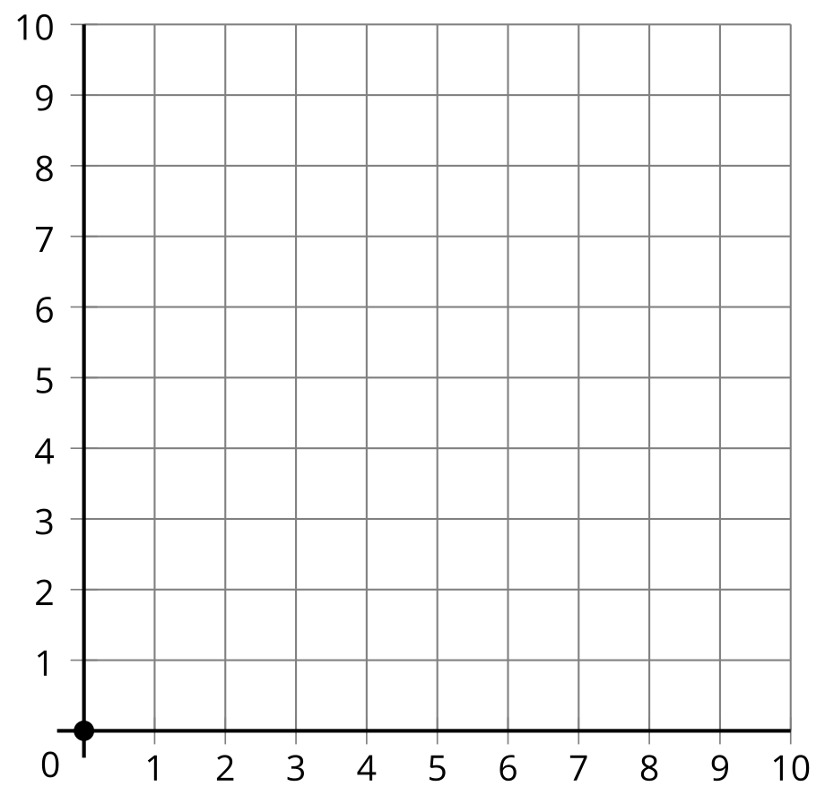

3.1: What’s the Point?
Partner A
- Estimate the location of each point.
- Point | - Coordinates
- $A$ | - $\left(5,1\right)$
- $B$ | - $\left(5,2\right)$
- $C$ | - $\left(5,3\right)$
- $D$ | - $\left(5,4\right)$
- 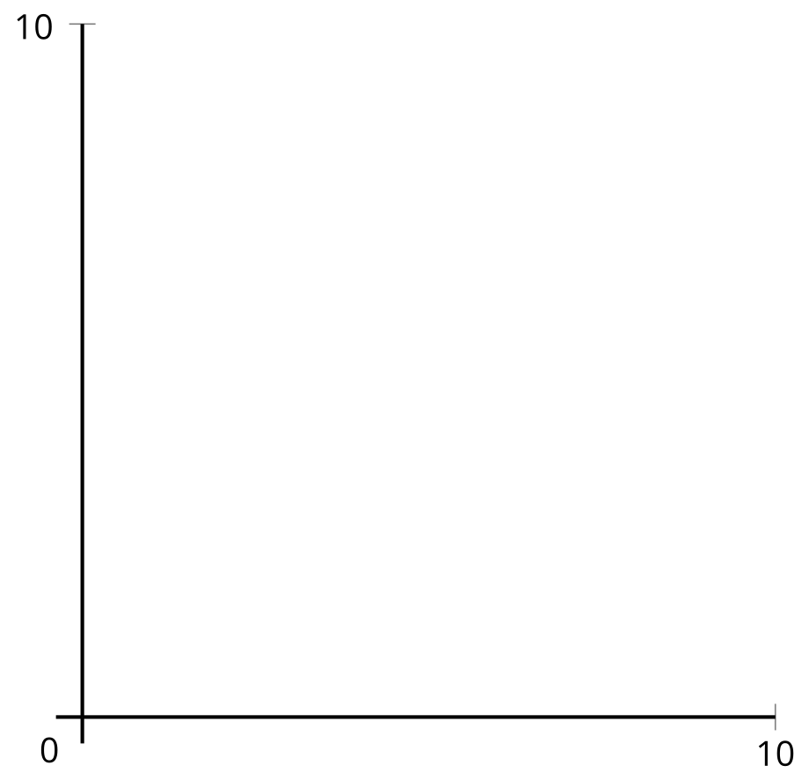
- Plot and label the points on the coordinate grid.
- 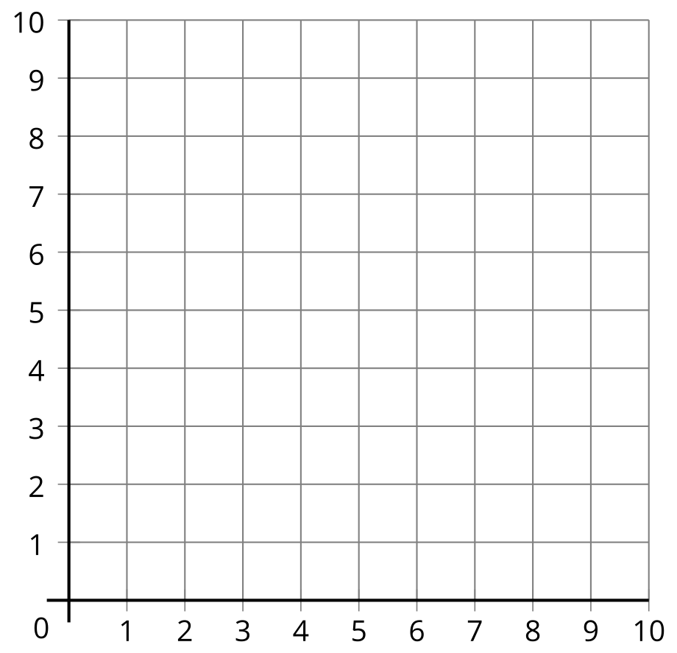
- What do the points have in common?
- Plot the point with coordinates $\left(5,0\right)$ on the coordinate grid.
Partner B
- Estimate the location of each point.
- Point | - Coordinates
- $A$ | - $\left(4,3\right)$
- $B$ | - $\left(5,3\right)$
- $C$ | - $\left(6,3\right)$
- $D$ | - $\left(7,3\right)$
- Plot and label the points on the coordinate grid.
- What do the points have in common?
- Plot the point with coordinates $\left(0,3\right)$ on the coordinate grid.

3.2: Plotting Points Without a Grid
- A point is labeled in the coordinate plane. Plot and label some other points. Explain or show your reasoning.
- 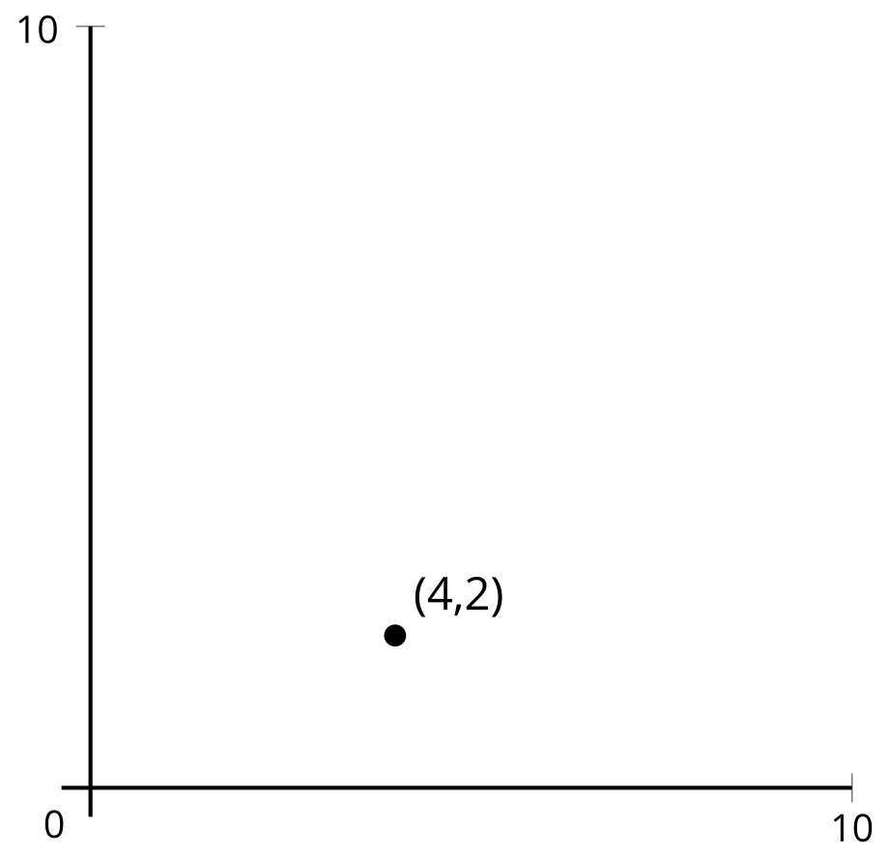
- Can you plot $\left(1,0\right)$ and $\left(0,1\right)$ accurately? Explain or show your reasoning.

Section Summary
Section Summary
In this section, we plotted and described points on the coordinate grid.
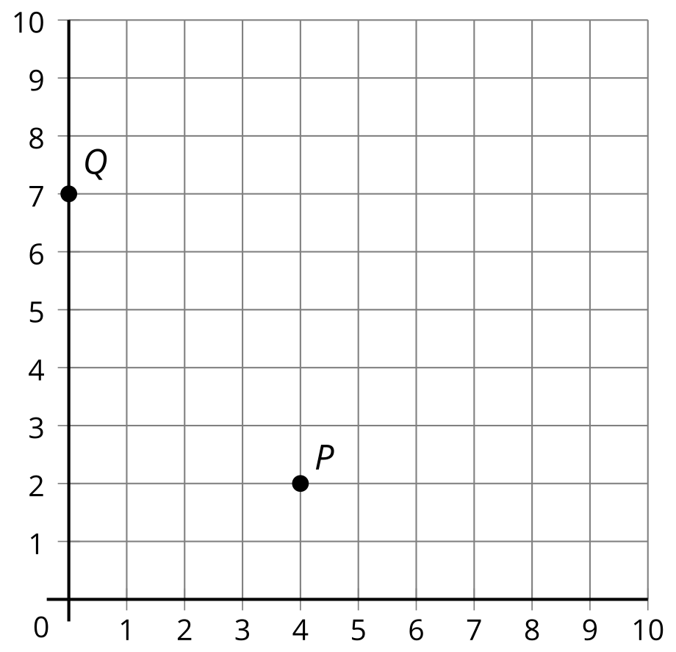
The point $P$ is 4 units from the vertical axis and 2 units from the horizontal axis. Its coordinates are $\left(4,2\right)$. The point $Q$ is 0 units from the vertical axis since it is on the vertical axis. It is 7 units from the horizontal axis. Its coordinates are $\left(0,7\right)$.
The first coordinate of a point tells us its horizontal position and the second coordinate gives its vertical position.
© CC BY 2021 Illustrative Mathematics®

