Lesson 9: From Feet to Inches

Standards Alignments
Addressing | 2.MD.A.1, 2.MD.A.2, 2.MD.A.3

Teacher-facing Learning Goals
- Compare measurements in feet and inches and describe the relationship between different measurements and the size of length units.
- Use rulers to measure length in feet and inches.

Student-facing Learning Goals
- Let’s measure longer lengths with customary units.

Lesson Purpose
The purpose of this lesson is for students to learn about a larger unit of customary measurement—the foot. Students measure in inches and feet, compare their measurements, and generalize about the relationship between the size of a length unit and the number of units needed to measure the length of an object.
In an earlier lesson, students were introduced to the inch as a length unit in the customary system. They developed a benchmark for an inch and measured objects with an inch ruler.
In this lesson, students use the length of a 12-inch ruler to develop an understanding of the length of 1 foot. They use a ruler as a benchmark for estimating the length of a foot. Throughout the lesson, students make decisions about which tools and which length units to use when measuring (MP5). They compare measurements for the same object in inches and feet and generalize that the more units are needed to measure the same length if you use a smaller length unit. This concept is a foundation for future work with measurement and their work with unit fractions in later grades.
Although the activities encourage students to notice that 1 foot is the same length as 12 inches, students are not expected to convert units in grade 2. Students express larger units in terms of smaller units in grade 4 and larger units in terms of smaller units in grade 5.

Access for:

Students with Disabilities
- Action and Expression (Activity 2)

English Learners
- MLR2 (Activity 1)

Instructional Routines
Estimation Exploration (Warm-up)

Materials to Gather
- Inch tiles: Activity 1, Activity 2
- Measuring tapes: Activity 2
- Objects of various lengths: Activity 2
- Rulers (inches): Activity 1, Activity 2
- Tape (painter's or masking): Activity 1

Lesson Timeline
Warm-up | 10 min
Activity 1 | 20 min
Activity 2 | 15 min
Lesson Synthesis | 10 min
Cool-down | 5 min

Teacher Reflection Question
In Activity 1, students measured the same length of tape in both inches and feet. What evidence did you see of students’ understanding that the different measurements for each line relate to the size of the unit used to measure?

Cool-down
(to be completed at the end of the lesson) 5min
Measure in Inches and Feet

Standards Alignments
Addressing | 2.MD.A.3

Student-facing Task Statement
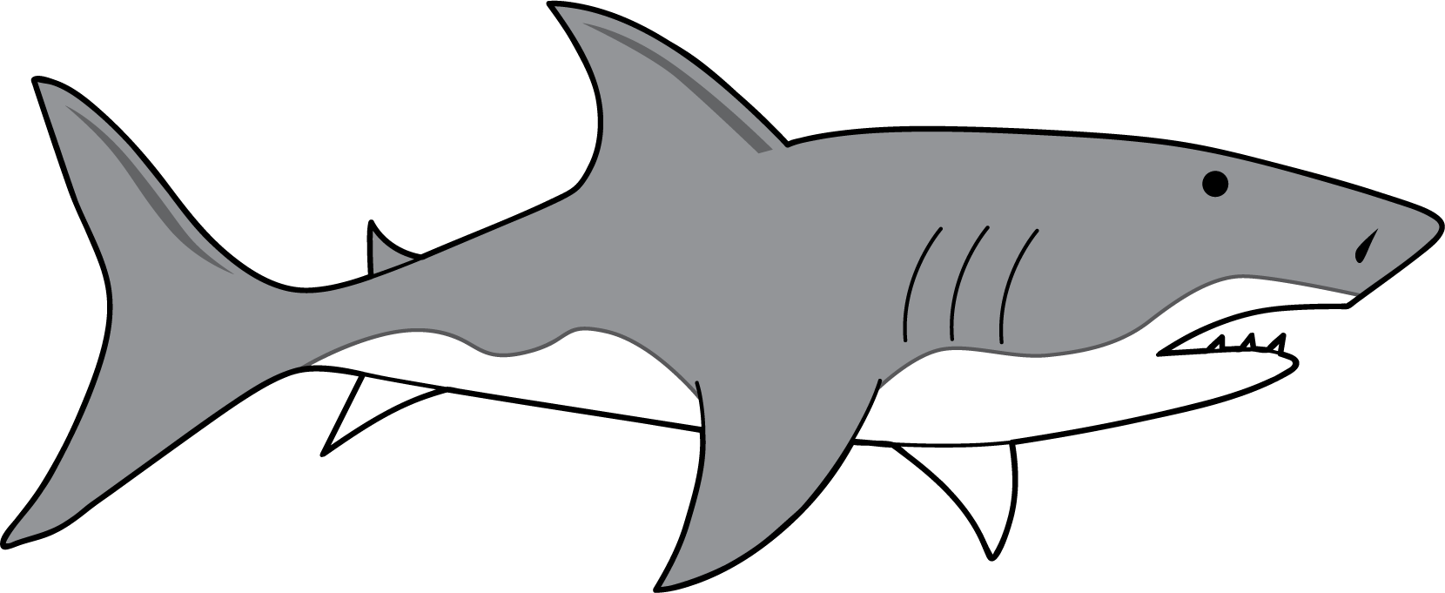
Tyler told Han that a great white shark is about 16 inches long, but Han disagrees. Han believes it would be about 16 feet long.
Who do you agree with? Explain.

Student Responses
Sample response: I think it is 16 feet long, because 16 inches would be way too small.

