Unit 8 Lesson 5: Put Together and Take Apart Story Problems

WU True or False: More or Less (Warm up)

Student Task Statement
Decide if each statement is true or false.
Be prepared to explain your reasoning.
- $57+20=59$
- $66−4=62$
- $17+76=59$

1 At the Planetarium

Student Task Statement
Solve each problem.
Show your thinking using drawings, numbers, or words.
- There are 7 first graders and some second graders at the planetarium.
There are 18 students at the planetarium.
How many second graders are at the planetarium?
- When the show started, 18 stars lit up in the sky.
13 stars were bright.
Some of the stars were dim.
How many stars were dim?
- 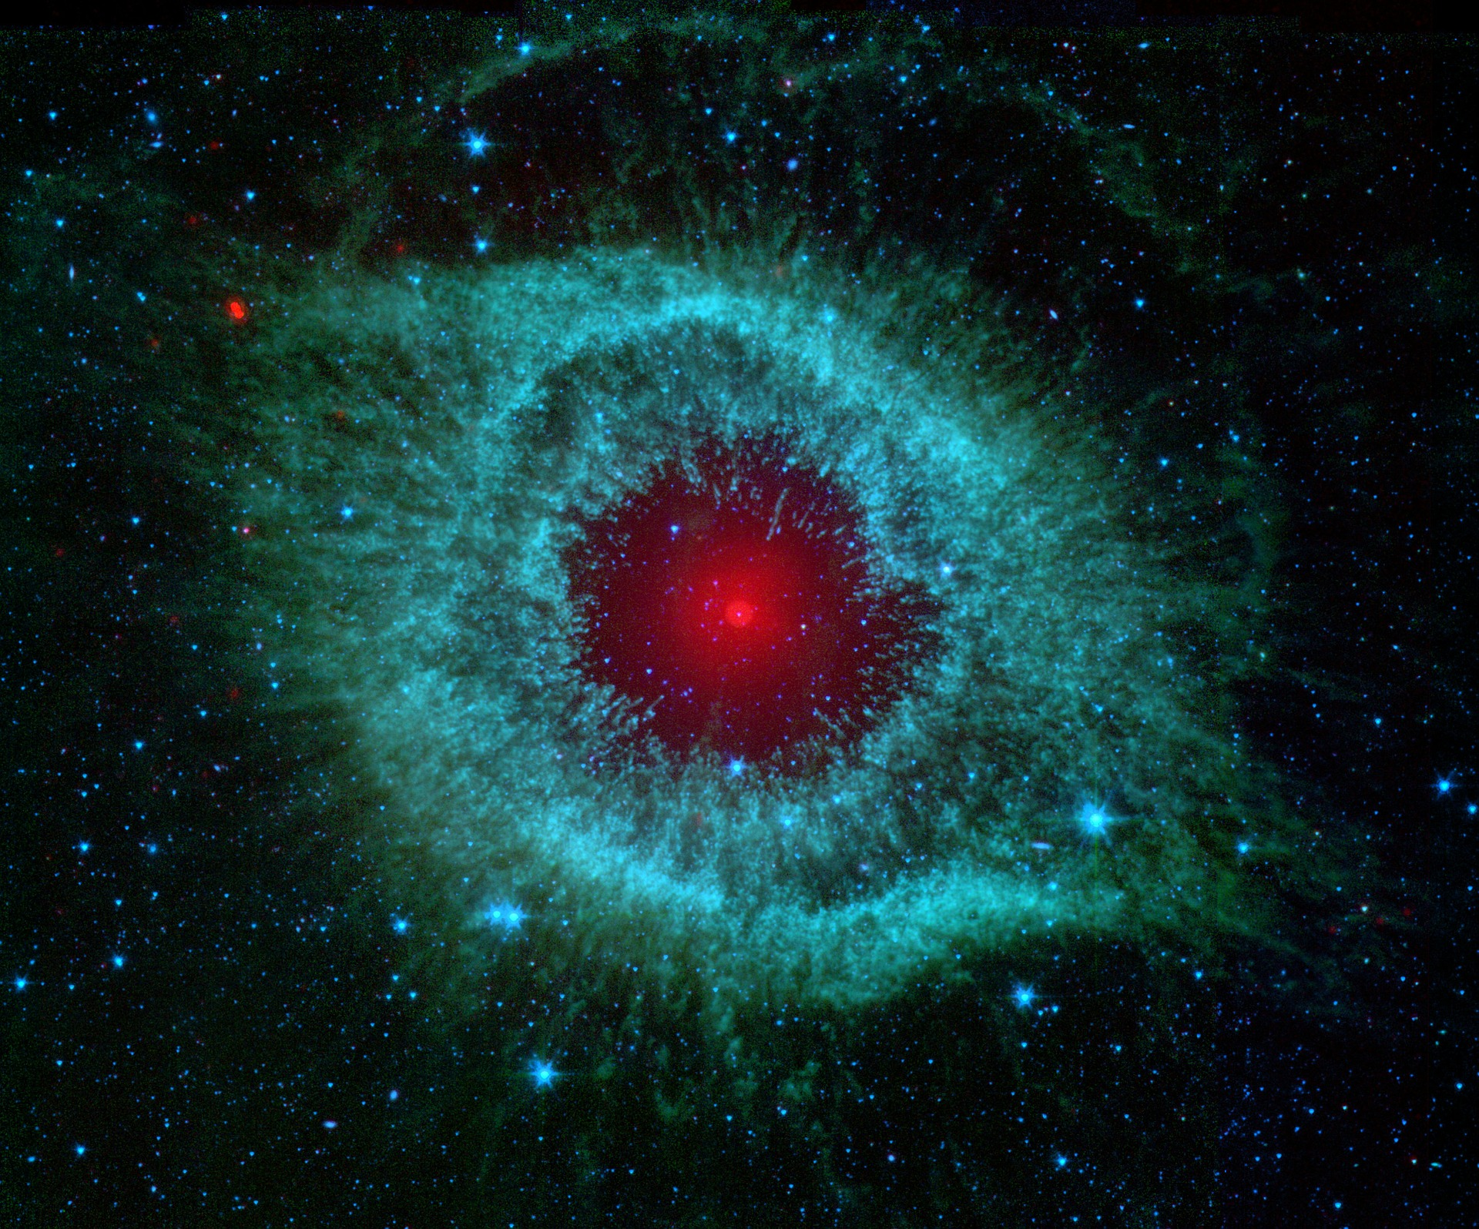
- Together, Diego and Tyler saw 15 shooting stars during the show.
Diego saw 6 shooting stars. Tyler saw the rest.
How many shooting stars did Tyler see?
- In the gift shop, Elena bought 12 star stickers.
She also bought some planet stickers.
Elena bought 20 stickers.
How many planet stickers did she buy?

2 Which Equations Match?

Student Task Statement
Circle 2 equations that can be used to solve each problem.
Be ready to explain how the equations represent the story and why the other equation doesn’t.
- Noah painted 9 white stars.
He also painted some yellow stars.
Noah painted 17 stars all together.
How many yellow stars did Noah paint?
  - 17−9=3
  - 9+17=3
  - 9+3=17
- Kiran saw 16 objects in the sky.
11 of the objects were stars.
The rest of the objects were planets.
How many of the objects were planets?
  - 16+11=3
  - 11+3=16
  - 16−11=3
If you have time: Solve each problem using both equations.
© CC BY 2021 Illustrative Mathematics®

